Investigating the replicability of the social and behavioral sciences
Andrew H. Tyner, Anna Lou Abatayo, Mason Daley, Samuel Field, Nicholas Fox, Noah A. Haber, Krystal M. Hahn, Melissa Kline Struhl, Brinna Mawhinney, Olivia Miske, Priya Silverstein, Courtney K. Soderberg, Theresa Stankov, Ahmed Abbasi, Christopher L. Aberson, Balazs Aczel, Matúš Adamkovič, Nihan Albayrak, Peter J Allen, Michael Andreychik, Eli Awtrey, Erick Axxe, Flavio Azevedo, Miles D. Bader, Bence Bago, James Bailey, Marjan Bakker, Gabriel Banik, George C. Banks, Ernest Baskin, Anatolia Batruch, Annika Beatteay, Sophie M. Behr, Nicholas Berente, Zachariah Berry, Jędrzej Białkowski, Bojana Bodroža, Laura Boeschoten, Miklos Bognar, Christian Bokhove, Diane Bonfiglio, Robin Bouwman, Timothy F. Brady, Scott Braithwaite, Gabriel Briceño Jiménez, Cameron Brick, Traci Bricka, Roman Briker, Annette N. Brown, Gordon D A Brown, Robbie C.M. van Aert, Kathryn Caldwell, Sara Capitan, Tabaré Capitán, Jesse Chandler, Tessa Charles, Christopher R. Chartier, Rahul Chawdhary, Kent Jason Cheng, William J. Chopik, Bruce Clark, Victoria E. Colvin, C. Cozette Comer, Giulio Costantini, Tom Coupé, Jamie Cummins, Aneta Czernatowicz-Kukuczka, Joshua de Leeuw, David Dobolyi, James N. Druckman, Jianhua Duan, Marin Dujmović, Daniel J. Dunleavy, Patrick K. Durkee, Cécile Emery, Kevin M. Esterling, Thomas R. Evans, Anna Fedor, Belén Fernández-Castilla, Nathan Fiala, James G. Field, Nathan Fong, Miguel A. Fonseca, Alexandra L.J. Freeman, Jeremy Freese, Sandra J. Geiger, Jing Geng, Laura M. Getz, Linda Marjoleine Geven, Ilka Helene Gleibs, Donna Pamella Gonzales, Janaki Gooty, Amélie Gourdon-Kanhukamwe, Cristina Greculescu, Siobhán M. Griffin, Lusine Grigoryan, Martina Grunow, Nicholas Gunby, Braeden Hall, Paul H. P. Hanel, Erin E. Hannon, Sam Harper, Marco Jürgen Held, Louis Hickman, Nathan C. Higgins, Svenja Hippel, Sven Hoeppner, Sanghyun Hong, Thomas J. Hostler, Michael Inzlicht, Kamil Izydorczak, Bastian Jaeger, Kristin Jankowsky, Johannes Jarke-Neuert, Matthew Jensen, Biljana Jokić, Daniel Jolles, Phillip Jolly, Angela M. Jones, Marie Juanchich, Pavol Kačmár, Hansika Kapoor, Andjela Keljanovic, Samjhana Koirala, Marta Kołczyńska, Dimitra Kouroupaki, Ulrich Kühnen, Michelangelo Landgrave, Michael J. Larson, Lyonel Laulié, Alice C E Lawrence, Joel M. Le Forestier, Katelin E. Leahy, Sungmok Lee, Jared Leslie, Savannah C. Lewis, Christopher Limnios, Hause Lin, An-Chiao Liu, John Wills Lloyd, Elliot A Ludvig, Dermot Lynott, Jordan MacDonald, Peter Mallik, Daniel J. Mallinson, Daniele Marinazzo, Corinna S. Martarelli, Joshua Matacotta, Andrew McBride, Cillian McHugh, Gail McMillan, Esteban Méndez, Mitchell Metzger, Michalis P. Michaelides, Johannes Michalak, Leticia Micheli, Jeremy K. Miller, Marina Milyavskaya, Daniel C. Molden, Ambar G. Monjaras, David Moreau, Audrey Morrow, Cristóbal Moya, Liad Mudrik, Laetitia B. Mulder, Katie A. Munt, Arijit Nandi, Kathryn Nason, Carolin Nast, Gideon Nave, Heinrich H. Nax, Florian Neubauer, Phuong Linh L. Nguyen, Austin Lee Nichols, Gustav Nilsonne, Ernest O'Boyle, Jule Oettinghaus, Jeewon Oh, Adoril Oshana, Thomas Ostermann, Rachel P. Ostrowski, Abiola Oyebanjo, Radoslaw Panczak, Jamie Patrianakos, Ignacio Pavez, Yuri G. Pavlov, Sofia Persson, Marco Perugini, Kim Peters, Constant Pieters, Vladimir Ponizovskiy, Nathaniel D. Porter, Jason M. Prenoveau, Danka Purić, Mariah F. Purol, Arathy Puthillam, Kimberly A. Quinn, Marco Ramljak, W. Robert Reed, Michaela Ritchie, Margaret Ritzau, Sean Patrick Roche, Romina Rodela, Jan Philipp Röer, Ivan Ropovik, Jacob Rothschild, Justine Saal, Hani Safadi, Jason Samaha, Mary Sanchez, Soorya Sankaran, David Santos, Amanda C. Sargent, Marian Sauter, Kathleen Schmidt, Landon Schnabel, Amber N Schroeder, Sebastian W. Schuetz, Brendan A. Schuetze, Michael Schulte-Mecklenbeck, Astrid Schütz, Eric L. Sevigny, Ellie Shackleton, Richard M. Shafranek, Samuel Shaki, Shishir Shakya, Miroslav Sirota, Matthew Ryan Sisco, Maksim M. Sitnikov, L. Robert Slevc, Laura Smalarz, Colin Tucker Smith, Joel S. Snyder, Nicolas Sommet, Fatih Sonmez, Barbara A. Spellman, Natalia Stanulewicz-Buckley, George Stock, Chris N. H. Street, Eirik Strømland, Tina Sundelin, Moin Syed, Anna Szabelska, Barnabas Szaszi, Ewa Szumowska, Anirudh Tagat, Susanne Täuber, Louis Tay, Stuti Thapa, Jason Thatcher, Domna Tsaklakidou, Lars Tummers, Elise Turkovich, Melba Verra Tutor, Karolina Urbanska, Anna Elisabeth van 't Veer, Marcel van Assen, Niels van de Ven, Elisabeth Julie Vargo, Leigh Ann Vaughn, Simine Vazire, Jentien M. Vermeulen, Diem Thi Hong Vo, Victor Volkman, Eric-Jan Wagenmakers, Deliah Wagner, Lukasz Walasek, Frank Walter, Lara Warmelink, Liuqing Wei, Marie Isabelle Weißflog, Nicholas Weller, Aaron L. Wichman, Jonathan Wilbiks, Jamal R. Williams, Kelly Wolfe, Finnian Wort, Ryan Wright, Jesper N. Wulff, Xindong Xue, Veronica X. Yan, Yuzhi Yang, Sangsuk Yoon, Iris Žeželj, Yinxian Zhang, Ignazio Ziano, Cristina Zogmaister, Zorana Zupan, Rolf A. Zwaan, Brian A. Nosek, & Timothy M. Errington

Abstract
We attempted replications of 274 claims of positive results from 164 quantitative papers published from 2009 to 2018 in 54 journals in the social and behavioral sciences. Replications were high-powered on average to detect the original effect size (Median = 99.1%), used original materials when relevant and available, and were peer-reviewed in advance through a standardized internal protocol. Replications showed statistically significant results in the same pattern as the original study for 151 of 274 claims (55.1% [95% CI 49.2 - 60.9%]) and for 80.8 of 164 papers (49.3% [95% CI 43.8 - 54.7%]) weighed for replicating multiple claims per paper. We observed modest variation in replication rates across disciplines (Range 42.5% to 63.1%) though some estimates had high uncertainty due to small sample size. For claims where effect sizes could be converted to Pearson’s r, the median effect size was 0.23 [95% CI 0.21 - 0.27] for original studies and 0.10 [95% CI 0.07 - 0.13] for replication studies, a 55.2% [95% CI 41.7 - 67.2%] reduction in correlation and a 80.0% [95% CI 66.5 - 89.5%] reduction in shared variance. Thirteen methods for evaluating replication success provided estimates ranging from 29.1% to 77.1% (median = 49.3%), though most methods could only be applied to a subset of the replicated papers (median = 88.9%; range 62.1% to 100.0%). Some decline is expected based on power to detect original effects and regression to the mean due to replicating only positive results. The conditions that promote or inhibit replicability are worthy of additional investigation.
Keywords: replication, credibility, reliability, validity, economics, political science, psychology, marketing, sociology, finance, management, public administration, organizational behavior, education, criminology, health research
A central aim of science is to discover regularities in nature. If a claimed discovery is true, independent researchers should be able to conduct a similar investigation and reach similar conclusions. A replication attempt is testing the same research question as a prior investigation with independent evidence.^{1,2}
Across several prior replication studies in the social and behavioral sciences totalling hundreds of replication attempts, approximately half of well-powered replication studies provided statistically significant evidence in the same direction as an original finding.^{3–11} Moreover, observed effect sizes in replication studies were about half as large as effect sizes in original studies on average.¹⁰ Similar results have been observed in other fields, such as preclinical cancer biology.¹²
Popular explanations for the low observed replication success rates include underreporting of negative or inconclusive evidence for claims; high measurement error from small samples and unreliable measures, coupled with a statistical threshold (p < .05) that serves as a publication filter; low rigor and quality control in research design and measurement; and questionable research practices that inflate the likelihood of obtaining positive outcomes.^{10,13–20} These factors are compounded by a research culture that rewards novel and interesting findings and discourages error correction.^{21–23} Replication failures are not necessarily due to the original findings having low credibility. Low replication rates can also be due to false negatives, poorly designed replications, and differences between original and replication studies that are unrecognized as important.^{3,24} More broadly, there are conceptual challenges in deciding what is a replication of a prior finding and how to assess whether a replication attempt succeeded. Replication attempts can provide a grounded context to wrestle with those challenges.
Identifying the potential causes of replication failures assumes that the existing evidence of replication failures is itself replicable. Most evidence comes from studies that examine replication outcomes within a single discipline and with relatively small samples. Here, we report a systematic replication of quantitative published claims conducted as part of the Defense Advanced Research Projects Agency (DARPA) Systematizing Confidence in Open Research and Evidence (SCORE) program. Papers and claims were drawn from a sample of well-known journals selected to represent a diversity of subdisciplines across the social and behavioral sciences (Table S1). The selected journals are aggregated for expository purposes into six disciplines: 11 journals in Business (including Organizational Behavior, Management, and Marketing), 9 journals in Economics (including Finance), 7 journals in Education, 7 journals in Political Science (including Public Administration), 13 journals in Psychology (including Health), and 7 journals in Sociology (including Criminology). See Supporting Information for outcomes separately by subdiscipline, selection effects, effect size comparisons, outcomes across claims, and subset analyses (Tables S5-S15; Figures S8-12). Papers and claims eligible for inclusion had to be quantitative research of any kind and contain a statistical inference that identified a positive result using non-simulated human data including any level of human organization (e.g., individuals, families, political entities, firms, economic units).

Results
We first summarize how the sample of completed replications compares with the sample of papers and claims. Then, we assess the replication outcomes across a variety of criteria¹².

Replications completed by discipline and year in comparison with the sample of papers and claims
We randomly selected papers and claims from those published within the selected journals and time frame (see Methods). However, replication attempts were constrained by feasibility, access to resources, and availability of teams with interest, expertise, and instrumentation, leading to potential selection effects.
Table 1 illustrates the proportion of the selected papers by discipline for which replication attempts were started and completed. Representativeness across disciplines stayed steady during identification and extraction of claims because we used random sampling strategies. Most of the change in representativeness occurred due to the non-random process of selecting and starting a replication study: education and political science decreased in relative proportion of the sample, and psychology increased. Compared with the original sample of papers (first row), the proportion of completed attempts of unique claims (last row) was within 3% for economics, education, political science, and sociology, and more notable variation was observed for business and psychology. Representativeness of replication attempts was relatively steady by year compared to the sample of papers as reported in the supporting information.
Table 1. Papers and claims selected, and replication attempts, by discipline.
 | Business | Economics | Education | Political Science | Psychology | Sociology | Total
 | n (%)
Claims selected
Papers with claims | 766 (19.6%) | 673 (17.3%) | 445 (11.4%) | 551 (14.1%) | 950 (24.4%) | 515 (13.2%) | 3900 (100%)
Papers eligible for replication | 294 (19.6%) | 255 (17.0%) | 172 (11.5%) | 212 (14.1%) | 369 (24.6%) | 198 (13.2%) | 1500 (100%)
Papers with multiple claims | 38 (19.0%) | 33 (16.5%) | 23 (11.5%) | 32 (16.0%) | 49 (24.5%) | 25 (12.5%) | 200 (100%)
Papers with single claim | 256 (19.7%) | 222 (17.1%) | 149 (11.5%) | 180 (13.8%) | 320 (24.6%) | 173 (13.3%) | 1300 (100%)
Replications attempted
Papers with replication started | 46 (23.2%) | 27 (13.6%) | 14 (7.1%) | 18 (9.1%) | 65 (32.8%) | 28 (14.1%) | 198 (100%)
Papers with replication attempts completed | 36 (22.0%) | 24 (14.6%) | 13 (7.9%) | 15 (9.1%) | 58 (35.4%) | 18 (11.0%) | 164 (100%)
Total replication attempts of claims | 42 (14.2%) | 40 (13.5%) | 28 (9.5%) | 45 (15.2%) | 108 (36.5%) | 33 (11.1%) | 296 (100%)
Unique claims with replication attempts | 36 (13.1%) | 38 (13.9%) | 28 (10.2%) | 45 (16.4%) | 94 (34.3%) | 33 (12.0%) | 274 (100%)
Note: The row “Total replication attempts of claims” is a count of all replication attempts with recognition that some claims were replicated multiple times (see Methods). The row “Unique claims with replication attempts” is a count of how many claims had a replication attempt.
We selected papers and attempted replications in two phases (see Methods) with 139 of the completed replications occurring from papers selected during the first phase, and 25 from papers selected during the second phase. Replication success rates were similar between the first (49.5% statistically significant with the same pattern) and second phase (48.0%).

Evaluating the replication outcome against the null hypothesis of no effect
A common method for evaluating whether a replication supports an original claim is to assess whether the observed replication test statistic meets a statistical threshold (e.g., alpha = .05) with the effect showing the same pattern as the original evidence. This approach is simple to explain and can be applied to a variety of statistical models. Yet, it also has some drawbacks such as binary assessment and failure to incorporate indicators of precision.^{8,9,25–27}
For most papers, we attempted to replicate a single claim; for some papers, we attempted to replicate multiple claims. If the replication success of claims is dependent (perfectly correlated within study), then claims should be weighted so that each study counts as a single observation. If replication successes are independent, then each claim should be counted as a single observation. Weighting by paper, 80.8 of 164 replicated papers had statistically significant findings with the same pattern as the original finding (49.3% [95% CI 43.8 - 54.7%]), 16.0 had statistically significant findings with an opposing pattern (9.7% [95% CI 6.5 - 13.0%]), and 66.2 replications showed a null effect (40.4% [95% CI 34.9 - 45.8%]). Unweighted (by claim), 151 of 274 replicated claims had statistically significant findings with the same pattern (55.1% [95% CI 49.2 - 60.9%]), 24 had statistically significant findings with an opposing pattern (8.8% [95% CI 6.0 - 12.7%]), and 98 showed a null effect (35.8% [95% CI 30.3 - 41.6%]).
We only selected claims for replication that were identified as positive results, usually by exceeding a statistical threshold (p < .05). This tends to bias the sample against studies that underestimate effect sizes. We can estimate this expected regression to the mean by estimating the proportion of significant results that would have been selected without the requirement for statistically significant results. For a subsample of 200 papers, using the same process for identifying claims, we selected all outcomes from the paper, regardless of whether they were significant results.²⁸ We estimated that 2747 of the 3066 claims had significant results (89.6%). The high proportion of significant findings replicates a well-documented bias in the published literature favoring significance.^{18,19,29,30} Nevertheless, because the significance rate was not 100%, some regression to the mean is expected in our replication success rates.
Replication attempts can also fail to produce a significant effect due to limited statistical power. Statistical power varies depending on research designs and assumptions. Given the diversity of methods across studies, we calculated power for studies under two different assumptions. Under the assumption that pairs of original and replication studies that used the same research design, the median power to detect the original effect size was approximately 100.0% (alpha = .05): 90.2% of replications had at least 50% power to detect the original effect size, and 87.2% of replications had at least 75% power to detect the original effect size. And, under the assumption that the replication study was equivalent to the original study except for the sample size, the median power to detect the original effect size was 99.1% (alpha = .05): 95.1% of replications had at least 50% power to detect the original effect size, and 84.5% of replications had at least 75% power to detect the original effect size.

Evaluating replication success with a variety of binary assessments
Several methods have been proposed to assess replication success, each with advantages and disadvantages.^{31,32} This project highlights a challenging problem: replication success metrics can only be applied to methods that meet their assumptions. In Figure 1, we present 13 replication success metrics along with the number of papers to which that metric could be applied. Some are necessarily binary assessments of replication success or failure, and others were simplified to provide a binary assessment. The binary assessments were usable for 63.4% to 100.0% of the total sample papers and 56.6% to 100.0% of the total sample of claims. Only the statistical significance metric could be applied in all cases. For some of those assessments, statistical assumptions needed to be applied to a subset of original and replication estimates.
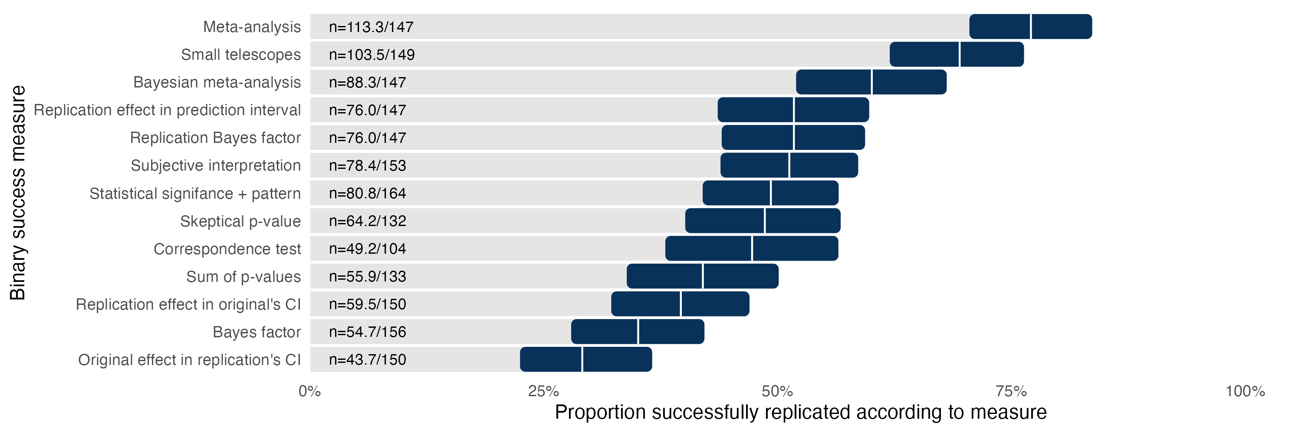
Across metrics, replication success rates ranged from 29.1% to 77.1% with a median of 49.3%. The observed variation highlights the impact of the different assumptions underlying each approach. For example, the highest estimate of 77.1% for the meta-analytic combination of the original and replication evidence provides strong evidence of success because it includes original studies that always provided evidence of success.
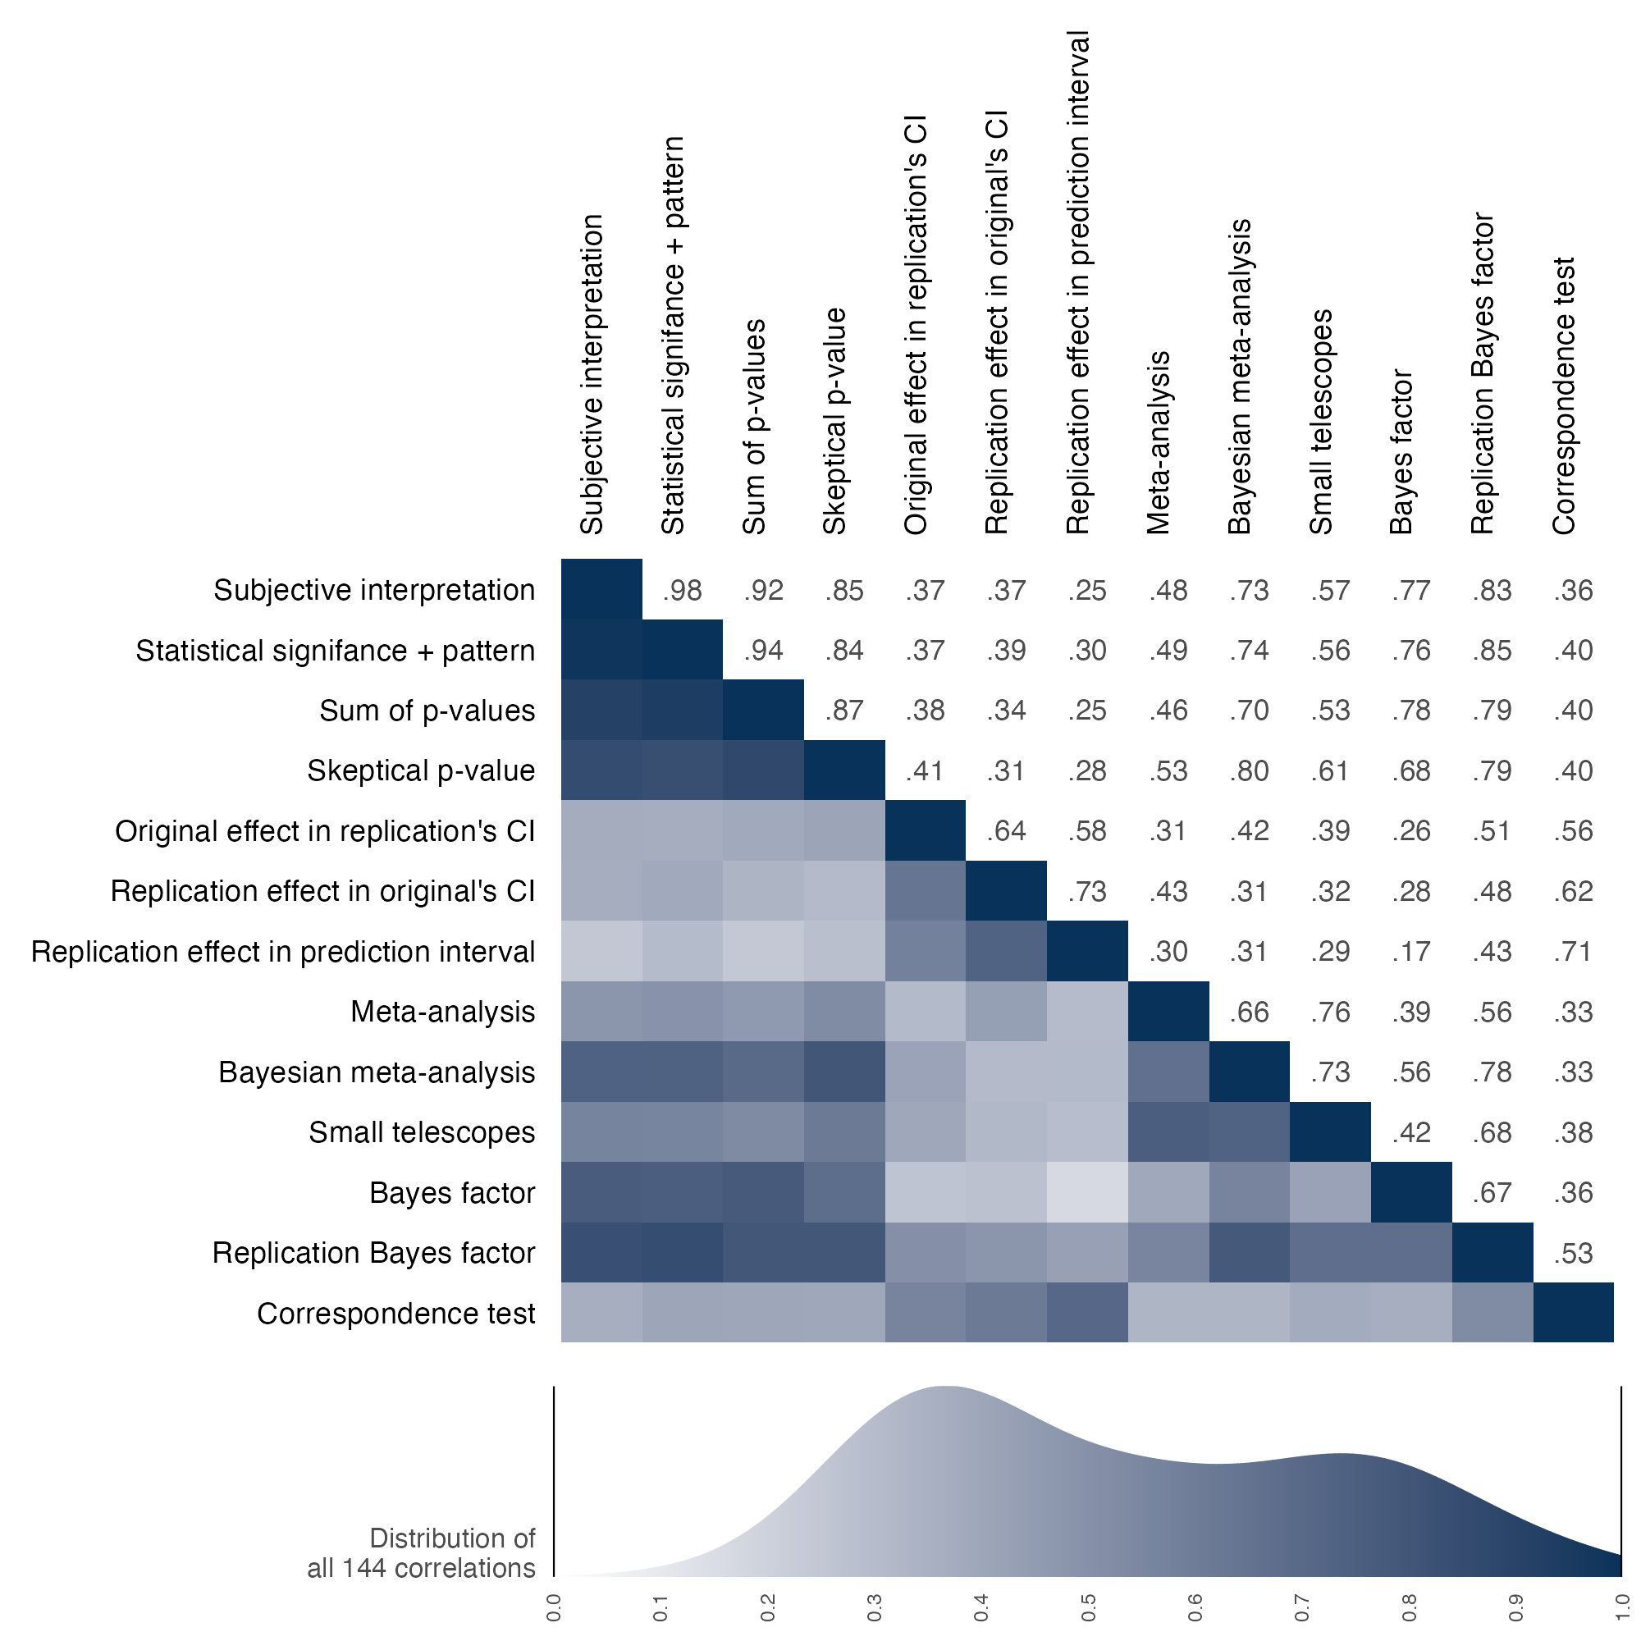
Variation in the observed replication rates are affected by both the assumptions of the binary assessment and by the subsample to which the metric could be used. Figure 2 presents correlations between each pair of binary assessments for replication outcomes to which both methods could be applied. Spearman correlations were positive and relatively high with some exceptions, median = 0.50, range 0.17 to 0.98. For example, analysts almost always interpreted success based on statistical significance (as reflected by a correlation of 0.98), whereas measures that used confidence or prediction intervals showed relatively strong correlations with each other (0.58, 0.64, 0.73) and weaker relations with other measures partly because they treated smaller and larger replication effects as failures to replicate (Median = 0.35, range = 0.17 to 0.71).

Evaluating replication effect size against original effect size
Replication can also be defined as the correspondence between effect size coefficients observed in original studies and in their replications. Regardless of whether original studies and replication studies fall on the same side of a statistical threshold, they should produce effects of about the same magnitude. For the purposes of this project, we sought effect size metrics that would be as standardized as possible.
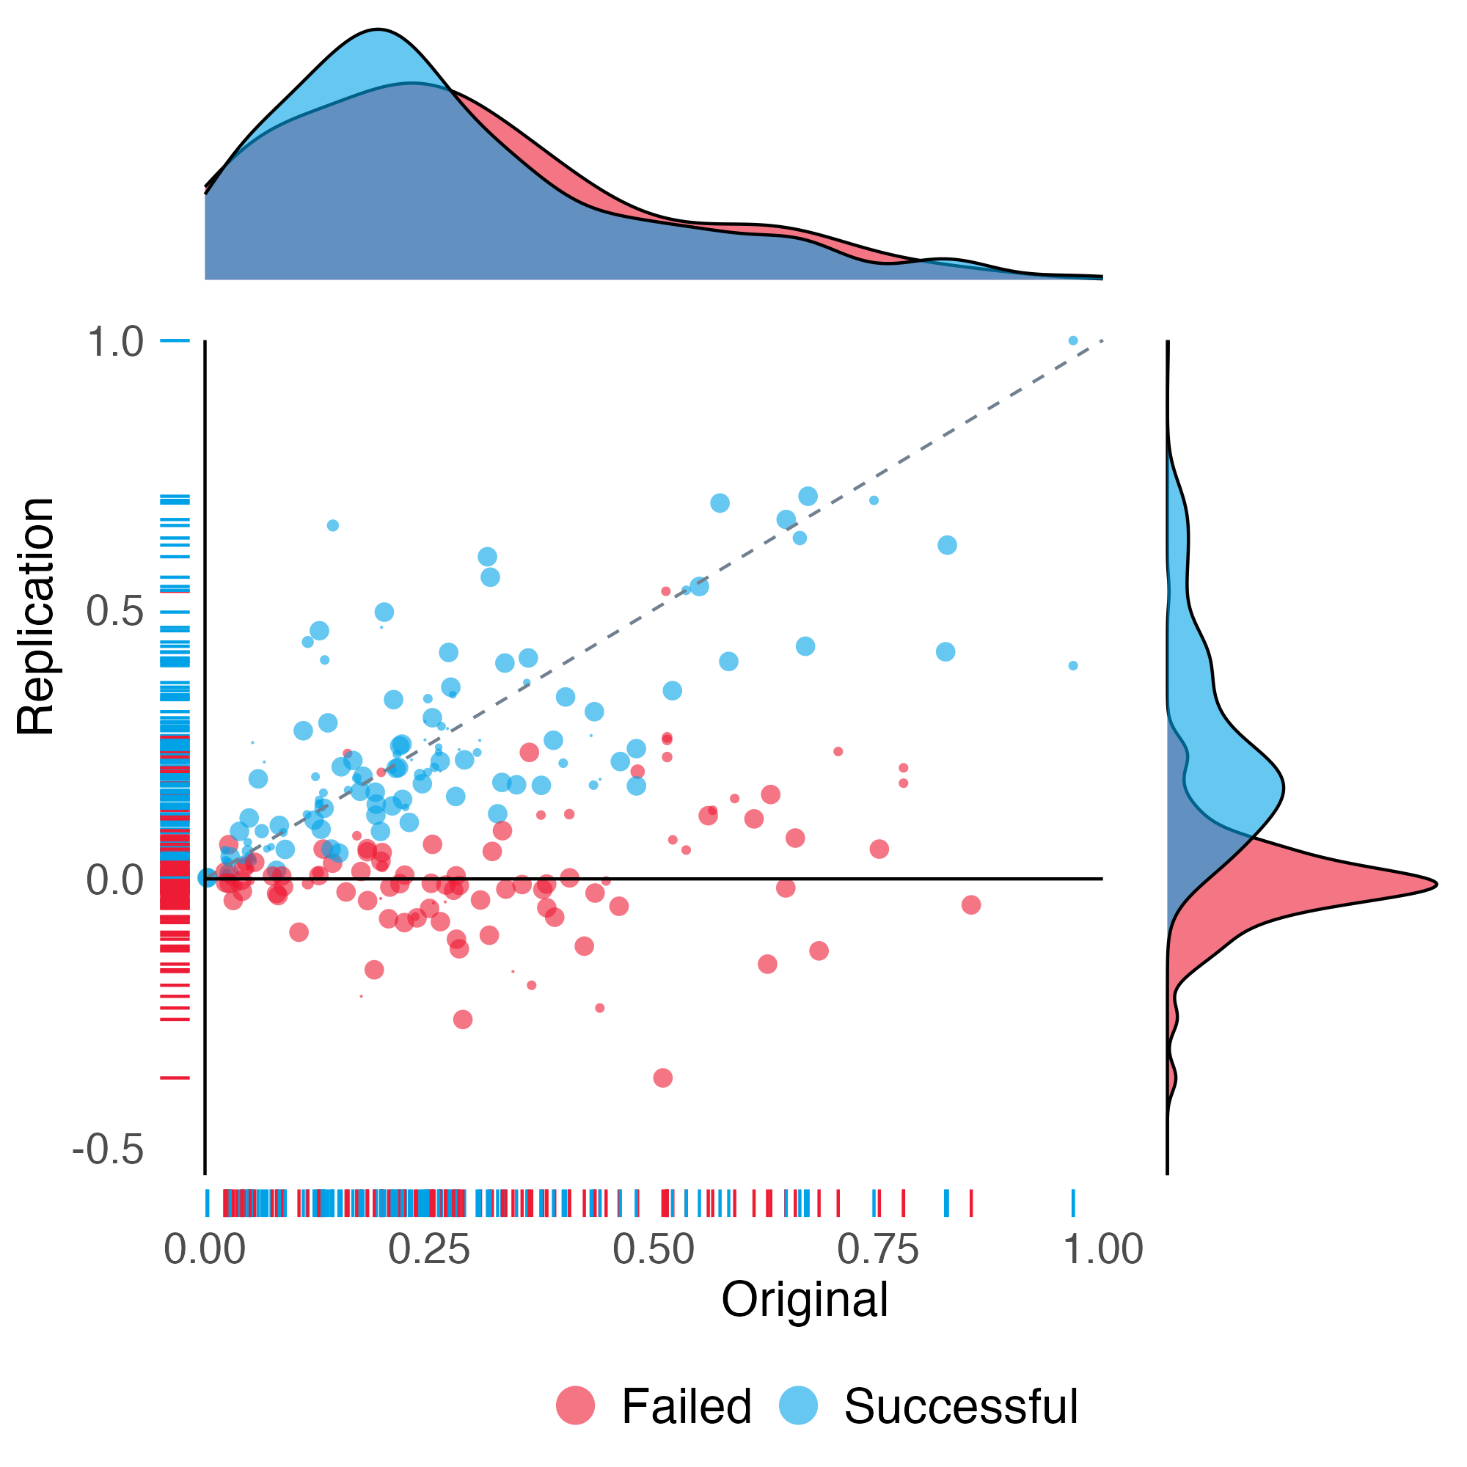
Figure 3 represents the replication effect sizes plotted against the original effect sizes for those claims that could be computed using the Pearson’s r effect size. Original and replication effect sizes were positively correlated (Spearman’s correlation 0.44). The median effect size was 0.23 [95% CI 0.21 - 0.27] for original studies and 0.10 [95% CI 0.07 - 0.13] for replication studies, a 55.2% [95% CI 41.7 - 67.2%] reduction in correlation and a 80.0% [95% CI 66.5 - 89.5%] reduction in shared variance. Data points below the diagonal line are cases in which the replication effect size was smaller than the original effect size. Blue data points were statistically significant replications with the same pattern as the original; red data points were not statistically significant or, if they are below 0, show a different pattern than the original. 117.3 of 150 papers (78.2%) had a smaller effect size for the replications compared with the original studies, and 164 of 225 claims (72.9%) had a smaller effect size for the replications compared with the original studies. Table 2 provides summary statistics of effect sizes by papers and by claims.
Table 2. Original and replication findings by Pearson’s r effect size by papers and claims.
 | Papers  (weighted) |  | Claims  (unweighted)
 | Original | Replication | Original | Replication
Number of r effect sizes | 150 |  | 225
Median [IQR] sample size | 206  [1061.0] | 516  [1624.0] | 236  [1840.0] | 556  [1920.0]
Median Pearson’s r effect size (SD) | 0.23  (0.20) | 0.10  (0.17) | 0.23  (0.20) | 0.13  (0.17)
Note: Sample for this table is the studies for which a Pearson’s r could be calculated for the original and replication outcomes. Papers are weighted combinations of claims accounting for multiple claims per paper replicated in some cases. SD=standard deviation, IQR=interquartile range.

Original and replication effects by discipline and year
Table 3 summarizes original and replication outcomes separately by discipline for statistical significance and effect size. By discipline, based on statistical significance, successful replication rates ranged from 42.5% to 63.1% weighted across papers (median 50.0%; chi-square p-value = 0.76). A range of 45.5% to 71.4% was observed unweighted across claims (median 50.8%; chi-square p-value = 0.13). A similar analysis, reported in the SI, examined variation of replication success by publication year across papers and did not observe a significant effect by year (p = 0.14).
Table 3. Original and replication outcomes by statistical significance and pattern and by Pearson's r effect size for 6 disciplines
 | Replication attempt statistical significance and pattern | Median Pearson’s r effect size (SD)
 | Replication attempt statistical significance and pattern | Original | Replication
Business | 17.0 / 36 (47.2%) | 0.24 (0.12) | 0.10 (0.13)
Economics | 10.2 / 24 (42.5%) | 0.28 (0.24) | 0.13 (0.21)
Education | 8.2 / 13 (63.1%) | 0.14 (0.20) | 0.16 (0.11)
Political Science | 7.8 / 15 (52.0%) | 0.13 (0.24) | 0.05 (0.19)
Psychology | 28.4 / 58 (49.0%) | 0.28 (0.21) | 0.11 (0.17)
Sociology | 9.2 / 18 (51.1%) | 0.14 (0.15) | 0.03 (0.19)

Original and replication effects by new data or secondary data replication
We explored whether replication success rates differed by attempts that collected new data versus secondary data that were not used in the original research (Table 4). Replication attempts using new data were 0.930 [95% CI 0.640 - 1.338] times as likely as those using secondary data to have outcomes that were statistically significant and with the same pattern (Unweighted by claims were 0.986 [95% CI 0.748 - 1.279] times as likely), suggesting similar replicability.
For outcomes with a Pearson’s r effect size, replication attempts using new data produced effects that were about half the size of their original effects. Replication attempts using secondary data showed less decline than those using new data, but from original findings that had smaller effect sizes on average.
These effect size comparisons imply higher replicability for secondary versus new data replication attempts, in contrast to similar replicability observed on the statistical significance metric (Table 5). That could occur if the power of secondary data replication attempts was weaker. Median power estimates across papers are slightly consistent with this possibility (secondary data 99.8%; new data 100.0%). Mean power estimates are more consistent because of a few more weakly powered secondary data replications (secondary data 82.5%; new data 94.6%).
Table 4. Original and replication outcomes by statistical significance and effect size by new or secondary data replications
 | Papers |  | Claims
 | Original outcome | Replication outcome | Original outcome | Replication outcome
Statistical significance and same pattern
New data replications | 98 / 98  (100.0%) | 46.9 / 98  (47.8%) | 128 / 128  (100.0%) | 70 / 128  (54.7%)
Secondary data replications | 66 / 66  (100.0%) | 33.9 / 66  (51.4%) | 146 / 146  (100.0%) | 81 / 146  (55.5%)
Median Pearson’s r effect size (SD)
New data replications | 0.28 (0.19) | 0.11 (0.17) | 0.27 (0.17) | 0.13 (0.16)
Secondary data replications | 0.13 (0.23) | 0.10 (0.16) | 0.15 (0.24) | 0.13 (0.18)
Median power to detect 75% of the original effect size
 | Papers |  | Claims
 | Assuming same scales | Assuming same designs | Assuming same scales | Assuming same designs
New data replications | 0.99 | 0.91 | 0.98 | 0.91
Secondary data replications | 0.96 | 0.82 | 0.93 | 0.88
Note: Original outcome refers to the published finding that was the target of the replication study. Replication outcome refers to the results of the replication attempt. New data replications are those that required data collection. Secondary data replications are those that used existing data that was independent of the original investigation. Papers are weighted combinations of claims accounting for multiple claims replicated in some papers. SD=standard deviation.
Figure 4 reproduces the scatterplots comparing original and replication effect sizes separately for new data (left panel) and secondary data (right panel). Among effect sizes that could be converted to Pearson’s r, 85.3% (80.2 of 94) of new data replication attempts, and 66.3% (37.1 of 56) of secondary data replication attempts, had a weaker effect size than the original study.
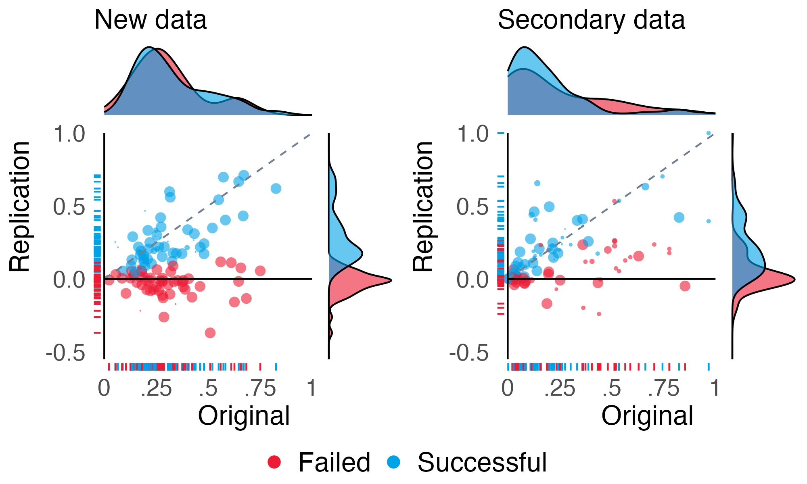

Discussion
About half of the findings from a sample of social and behavioral science papers published from 2009 to 2018 replicated successfully with variation in success estimates across 13 binary assessments and effect size comparisons. These findings are consistent with the cumulative evidence across systematic replications in the social and behavioral sciences^{3,8,33} and from other fields¹², and they illustrate that there is substantial uncertainty in estimating replicability.

Assessing replicability
There are conceptual, methodological, and inferential challenges to assessing replicability.
Conceptually, it can be challenging to attempt a replication of a prior finding. There is no such thing as exact replication. Replications inevitably differ in many ways including the units, treatments, observations, and settings from the original research. Researchers must make decisions about how to conduct a good faith replication of an original claim. For example, should a present day replication of a 2009 U.S. study of political behavior that used a scenario with President Obama as a stimulus use Obama again, use the current U.S. president, or use the leader of the participants’ nation? The answer depends on what features of that stimulus are essential for testing the original claim. The decision that a new study is a replication of a prior study is a theoretical commitment that they are testing the same claim.¹ Theoretical commitments can be wrong. When ostensible replications produce different results from original studies, it is common and reasonable for the subsequent debate to center on whether it should be considered a replication.
Methodologically, it can be challenging to determine how to measure replication success. We used 13 binary metrics and compared effect sizes. Each approach has features that affect their usability across research designs and statistical models. There is no singular success metric as illustrated with the observed variation in their success rates.
Inferentially, it can be challenging to determine whether original and replication studies produced the same outcomes. Each of the replication assessment criteria has strengths and weaknesses. When there is variation among measures of replication success, substantive debate about the replication outcome rests on the differences in the measures’ assumptions. For example, metrics that combined original and replication evidence tended to be among the highest success rates, whereas metrics that treated replication effect sizes that were significantly larger and smaller than the original effect sizes as failures to replicate tended to be among the lowest success rates. Reasonable minds may disagree on the best way to assess replication success. A productive follow-on investigation would employ this dataset to evaluate the merits of these metrics.
In sum, the question “did it replicate?” can be difficult to answer. Fortunately, the answer for any given study does not matter much in the long run. Research is conducted on a study by study basis; replicability is established via a cumulative body of evidence. Over time, evidence accumulates and explanations mature. The explanations anticipate and account for variation across studies and contexts. The importance of deciding whether any two studies showed similar results fades away.

Understanding replicability
Failure to replicate does not mean the original claim was wrong. A single failure to replicate does not justify concluding that the original research was wrong. Even if the replication was perfectly designed, the outcome could be missed or underestimated because of sampling error—a false negative. Even if the replication appeared to be testing the same research question, there could be differences in the methodology, sample, or context that are unrecognized moderators of the outcome. And, even if the replication researchers were diligent in conducting the research, there could be unrecognized errors or flaws in implementing the replication protocol that interfered with observing the outcome.
We attempted to minimize these reasons for failing to replicate by using research designs that were well-powered to detect the original effect size. We also obtained and adapted original materials whenever possible, conducted peer review in advance, preregistered the replication studies, and promoted accountability by committing that materials and data available would be publicly accessible for review to the extent possible. These efforts provide some confidence in the rigor of the replication studies, but do not justify treating the outcomes as sacrosanct.
Successful replication does not mean the original claim was right. A single successful replication does not justify concluding that the original research was correct. The original and replication studies’ results could both be observed because of sampling error—a false positive. More importantly, the replicability of an effect is not the same as the validity of its interpretation. Original and replication studies may share confounds, faulty measures, or other design weaknesses that produce replicable, but misinterpreted, outcomes.
The optimal replicability rate is not known. For example, in discovery contexts, it is understood that taking risks on unlikely possibilities will produce many false leads and occasional big rewards. Conducting replications help to reveal weak spots and dead ends, identify boundary conditions, and mature theoretical predictions and explanations that improve replicability over time. In translation of research claims to policy and practice, it may be more important to have established high replicability to have confidence in their applicability and effectiveness.
The problem to solve is not unreplicability per se, it is overconfidence. Published and true are not synonyms²² and the uncertainty of published claims may be underestimated. For many published findings, it is uncertain whether they will replicate at all, whether they are robust to minor variations in the research context, whether they are generalizable to other contexts, and whether they are valid interpretations of the evidence. Recognition of uncertainty will reduce overconfidence and increase recognition of the value of conducting replications and other verification methods to confront present understanding.¹

Constraints on generalizability
The sampling frame for this research was a selective representation of the social-behavioral sciences. The inclusion criteria required a positive claim that is supported by a statistical inference. This was practically sensible for the purposes of the program, but it does not cover all relevant research. For example, there is a productive and active debate on the meaning of conducting replications in qualitative research.^{34–36} The present findings do not offer insight for that discussion.
The sampling frame covered a wide range of the social and behavioral sciences. However, the selection of relatively prominent journals might have led to higher or lower replicability than what would be observed if less prominent journals were selected. Replicability might have been higher or lower if sampling had reached further back in history, and replicability might be changing in research published after the conducting of this project.
Selection effects were minimized within the sampling frame by using stratified random sampling of papers that met the inclusion criteria, but selection effects were introduced in attempting replications. The main selection effect was feasibility of conducting a replication. It is not difficult to generate plausible hypotheses that original findings from more resource intensive research would be more, less, or similarly replicable as original findings from less resource intensive research.
We did not explore correlations with replication outcomes that might help advance understanding of the conditions for achieving replicability. An initial exploration using this dataset is reported by Abatayo and colleagues.²⁸

Conclusion
We provided evidence about the replicability of the social and behavioral sciences, but we did not explore the reasons for replication success and failure or the merits of the different methods for assessing replicability outcomes. The conditions that promote or inhibit replicability and how to assess it are worthy of additional investigation with an aim of improving the credibility of research. Making progress on the reliability of evidence will open pathways for developing theory to explain that evidence and for translating research insights into practice.³⁷

References
[move references 1-37 here]

Figure Legends
Figure 1. Replication success rates across 13 binary assessments for papers. The vertical white line in each row is the estimate of the percentage of papers replicated successfully, and the 95% confidence interval around the estimate is represented by the dark bar. CI = confidence interval. The sample sizes are the weighted number of papers with successful replications by the number of papers to which that binary assessment could be applied. See Methods for explanations of each binary assessment.
Figure 2: Correlation matrix among binary assessments of replication success across papers. Correlation values are right of the diagonal, and correlation magnitude is visualized left of the diagonal with darker shading indicating stronger correlations. CI = confidence interval.
Figure 3. Scatterplot of Pearson’s r effect sizes for original and replication studies. Each data point represents the estimated original and replication effect sizes for replicated claims. Size of the bullet is proportional to the number of claims there are per paper to illustrate paper weighting. Replication effect sizes are positive if the observed relationship has the same pattern as the original effect size, and negative if the observed relationship has a different pattern. Data points are classified as successful for effect sizes that achieved statistical significance (p < .05) with the same pattern as the original study, and failed for effect sizes that did not. (cf Figure 3 in Open Science Collaboration [2015])³
Figure 4. Scatterplot of Pearson’s r effect sizes for original and replication outcomes for new data (left) and secondary data (right) replication attempts. New data refers to replication attempts involving data collection (n = {}). Secondary data refers to replication attempts based on existing data (n = {}). Each data point represents the estimated original and replication effect sizes for replicated claims. Size of the bullet is proportional to the number of claims there are per paper to illustrate paper weighting. Replication effect sizes are positive if the observed relationship has the same pattern as the original effect size, and negative if the observed relationship has a different pattern. Data points are classified as successful for effect sizes that achieved statistical significance (p < .05) with the same pattern as the original study, and failed for effect sizes that did not.

Methods
This systematic replication effort was part of the SCORE program funded by DARPA to generate and evaluate automated measures of confidence in research claims.³⁸ Replications provided test data to evaluate the accuracy of human and machine predictions of replicability of claims. Evidence for reproducibility (same analysis, same data) and robustness (different analysis, same data) were also gathered as part of the program. Relations among credibility assessments are reported by Abatayo and colleagues (2025). A full report of the SCORE methodology is accessible through several supporting papers.^{28,38,39} Data, materials, code, and other outputs from the program are organized and publicly accessible for evaluation and re-use. This methods section summarizes key features of sampling, conducting the replication studies, aggregating the data across replications, and assessment of replication success.

Sampling frame and selection of claims for replication
Claims to replicate were identified with a systematic selection process to reduce selection effects and increase generalizability of the findings to quantitative social and behavioral research. The project was conducted in two phases. The project started with a sample of 3900 papers selected by a stratified random sampling from a larger set of papers to ensure representativeness across the 62 journals and publication dates from 2009 to 2018. From that pool, 600 papers were randomly selected during Phase 1 as the papers eligible for conducting replication studies with a similar stratified random sampling process to maintain representativeness, and no additional random selection was conducted during Phase 2 to constrain the sample of eligible papers (n = 900). This resulted in a total of 1500 papers eligible for replication with most replication attempts selected from the Phase 1 portion. See Abatayo and colleagues [2025] for further details on the sampling frame and selection process.⁴⁰
Eligible papers were matched with research teams with relevant expertise to design and conduct the replication study. Here, random sampling is lost because selection is based on feasibility, available resources, and available expertise. Whenever possible, original methods and materials were collected from the original authors and adapted for the replication study. Replication teams prepared the research design including the methodology and analysis plan and put those through a peer review process that was managed by an independent editor and included independent reviewers plus at least one author of the original study if they agreed to provide review. Replication designs could involve either the collection of new data or finding independent, existing data that was not used for the original research. Approved designs and analysis plans were preregistered on the OSF prior to conducting the research. For the purposes of this project, initiating a draft of the preregistration for the replication study was the milestone defining that the replication had started.
In most cases, a single claim was identified in a single paper and subjected to a single replication attempt with independent data. Of the 1500 papers eligible for replication, 1300 had a single claim isolated for replication and 200 contained additional claims that could be replicated. For 3 claims, multiple replications were conducted using the same protocol, akin to “many labs” studies^{4,5,41}. And, for 15 claims, multiple replications were conducted using distinct protocols. For both of these cases, the primary reporting aggregates evidence across multiple replications of a single claim. Finally, there were 27 replications that added new data to data that had been used in the original research. These “hybrid” replications were not included in the main text outcomes because the replications were not independent of the original studies, but they are reported in the SI (Tables S13-S15).
Completed replication reports were reviewed for quality control by team members not involved in the replication study. Data, materials, and code were archived on the OSF and made openly available to the maximum extent allowed without violating privacy of participants or intellectual property licenses for any original materials. A total of 296 replications were conducted and, following aggregation evidence for multiple replications of a single claim there were 274 replications of unique claims from 164 papers. See Figures S1-S7 and Tables S1-S4 for details about sample selection, study design, attrition, statistical power, and effect size estimation.

Replication Assessment Metrics
We assessed the replicability of individual claims from papers that used diverse methodologies. We did this using statistical results of pairs of original and corresponding replication studies. In this section, we describe the approach for each of our 13 binary assessments of replication success.

Statistical Significance and Same Pattern

A common measure of concluding that there is evidence for an original claim and replication of that claim is achieving statistical significance (p < .05) with the hypothesized pattern of results. For papers to be included in the sample, the original research needed to have an outcome that could be assessed for replicability with this criterion.

Subjective Interpretation
Subjective assessment of whether the original finding replicated successfully or not, provided by replication teams or project coordinators. The only reason that this criterion was not used for some findings was because an interpretation was not collected.

Sum of p-values
Calibrating the sum of original and replication p-values can control the overall false positive rate and enable replication success even if the original study was non-significant.⁴² An unweighted sum of p-values concludes that the replication succeeded if the sum of one-sided p-values is less than 0.035 (or equivalently, if the sum of two-sided p-values is less than 0.07). A weighted version can be used if there are concerns about the diagnosticity of the original evidence, such as the possibility of questionable research practices artificially reducing the p-value. We employed the unweighted version, because this method highlights the maximum success rate compared to downweighting the influence of the original study.

Skeptical p-value
This criterion generates a prior using the data from the original result to construct a posterior with an associated credible interval that just overlaps with zero.⁴³ The skeptical p-value assesses the extent to which the replication data is inconsistent with this skeptical prior. The logic is to define in advance how skeptical to be about the replication evidence to believe that the effect does not exist.

Original in the Replication Confidence Interval
This criterion assessed whether the original effect estimate was within the 95% confidence interval of the replication study. This assumes that the original effect was estimated without error and assesses whether it is different from the replication estimate. Replications can produce stronger, weaker, or opposing effects than original studies and fail on this metric.

Replication in the Original Confidence Interval
The complementary criterion is whether the replication effect estimate was within the 95% confidence interval of the original study. This assumes that the replication was estimated without error and assesses whether it is different from the original estimate. Replications can produce stronger, weaker, or opposing effects than original studies and fail on this metric.

Replication in Prediction Interval
The 95% prediction interval has the same basic logic as the approaches using confidence intervals except that it incorporates the precision of both the original and replication effect size in determining the boundaries. As such, this criterion is the most liberal of the interval based methods, including considering some replications estimated near zero or with an opposing pattern to be successful.

Meta-analysis
The fixed-effect meta-analysis criterion combines original and replication evidence into a single estimate and assesses whether the combined evidence is statistically significant with the same pattern as the original study. Because all original studies were positive results, this criterion is necessarily generous to observing replication success as it is not independent of the original evidence.

Bayesian Meta-Analysis
This criterion is the conceptual equivalent of meta-analysis in the Bayesian framework.⁴⁴ We used a fixed-effect model to quantify evidence of the effect being present versus absent across both studies. In our implementation the outcome needed to have ‘moderate,’ ‘strong,’ or ‘extreme’ evidence against the null to qualify as a success. The prior for the average effect size is centered at 0 with a standard deviation of 0.25. 1500 iterations per chain were used, with the log-marginal likelihood being estimated by numerical integration with a relative tolerance of 0.1.

Small telescopes
The small telescopes approach assesses whether replication results are consistent with an effect size that could have been detected in the original study.⁴⁵ This is calculated in two steps. First, compute the effect size that would have given the original study 33% power. Second, conduct a one-sided hypothesis test of whether the replication data can reject the null hypothesis that it is not smaller than that effect size. This approach recognizes the difficulty of providing evidence for the absence of an effect, so instead defines replication failure as demonstrating that the original study could not have provided evidence for an effect as small as was observed in the replication.

Bayes Factor
The Jeffreys-Zellner-Siow (JZS) Bayes factor is the conceptual equivalent of the standard null hypothesis significance test in the Bayesian framework.⁴⁶ It provides relative favorability for the null versus alternative hypothesis, indicating both the absence or presence of an effect. In our implementation the outcome needed to have a Bayes factor against the null of greater than 10 to qualify as a success, corresponding to the interpretation categories of ‘strong,’ ‘very strong,’ or ‘extreme’ evidence.

Replication Bayes Factor
Replication Bayes factor is an alternative to JZS Bayes factor that directly examines the replication evidence in comparison to the original study.^{46,47} It provides relative evidence that the replication effect is similar to the original versus being absent. It can only be applied in cases of a non-zero result. In our implementation the outcome needed to have a Bayes factor against the null less than 1 to qualify as a success.

Correspondence test
This criterion considers the correspondence in the effect size estimates between original and replication studies.⁴⁸ It combines comparing [a] whether the hypothesis that the effect sizes are the same can be rejected in terms of statistical significance with [b] an equivalence test evaluating whether the hypothesis that the observed difference in effect sizes is not larger than a predefined equivalence threshold. The correspondence test provides four outcomes: [1] equivalent = failing to reject that the effect sizes are the same and rejecting that the difference in effect sizes is larger than an equivalence threshold, [2] trivially different = rejecting that the effect sizes are the same and rejecting that the difference in effect sizes is larger than an equivalence threshold, [3] different = rejecting that the effect sizes are the same and failing to reject that the difference in effect sizes is larger than an equivalence threshold, and [4] indeterminate = failing to reject that the effect sizes are the same and failing to reject that the difference in effect sizes is larger than an equivalence threshold. There are enriched possibilities of considering these four outcomes independently using this dataset. For the purposes of creating binary outcomes for comparison and parallelism with other approaches, we treated equivalent and trivially different as successful replications, different as failed replications, and left out indeterminate outcomes.

Data aggregation
For most studies, the original main finding and its corresponding replication findings used the same statistical methods and thus could be assessed on the same effect size scale. However, studies used different statistical methods, and thus also used different effect size scales (e.g., Cohen’s d, odds ratio, regression coefficient in a multilevel analysis, etc.). These measures cannot be meaningfully compared unless they are converted to a common scale.
A standard approach for converting effect sizes to a standard form uses sample sizes and test statistics to approximate effect sizes, and then converts between standardized units using established transformations (e.g., Cohen’s d is twice Cohen’s f, and the [partial] correlation is equal to Cohen’s d divided by the square root of Cohen’s d plus four if the sample sizes per group are equal). This approach is straightforward for many common analyses in the social-behavior sciences such as single-level regressions and evaluating the difference between means. Where appropriate, we implemented this approach using the effectsize R package.⁴⁹ Some analyses, such as multilevel regression or regressions with clustered standard errors, required a tailored approach to approximate the effective sample size for converting to standard effect sizes. Tailored solutions are available in individual R scripts and examples of non-standard cases are reported in the supporting information.

Data analysis and inference
Statistics presented in the paper are largely in the form of descriptive statistics and precision estimates. Proportions of successful replications and similar statistics are aggregated to the paper level unless otherwise noted. Where there are multiple items per paper (e.g., three claims assessed in replication attempts), the sub-level items (e.g., claims assessed nested within papers) are weighted by simple proportion (e.g., each of the three claims receives a weight of ⅓). The code used to generate each statistic reported in this paper is provided both in the data and code repository and as a web-app.
All standard errors, confidence intervals, and other metrics of statistical uncertainty are generated by simple clustered bootstrap. Statistical uncertainty for statistics aggregated to the paper level are clustered at the paper level using a clustered bootstrap procedure. 95% confidence intervals are estimated through percentile intervals of the bootstrapped sample distribution.

Inclusion and Ethics
[Tim to add and verify this]

Methods References
[Put references 38 to end here]

Summary Paragraph
Replication attempts tend to focus on outcomes in a single discipline and with relatively small samples. We report a systematic replication of 274 positive claims from 164 papers from 2009 to 2018 from 54 journals to capture diversity across the social and behavioral sciences. Replications were high-powered, used original materials where possible, and were peer-reviewed in advance through a standardized protocol. Our work finds statistically significant results with the same pattern as the original study for 151 of 274 claims and for 80.8 of 164 papers weighed for replicating multiple claims per paper. For claims where effect sizes could be converted to Pearson’s r, the median effect size saw a 55.2% [95% CI 41.7 - 67.2%] correlation reduction from the original claims to our replication attempts and a 80.0% [95% CI 66.5 - 89.5%] reduction in shared variance. Thirteen methods for evaluating replication success provided estimates ranging from 29.1% to 77.1% with a median of 49.3%. This paper demonstrates the challenges of determining replicability across the social and behavioral sciences.

Competing Interest Statement
A.H.T., M.D., N.H., K.H., O.M., T.Stankov, B.A.N., and T.M.E. are employees of the non-profit organization Center for Open Science that has a mission to increase openness, integrity, and reproducibility of research.

Data, Materials, and Code Availability Statement
[Tim to add and verify this]

Acknowledgements
This work was supported by the Defense Advanced Research Projects Agency (DARPA) under cooperative agreements No: N660011924015 (PI: Brian A. Nosek) and HR00112020015 (PI: Timothy M. Errington). The views, opinions, findings, and conclusions or recommendations expressed in this material are those of the authors and should not be interpreted as representing the official views or policies of the Department of Defense or the U.S. Government. We thank Beatrix Arendt, Alexandria Denis, Mirka Dirzo, Zachary Loomas, Bri Luis, Lesley Markham, E. Simon Parsons, Adam Russell, and Ruben van den Goorbergh for their contributions to this project.

Additional Information
Contact Brian Nosek, nosek@cos.io, for correspondence concerning this paper.

Author ORCiDs and Institutions
Given name | Family Name | ORCID | Institution 1 | Institution 2
Andrew H. | Tyner | 0000-0001-9180-4490 | Center for Open Science
Anna Lou | Abatayo | 0000-0002-2686-5075 | Wageningen University and Research
Mason | Daley | 0000-0002-3460-3673 | Center for Open Science
Samuel | Field | 0009-0007-4524-2088 | SAS Institute
Nicholas | Fox | 0000-0002-3772-8666 | Center for Open Science
Noah A. | Haber | 0000-0002-5672-1769 | Center for Open Science
Krystal M. | Hahn | 0009-0006-2551-4528 | Center for Open Science
Melissa | Kline Struhl | 0000-0003-2217-9331 | Massachusetts Institute of Technology
Brinna | Mawhinney |  | Center for Open Science
Olivia | Miske | 0000-0003-4787-3995 | Center for Open Science
Priya | Silverstein | 0000-0003-0095-339X | Ashland University | Institute for Globally Distributed Open Research and Education
Courtney K. | Soderberg | 0000-0003-1227-7042 | Center for Open Science
Theresa | Stankov |  | Center for Open Science
Ahmed | Abbasi | 0000-0001-7698-7794 | University of Notre Dame
Christopher L. | Aberson | 0000-0003-3481-7177 | The Dissertation Coach
Balazs | Aczel | 0000-0001-9364-4988 | Institute of Psychology, ELTE Eötvös Loránd University
Matúš | Adamkovič | 0000-0002-9648-9108 | Slovak Academy of Sciences | University of Jyväskylä, Finland & Charles University, Czech Republic
Nihan | Albayrak | 0000-0003-3412-4311 | Boğaziçi University | London School of Economics and Political Science
Peter J | Allen | 0000-0002-9690-1545 | University of Bristol
Michael | Andreychik | 0000-0002-8542-5504 | Fairfield University
Eli | Awtrey | 0000-0002-6712-0256 | University of Cincinnati
Erick | Axxe | 0000-0002-0426-5722 | Hendrix College
Flavio | Azevedo | 0000-0001-9000-8513 | University of Cambridge | University of Utrecht
Miles D. | Bader | 0009-0008-2369-2720 | Vassar College
Bence | Bago | 0000-0001-6905-1832 | Tilburg University
James | Bailey | 0000-0002-6132-6026 | Providence College
Marjan | Bakker | 0000-0001-9024-337X | Tilburg University
Gabriel | Banik | 0000-0002-6601-3619 | Pavol Jozef Safarik University, Slovakia
George C. | Banks | 0000-0002-2261-2935 | University of North Carolina at Charlotte
Ernest | Baskin | 0000-0001-9484-2839 | Saint Joseph's University
Anatolia | Batruch | 0000-0002-4669-1463 | University of Lausanne
Annika | Beatteay |  | University of New Brunswick
Sophie M. | Behr | 0000-0001-5171-671X | DIW Berlin | Technical University of Berlin
Nicholas | Berente | 0000-0002-1403-4696 | University of Notre Dame
Zachariah | Berry | 0000-0002-0827-6437 | University of Southern California
Jędrzej | Białkowski | 0000-0003-1066-7688 | University of Canterbury, New Zealand
Bojana | Bodroža | 0000-0003-4165-0678 | Faculty of Philosophy, University of Novi Sad
Laura | Boeschoten | 0000-0002-3536-0474 | Utrecht University
Miklos | Bognar | 0000-0003-3303-9852 | Institute of Psychology, ELTE Eötvös Loránd University
Christian | Bokhove | 0000-0002-4860-8723 | University of Southampton
Diane | Bonfiglio |  | Ashland University
Robin | Bouwman | 0000-0003-1218-4540 | Erasmus University Rotterdam
Timothy F. | Brady | 0000-0001-5924-5211 | University of California, San Diego
Scott | Braithwaite | 0000-0002-6180-9765 | Brigham Young University
Gabriel | Briceño Jiménez | 0000-0002-3760-9202 | Universidad de Chile
Cameron | Brick | 0000-0002-7174-8193 | University of Amsterdam | University of Inland Norway
Traci | Bricka | 0000-0002-9910-5341 | University of Texas at Arlington
Roman | Briker | 0000-0001-6328-7430 | Maastricht University
Annette N. | Brown | 0000-0002-4618-8286 | FHI 360
Gordon D A | Brown | 0000-0002-2257-1459 | University of Warwick
Robbie | C.M. van Aert | 0000-0001-6187-0665 | Tilburg University
Kathryn | Caldwell | 0000-0002-2399-7400 | Ithaca College | The Analysis Factor
Sara | Capitan | 0000-0001-6519-6073 | Swedish University of Agricultural Sciences
Tabaré | Capitán | 0000-0002-5055-3995 | Swedish University of Agricultural Sciences
Jesse | Chandler | 0000-0001-8151-0915 | Mathematica | University of Michigan
Tessa | Charles |  | Vassar College
Christopher R. | Chartier | 0000-0002-4568-4827 | Ashland University
Rahul | Chawdhary | 0000-0001-6260-5935 | Kingston University
Kent Jason | Cheng | 0000-0002-8931-4086 | The Pennsylvania State University
William J. | Chopik | 0000-0003-1748-8738 | Michigan State University
Bruce | Clark |  | Southern Illinois University
Victoria E. | Colvin |  | University of Florida
C. Cozette | Comer | 0000-0001-5647-9549 | Virginia Tech
Giulio | Costantini | 0000-0001-6610-5452 | University of Milan-Bicocca
Tom | Coupé | 0000-0002-9520-5556 | University of Canterbury | UCMeta
Jamie | Cummins | 0000-0002-9729-4900 | University of Bern
Aneta | Czernatowicz-Kukuczka | 0000-0001-7176-8365 | Jagiellonian University
Joshua | de Leeuw | 0000-0003-4815-2364 | Vassar College
David | Dobolyi | 0000-0002-9493-3447 | University of Colorado Boulder
James N. | Druckman | 0000-0002-1249-6790 | University of Rochester
Jianhua | Duan | 0000-0002-4750-0243 | Stats NZ | University of Canterbury
Marin | Dujmović | 0000-0003-1523-227X | University of Bristol
Daniel J. | Dunleavy | 0000-0002-3597-7714 | Office of Program Policy Analysis and Government Accountability
Patrick K. | Durkee | 0000-0001-6159-4277 | The University of Texas at Austin | California State University, Fresno
Cécile | Emery | 0000-0002-7272-1144 | University of Exeter
Kevin M. | Esterling | 0000-0002-5529-6422 | University of California Riverside
Thomas R. | Evans | 0000-0002-6670-0718 | University of Greenwich, UK
Anna | Fedor | 0000-0003-2290-2323 | independent researcher
Belén | Fernández-Castilla | 0000-0002-3451-0637 | Universidad Nacional de Educación a Distancia
Nathan | Fiala |  | University of Connecticut | RWI - Leibniz Institute for Economic Research
James G. | Field | 0000-0001-8487-6648 | West Virginia University
Nathan | Fong | 0000-0001-7891-3262 | Rutgers University
Miguel A. | Fonseca | 0000-0002-5294-6784 | University of Exeter
Alexandra L.J. | Freeman | 0000-0002-4115-161X | University of Cambridge
Jeremy | Freese |  | Stanford University
Sandra J. | Geiger | 0000-0002-3262-5609 | University of Amsterdam | University of Vienna
Jing | Geng | 0000-0002-7059-7725 | Virginia Tech
Laura M. | Getz | 0000-0002-3429-7506 | University of San Diego
Linda Marjoleine | Geven | 0000-0001-5075-5223 | Leiden University
Ilka Helene | Gleibs | 0000-0002-9913-250X | London School of Economics
Donna Pamella | Gonzales | 0009-0006-7076-661X | NA
Janaki | Gooty | 0000-0002-9447-0454 | UNC, Charlotte
Amélie | Gourdon-Kanhukamwe | 0000-0002-3060-1320 | Kingston University | King's College London
Cristina | Greculescu | 0000-0003-0384-552X | Bremen International Graduate School of Social Sciences (BIGSSS) | Constructor University
Siobhán M. | Griffin | 0000-0002-3613-2844 | University of Limerick, Ireland
Lusine | Grigoryan | 0000-0002-2077-1975 | University of York | Ruhr University Bochum
Martina | Grunow | 0000-0003-2617-9638 | Leuphana University of Lüneburg
Nicholas | Gunby | 0009-0001-6003-9068 | Contact Energy | UCMeta
Braeden | Hall | 0000-0002-4157-3054 | Southern Illinois University Carbondale
Paul H. P. | Hanel | 0000-0002-3225-1395 | University of Essex | University of Bath
Erin E. | Hannon | 0000-0002-3482-5954 | University of Nevada Las Vegas
Sam | Harper | 0000-0002-2767-1053 | McGill University
Marco Jürgen | Held | 0000-0003-2370-2905 | University of Bamberg
Louis | Hickman | 0000-0002-2752-7705 | Virginia Tech
Nathan C. | Higgins | 0000-0002-1219-6448 | University of Nevada Las Vegas | University of South Florida (current)
Svenja | Hippel | 0000-0002-5447-3730 | University of Bonn
Sven | Hoeppner | 0000-0003-2697-4420 | Charles University | Freie Universität Berlin
Sanghyun | Hong | 0000-0003-0135-2617 | University of Canterbury
Thomas J. | Hostler | 0000-0002-4658-692X | Manchester Metropolitan University
Michael | Inzlicht | 0000-0001-9297-6497 | University of Toronto | Rotman School of Management
Kamil | Izydorczak | 0000-0002-9870-3825 | SWPS University
Bastian | Jaeger | 0000-0002-4398-9731 | Tilburg University
Kristin | Jankowsky | 0000-0002-4847-0760 | University of Kassel
Johannes | Jarke-Neuert | 0000-0001-6407-5202 | Forschungszentrum Jülich | Universität Hamburg
Matthew | Jensen | 0000-0001-8711-1827 | University of Oklahoma
Biljana | Jokić | 0000-0002-0829-4037 | University of Belgrade, Faculty of Philosophy | Metropolitan University, Belgrade
Daniel | Jolles | 0000-0003-1277-0793 | London School of Economics and Political Science | University of Essex
Phillip | Jolly | 0000-0001-7835-3613 | Pennsylvania State University
Angela M. | Jones | 0000-0001-7605-4206 | Texas State University
Marie | Juanchich | 0000-0003-4256-4501 | University of Essex
Pavol | Kačmár | 0000-0003-0076-1945 | Faculty of Arts, Pavol Jozef Šafárik University in Košice
Hansika | Kapoor | 0000-0002-0805-7752 | Monk Prayogshala | University Of Connecticut
Andjela | Keljanovic | 0000-0002-0562-394X | University of Pristina-Kosovska Mitrovica, Faculty of Philosophy | University of Novi Sad, Faculty of Philosophy
Samjhana | Koirala |  | University of Connecticut
Marta | Kołczyńska | 0000-0003-4981-0437 | Institute of Political Studies of the Polish Academy of Sciences
Dimitra | Kouroupaki |  | Atticon University General Hospital, 2nd Psychiatric Clinic
Ulrich | Kühnen | 0000-0001-9059-4719 | Constructor University, Bremen, Germany
Michelangelo | Landgrave | 0000-0003-4348-380X | University of Colorado, Boulder | University of California, Riverside
Michael J. | Larson | 0000-0002-8199-8065 | Brigham Young University
Lyonel | Laulié | 0000-0001-9817-4110 | Universidad de Chile
Alice C E | Lawrence | 0000-0002-8771-4844 | University of Cambridge
Joel M. | Le Forestier | 0000-0003-3330-2171 | University of Pittsburgh
Katelin E. | Leahy | 0000-0002-3638-3694 | Michigan State University
Sungmok | Lee |  | University of New Brunswick
Jared | Leslie |  | University of Nevada Las Vegas
Savannah C. | Lewis | 0000-0002-9948-1195 | Ashland University | University of Alabama
Christopher | Limnios | 0000-0001-5387-1334 | Providence College
Hause | Lin | 0000-0003-4590-7039 | Cornell University | Massachusetts Institute of Technology
An-Chiao | Liu | 0000-0003-4064-0515 | Utrecht University
John Wills | Lloyd | 0000-0002-2597-6216 | University of Virginia
Elliot A | Ludvig | 0000-0002-0031-6713 | University of Warwick
Dermot | Lynott | 0000-0001-7338-0567 | Maynooth University
Jordan | MacDonald | 0000-0001-6687-3638 | University of New Brunswick
Peter | Mallik | 0000-0003-3429-2198 | Hubbard Decision Research
Daniel J. | Mallinson | 0000-0002-8094-6685 | Penn State Harrisburg
Daniele | Marinazzo | 0000-0002-9803-0122 | Ghent University
Corinna S. | Martarelli | 0000-0001-9160-793X | UniDistance Suisse
Joshua | Matacotta | 0000-0002-0192-5254 | Western University of Health Sciences | Integrated Behavioral Health Research Institute
Andrew | McBride | 0000-0002-0810-9751 | Santa Clara University
Cillian | McHugh | 0000-0002-9701-3232 | University of Limerick
Gail | McMillan | 0000-0001-5619-5618 | Carleton University
Esteban | Méndez | 0000-0002-7248-6092 | Central Bank of Costa Rica
Mitchell | Metzger |  | Ashland University
Michalis P. | Michaelides | 0000-0001-6314-3680 | University of Cyprus
Johannes | Michalak | 0000-0003-4701-5464 | Witten/Herdecke University
Leticia | Micheli | 0000-0003-0066-8222 | Julius-Maximilian University of Würzburg | Leiden University
Jeremy K. | Miller | 0000-0003-4409-7660 | Willamette University
Marina | Milyavskaya | 0000-0002-0510-4891 | Carleton University
Daniel C. | Molden | 0000-0002-2182-5621 | Northwestern University
Ambar G. | Monjaras |  | University of Nevada, Las Vegas | University of Nevada, Las Vegas
David | Moreau | 0000-0002-1957-1941 | University of Auckland
Audrey | Morrow | 0000-0001-9143-0708 | University of California Santa Cruz
Cristóbal | Moya | 0000-0002-7176-4775 | DIW Berlin | Universität Bielefeld
Liad | Mudrik | 0000-0003-3564-6445 | Tel Aviv University
Laetitia B. | Mulder | 0000-0003-3203-7601 | University of Groningen
Katie A. | Munt | 0000-0002-3823-2005 | The University of Queensland
Arijit | Nandi | 0000-0002-3399-0536 | McGill University
Kathryn | Nason | 0000-0001-6882-5517 | University of New Brunswick
Carolin | Nast | 0000-0003-1067-2946 | UiS Business School
Gideon | Nave | 0000-0001-6251-5630 | The Wharton School of Business, University of Pennsylvania
Heinrich H. | Nax | 0000-0003-1261-8134 | University of Zurich | ETH Zurich
Florian | Neubauer | 0000-0001-7134-3439 | University of Connecticut | RWI - Leibniz Institute for Economic Research
Phuong Linh L. | Nguyen | 0000-0002-1575-0395 | University of Minnesota
Austin Lee | Nichols | 0000-0003-4580-3301 | Central European University
Gustav | Nilsonne | 0000-0001-5273-0150 | Karolinska Institutet | Stockholm University
Ernest | O'Boyle | 0000-0002-9365-1069 | Indiana University
Jule | Oettinghaus |  | Ruhr-Universität Bochum
Jeewon | Oh | 0000-0001-8103-906X | Syracuse University
Adoril | Oshana | 0000-0003-2386-826X | University of North Carolina at Charlotte
Thomas | Ostermann | 0000-0003-2695-0701 | Witten/Herdecke University
Rachel P. | Ostrowski | 0009-0006-3953-6955 | Vassar College
Abiola | Oyebanjo |  | Policy Innovation Center
Radoslaw | Panczak | 0000-0001-5141-683X | University of Bern
Jamie | Patrianakos | 0000-0002-0198-844X | Loyola University Chicago
Ignacio | Pavez | 0000-0001-5257-5330 | Pontificia Universidad Católica de Chile | Pontificia Universidad Católica de Chile
Yuri G. | Pavlov | 0000-0002-3896-5145 | University of Tuebingen
Sofia | Persson | 0000-0002-7353-5204 | Leeds Beckett University
Marco | Perugini | 0000-0002-4864-6623 | University of Milan Bicocca
Kim | Peters |  | University of Exeter
Constant | Pieters | 0000-0001-5567-6401 | Copenhagen Business School
Vladimir | Ponizovskiy | 0000-0002-1592-5482 | Ruhr-Universität Bochum | Durham University
Nathaniel D. | Porter | 0000-0002-0479-6777 | Virginia Tech
Jason M. | Prenoveau | 0000-0001-9388-7410 | Loyola University Maryland
Danka | Purić | 0000-0001-5126-3781 | University of Belgrade, Faculty of Philosophy
Mariah F. | Purol | 0000-0003-2921-3600 | Union College
Arathy | Puthillam | 0000-0003-2426-8362 | Monk Prayogshala | UC San Diego
Kimberly A. | Quinn | 0000-0002-0751-0172 | DePaul University
Marco | Ramljak | 0009-0008-1502-6453 | Utrecht University
W. Robert | Reed | 0000-0002-6459-8174 | University of Canterbury | UCMeta
Michaela | Ritchie | 0000-0001-9872-3220 | University of New Brunswick Saint John
Margaret | Ritzau |  | Vassar College
Sean Patrick | Roche | 0000-0003-2662-2716 | Texas State University
Romina | Rodela | 0000-0003-0070-6794 | Södertörn University
Jan Philipp | Röer | 0000-0001-7774-3433 | Witten/Herdecke University
Ivan | Ropovik | 0000-0001-5222-1233 | Charles University | Czech Academy of Sciences
Jacob | Rothschild | 0000-0002-8416-9879 | Verasight
Justine | Saal |  | Ruhr-Universität Bochum
Hani | Safadi | 0000-0003-0609-8005 | The University of Georgia
Jason | Samaha | 0000-0001-8010-5993 | University of California, Santa Cruz
Mary | Sanchez | 0009-0009-7217-7538 | University of Nevada, Las Vegas
Soorya | Sankaran | 0000-0001-6169-3080 | University of California, Santa Cruz
David | Santos | 0000-0001-9786-5219 | IE University (Spain)
Amanda C. | Sargent | 0000-0003-4599-622X | Bentley University
Marian | Sauter | 0000-0003-3123-8073 | Universität Ulm
Kathleen | Schmidt | 0000-0002-9946-5953 | Southern Illinois University | Ashland University
Landon | Schnabel | 0000-0002-2674-3019 | Cornell University
Amber N | Schroeder | 0000-0002-6955-4322 | The University of Texas at Arlington
Sebastian W. | Schuetz |  | University of Colorado Boulder
Brendan A. | Schuetze | 0000-0002-5210-6785 | The University of Texas at Austin | University of Potsdam
Michael | Schulte-Mecklenbeck | 0000-0002-0406-8809 | University of Bern | Max Planck Institute for Human Development
Astrid | Schütz | 0000-0002-6358-167X | University of Bamberg
Eric L. | Sevigny | 0000-0002-1596-0042 | Georgia State University
Ellie | Shackleton | 0009-0008-4044-3558 | University of Limerick
Richard M. | Shafranek | 0000-0002-8055-4008 | Northwestern University
Samuel | Shaki | 0000-0002-2340-5401 | Ariel University
Shishir | Shakya | 0000-0002-6272-6654 | Appalachian State University
Miroslav | Sirota | 0000-0003-2117-9532 | University of Essex
Matthew Ryan | Sisco | 0000-0003-0296-7664 | Columbia University
Maksim M. | Sitnikov | 0009-0005-0904-7395 | Tilburg University
L. Robert | Slevc | 0000-0002-5183-6786 | University of Maryland, College Park
Laura | Smalarz | 0000-0002-2435-7843 | Arizona State University
Colin Tucker | Smith | 0000-0002-8132-9988 | University of Florida
Joel S. | Snyder | 0000-0002-5565-3063 | University of Nevada, Las Vegas
Nicolas | Sommet | 0000-0001-8585-1274 | University of Lausanne
Fatih | Sonmez | 0000-0002-4054-0269 | Muş Alparslan University
Barbara A. | Spellman | 0000-0003-2823-1292 | University of Virginia
Natalia | Stanulewicz-Buckley | 0000-0003-3672-3422 | Aston University
George | Stock | 0000-0002-6391-2731 | UNC Charlotte
Chris N. H. | Street | 0000-0002-0416-485X | Keele University
Eirik | Strømland |  | Western Norway University of Applied Sciences
Tina | Sundelin | 0000-0002-7590-0826 | Stockholm University | Karolinska Institutet
Moin | Syed | 0000-0003-4759-3555 | University of Minnesota
Anna | Szabelska | 0000-0001-5362-3787 | Psychological Science Accelerator
Barnabas | Szaszi | 0000-0001-7078-2712 | Institute of Psychology, ELTE Eötvös Loránd University
Ewa | Szumowska | 0000-0002-4181-6175 | Jagiellonian University | University of Maryland, College Park
Anirudh | Tagat | 0000-0002-7707-453X | Monk Prayogshala
Susanne | Täuber | 0000-0003-2859-1474 | University of Amsterdam
Louis | Tay | 0000-0002-5522-4728 | Purdue University
Stuti | Thapa | 0000-0002-0740-7204 | University of Tulsa
Jason | Thatcher | 0000-0002-7136-8836 | Temple University | Colorado University-Boulder
Domna | Tsaklakidou |  | ATTIKON' University General Hospital
Lars | Tummers | 0000-0001-9940-9874 | Utrecht University
Elise | Turkovich | 0000-0002-7333-9190 | University of California, Santa Cruz
Melba Verra | Tutor | 0000-0001-7951-3690 | Independent researcher
Karolina | Urbanska | 0000-0001-5063-4747 | Independent Researcher
Anna Elisabeth | van 't Veer | 0000-0002-2733-1841 | Institute of Psychology, Leiden University
Marcel | van Assen | 0000-0002-7517-6081 | Tilburg University | Utrecht University
Niels | van de Ven | 0000-0002-6730-9200 | Tilburg University
Elisabeth Julie | Vargo | 0000-0002-5123-1170 | Institute for Globally Distributed Open Research and Education (IGDORE)
Leigh Ann | Vaughn | 0000-0002-2399-7400 | Ithaca College
Simine | Vazire | 0000-0002-3933-9752 | University of Melbourne
Jentien M. | Vermeulen | 0000-0002-6245-6498 | Amsterdam UMC location AMC
Diem Thi Hong | Vo | 0000-0002-5289-2325 | RMIT University Vietnam | UCMeta
Victor | Volkman | 0000-0003-2781-535X | University of Connecticut
Eric-Jan | Wagenmakers | 0000-0003-1596-1034 | University of Amsterdam
Deliah | Wagner | 0000-0002-1508-3190 | Center for Criminological Research Saxony (ZKFS) | University of Jena
Lukasz | Walasek | 0000-0002-7360-0037 | University of Warwick
Frank | Walter |  | Justus-Liebig-University Giessen
Lara | Warmelink | 0000-0003-1218-9448 | Lancaster University
Liuqing | Wei | 0000-0001-6488-7454 | Hubei University
Marie Isabelle | Weißflog | 0000-0003-0686-0581 | Ruhr University Bochum
Nicholas | Weller | 0000-0002-2198-5625 | University of California, Riverside
Aaron L. | Wichman | 0000-0002-2641-440X | Western Kentucky University
Jonathan | Wilbiks | 0000-0002-6882-5215 | University of New Brunswick
Jamal R. | Williams | 0000-0002-3034-511X | University of California, San Diego
Kelly | Wolfe | 0000-0002-4077-6415 | Heriot-Watt University
Finnian | Wort | 0000-0002-7618-7700 | University of Warwick
Ryan | Wright | 0000-0002-9719-415X | University of Virginia
Jesper N. | Wulff | 0000-0002-7976-0939 | Aarhus University
Xindong | Xue | 0009-0000-6959-0924 | Zhongnan University of Economics & Law
Veronica X. | Yan | 0000-0002-3988-3184 | The University of Texas at Austin
Yuzhi | Yang | 0009-0005-2091-6299 | University of New Brunswick
Sangsuk | Yoon | 0000-0002-3399-1096 | University of Dayton
Iris | Žeželj | 0000-0002-9527-1406 | University of Belgrade, Serbia
Yinxian | Zhang | 0000-0002-5343-5898 | Queens College, CUNY
Ignazio | Ziano |  | University of Geneva
Cristina | Zogmaister | 0000-0002-1540-7503 | Università di Milano-Bicocca
Zorana | Zupan | 0000-0002-0763-8192 | University of Belgrade
Rolf A. | Zwaan | 0000-0001-9967-7879 | Erasmus University Rotterdam
Brian A. | Nosek | 0000-0001-6797-5476 | Center for Open Science | University of Virginia
Timothy M. | Errington | 0000-0002-4959-5143 | Center for Open Science
Author Contributions: CReDiT Taxonomy
Full name | Conceptualization | Data curation | Formal Analysis | Funding acquisition | Investigation | Methodology | Project admin | Resources | Software | Supervision | Validation | Visualization | Original draft | Review & editing | Contribution Explanation
Andrew H. Tyner | 1 | 1 | 0 | 0 | 1 | 1 | 1 | 0 | 0 | 1 | 1 | 1 | 1 | 1 | I was a Research Scientist and then Principal Research Scientist for the duration of SCORE. In these roles I was involved in most aspects of implementing the project, including claim extraction, facilitating replications and reproductions, quality assurance, data curation, analysis, visualizations, and oversight responsibilities.
Anna Lou Abatayo | 0 | 0 | 0 | 0 | 1 | 1 | 0 | 0 | 1 | 0 | 1 | 0 | 0 | 0 | Extracted claims, mostly from economics journals but helped out on non-economics journals / covid-preprints when needed. Reviewed others' extracted claims. Part of the team (along with Andrew Tyner) that created the process to replicate extracted claims. Collected data for replication (also collected data for reproduction when replication and reproduction data overlapped). Analyzed data for replication. Managed excel file where external individuals picked a claim / journal article to replicate. Read through and checked pre-analysis plans for replication by others before they were submitted. Read through and checked the analysis (for replication). Recruited external individuals that helped with replication (and they might have helped for reproduction too).
Mason Daley | 0 | 0 | 0 | 0 | 1 | 0 | 0 | 0 | 0 | 0 | 0 | 0 | 0 | 1 | PR coding
Samuel Field | 1 | 0 | 0 | 0 | 1 | 1 | 0 | 0 | 0 | 0 | 0 | 0 | 0 | 0 | I collaborated in the development and execution of research methodology related to the identification of research claims in sampled articles. I also conducted preliminary power analyses for the sub-sample of studies selected for replication.
Nicholas Fox | 0 | 0 | 0 | 0 | 1 | 1 | 0 | 0 | 0 | 0 | 0 | 0 | 0 | 0 | Research scientist in TA1, coding scientific papers to generate datasets for TA2 and TA3 usage, as well as managing research laboratories conducting replication attempts for validation
Noah A. Haber | 0 | 1 | 1 | 0 | 0 | 1 | 0 | 0 | 0 | 0 | 1 | 1 | 0 | 1 | Assisted in the analysis portion of this project, contributing primarily to analysis code, data visualizations, data management, manuscript reproducibility, and methods.
Krystal M. Hahn | 0 | 0 | 0 | 0 | 1 | 0 | 0 | 0 | 0 | 1 | 0 | 0 | 0 | 0 | I coordinated IRB and HRPO review, submissions, and approvals. I also assisted with preregistration templates and review. I contributed to non-HSR coordination and sourcing, as well as the OSF audit.
Melissa Kline Struhl | 1 | 0 | 1 | 0 | 1 | 1 | 0 | 0 | 1 | 1 | 0 | 0 | 0 | 0 | I was one of four research scientists on the COS SCORE team, involved in designing and executing processes for SCORE claim selection, replication/reproduction design, data management & analysis of primary outcomes of finished replications/reproductions
Brinna Mawhinney | 0 | 0 | 0 | 0 | 1 | 1 | 0 | 0 | 0 | 0 | 0 | 1 | 1 | 1 | As a Project Coordinator with Center for Open Science, I have helped with the development of coding schemes relevant to SCORE's methodology, conducted data collection, created charts/graphs for presentations about SCORE, and will be contributing to writing and review of publications.
Olivia Miske | 0 | 0 | 0 | 0 | 1 | 1 | 1 | 0 | 0 | 1 | 1 | 0 | 1 | 1 | I was a Project Coordinator (and later Assistant Research Scientist) for SCORE at COS. I was involved in a range of activities which included: communicating with replication labs and managing coordination/tracking throughout the process; assisting with the preregistration review process; managing the IRB/HRPO submission and review process; conducting power analyses for a subset of replication studies; data entry/validation of replication outcomes for a subset of projects; assisting with the OSF audit process, contributing to the methods write-up.
Priya Silverstein | 0 | 0 | 0 | 0 | 0 | 1 | 0 | 0 | 0 | 0 | 1 | 0 | 0 | 1 | I was involved in lots of different bits and bobs! CE (single-trace and bushel), had input on some P2 process stuff (especially bushel CE), variable coding (original, replication, reproduction), and some validation stuff (OSF audits, checking CE and variable coding, etc.)
Courtney K. Soderberg | 0 | 0 | 0 | 0 | 1 | 1 | 0 | 0 | 0 | 1 | 0 | 0 | 0 | 0 | While at COS, developed practices and methodologies for project's original paper statisical coding and power and sample size analysis and planning. I implemented them myself as well as trained and supervised other research scientists and associates on the application of the processes and analyses.
Theresa Stankov | 0 | 0 | 0 | 0 | 0 | 0 | 0 | 0 | 1 | 0 | 0 | 0 | 0 | 0 | Set up raw data to processed data pipeline for replication outcomes
Ahmed Abbasi | 0 | 0 | 0 | 1 | 1 | 0 | 0 | 0 | 0 | 0 | 0 | 0 | 0 | 0 | I was part of the investigation team for "Replication of a Research Claim from Johnson et al. (2012), from The Journal of Organizational Behavior." I worked closely with David Dobolyi at CU-Boulder (he was involved with investigation and also performed formal analysis), Ryan Wright at UVa (McIntire School of Commerce), and others. My role was data collection (at Notre Dame and UVa) for Stage 1 and 2. I also worked with collaborators at UVa to secure funding for our replication (to compensate student subjects) through the McIntire Center for Business Analytics at UVa. See final report for details.
Christopher L. Aberson | 0 | 0 | 1 | 0 | 0 | 0 | 0 | 0 | 0 | 0 | 0 | 0 | 0 | 0 | Statistical power and sample size requirement calculations
Balazs Aczel | 0 | 0 | 0 | 0 | 1 | 0 | 0 | 0 | 0 | 0 | 0 | 0 | 0 | 0 | We conducted a replication research for Mason et al. 2012
Matúš Adamkovič | 0 | 0 | 1 | 0 | 1 | 1 | 0 | 0 | 0 | 0 | 0 | 0 | 0 | 1 | Together with my colleagues Ivan Ropovik and Gabriel Baník, we carried out a replication of Stahl_JournPerSocPsy_2012_gbl9 (393) in SCORE Phase 1. In Phase 2, we conducted a data analytic replication of BERSANI_Criminology_2013_zmYY_6zz3k.
Nihan Albayrak | 0 | 0 | 1 | 0 | 1 | 1 | 0 | 0 | 1 | 0 | 1 | 0 | 0 | 1 | I planned and conducted a replication.
Peter J Allen | 0 | 0 | 1 | 0 | 1 | 1 | 0 | 0 | 0 | 0 | 0 | 0 | 0 | 0 | Ran one of the replication studies.
Michael Andreychik | 0 | 0 | 1 | 0 | 1 | 1 | 0 | 0 | 1 | 0 | 0 | 0 | 0 | 0 | I completed a replication of Nyhan and Reifler (2015). This included creating the replication materials and programming the software to conduct the replication, analyzing the results of the replication, and writing a report of the methods and results. I worked closely with Andrew Tyner and Zack Loomis of COS on the project.
Eli Awtrey | 0 | 0 | 0 | 0 | 0 | 0 | 0 | 0 | 0 | 0 | 1 | 0 | 0 | 0 | Reviewer for reproduction of claims from (1) Smith et al. (2016), (2) Fox (2009), (3) Denson & Chang (2009), (4) Fitzgerald et al. (2018), (5) Wise et al. (2020), (6) Teovanovic et al. (2020)
Erick Axxe | 0 | 0 | 1 | 0 | 1 | 1 | 0 | 0 | 1 | 0 | 0 | 0 | 0 | 0 | I conducted one replication study. (O’Brien_AmSocioRev_2015_7X54 - Ramljak/Axxe - Data Analytic Replication - 93k7)
Flavio Azevedo | 1 | 0 | 1 | 1 | 1 | 1 | 0 | 0 | 1 | 1 | 1 | 1 | 1 | 1 | I was the lead/PI for the Replication of a research Claim from Ihme & Tausendpfund (2018)  from The Journal of Experimental Political Science Ihme_JournExpPoliSci_2018_xYbO_yk16. The other two members were Leticia Micheli and Deliah Bolesta.
Miles D. Bader | 0 | 0 | 0 | 0 | 1 | 1 | 0 | 0 | 1 | 0 | 0 | 0 | 0 | 0 | I developed methodology, designed software, and executed data collection for a replication study and a generalization study, Rich & Gureckis and Griffiths & Tenenbaum respectively, in collaboration with Rachel Ostrowski and under the supervision and tremendous guidance of Josh de Leeuw in his Cognitive Science lab at Vassar College.
Bence Bago | 0 | 0 | 1 | 0 | 1 | 1 | 0 | 0 | 1 | 0 | 0 | 0 | 0 | 0 | I completed 1 replication research; formal analysis, software, methodology, and investigation as well.
James Bailey | 0 | 0 | 1 | 0 | 1 | 1 | 0 | 0 | 1 | 0 | 1 | 0 | 0 | 0 | Prepared data for 2 replications, and served as a reviewer for 2 replications.
Marjan Bakker | 0 | 0 | 1 | 0 | 0 | 0 | 0 | 0 | 0 | 0 | 0 | 0 | 0 | 1 | I was involved in the power analysis group
Gabriel Banik | 0 | 0 | 0 | 0 | 1 | 0 | 0 | 0 | 0 | 0 | 0 | 0 | 0 | 1 | Together with my colleagues Matus Adamkovic and Ivan Ropovik, we carried out a replication of Stahl_JournPerSocPsy_2012_gbl9 (393) in SCORE Phase 1. In Phase 2, we conducted a data analytic replication of BERSANI_Criminology_2013_zmYY_6zz3k.
George C. Banks | 0 | 0 | 1 | 0 | 1 | 1 | 0 | 0 | 0 | 1 | 1 | 0 | 0 | 1 | I led and participated in the completion of two replication studies. The first was a primary data collection using a survey-based design. The second was a meta-analysis replication.
Ernest Baskin | 0 | 0 | 1 | 0 | 1 | 1 | 0 | 0 | 1 | 1 | 1 | 0 | 0 | 0 | I need a number of replications across 2 waves of the project. My recollection is that there were at least 15 replications. Replications were completed and shepherded through peer review by myself alone. I also participated in areas where I replicated the analyses of original papers.
Anatolia Batruch | 0 | 0 | 1 | 0 | 1 | 1 | 0 | 0 | 1 | 0 | 0 | 0 | 0 | 0 | I conducted the replication of a sociological study with Nicolas Sommet
Annika Beatteay | 0 | 0 | 1 | 0 | 1 | 1 | 0 | 0 | 1 | 0 | 0 | 0 | 0 | 0
Sophie M. Behr | 0 | 0 | 0 | 0 | 1 | 1 | 0 | 0 | 1 | 0 | 0 | 0 | 0 | 0 | I did data preparation work for 2 replication studies: Lersch_EurSocioRev_2014_LJXK and Bro_ckel_EurSocioRev_2015_PyYd.
Nicholas Berente | 0 | 0 | 0 | 0 | 1 | 0 | 0 | 0 | 0 | 0 | 0 | 0 | 0 | 0 | Helped with data collection at the University of Notre Dame and the University of Georgia (my previous institution)
Zachariah Berry | 0 | 0 | 1 | 0 | 1 | 1 | 0 | 0 | 1 | 0 | 0 | 0 | 0 | 0 | I conducted 4 replication studies to replicate a variety of effects within 4 different published articles.
Jędrzej Białkowski | 0 | 0 | 0 | 0 | 1 | 0 | 0 | 0 | 0 | 0 | 1 | 0 | 0 | 0 | Planned and conducted a replication 1 & Prepared data for replication 2
Bojana Bodroža | 0 | 0 | 0 | 0 | 1 | 1 | 0 | 0 | 0 | 0 | 0 | 0 | 0 | 1 | I participated in the study Luttrell (2016). I participated in writing the preregistration of the study. I gathered data (student sample from my university) i.e. a part of the sample. I also wrote the SCORE report which is uploaded to the OSF.io project page.
Laura Boeschoten | 0 | 0 | 0 | 0 | 0 | 0 | 0 | 0 | 0 | 0 | 1 | 0 | 0 | 0 | I was a data finder as part of the replication of a Research Claim from Böhnke & Link (2017), from European Sociological Review (see https://osf.io/w56ve/)
Miklos Bognar | 0 | 0 | 1 | 0 | 1 | 1 | 0 | 0 | 1 | 0 | 0 | 0 | 0 | 0 | I conducted a replication for Mason et al. (2012) with all of its tasks, like programming the experiment software, collecting and analysing data and reporting the results.
Christian Bokhove | 0 | 0 | 1 | 0 | 1 | 1 | 0 | 0 | 1 | 0 | 0 | 0 | 0 | 0 | I performed a (conceptual) replication of the article by Kim et al. (2014) with secondary data from the IEA's 2018 International Computer and Information Literacy Study. I created the statistical models, created the R-code, and provided interpretation of the findings. Apart from the OSF repository, the results have also been published in https://www.tandfonline.com/doi/full/10.1080/13803611.2021.2022319
Diane Bonfiglio | 0 | 0 | 0 | 0 | 1 | 0 | 0 | 0 | 0 | 0 | 0 | 0 | 0 | 0 | Along with my colleague Peter Mallik, I collected data to perform a replication of Bursztyn (2017).
Robin Bouwman | 0 | 0 | 1 | 0 | 1 | 1 | 0 | 0 | 1 | 0 | 0 | 0 | 0 | 0 | I designed and programmed 1 replication study for lab testing. Given COVID lockdowns, i re-programmed the experiment for online fielding. I ran the data collection, and the data analysis (R-code) and presented the results in the results report. I collaborated with Prof. dr. Lars Tummers from Utrecht university, the Netherlands.
Timothy F. Brady | 0 | 0 | 1 | 0 | 1 | 1 | 0 | 0 | 1 | 0 | 0 | 0 | 0 | 0 | I conducted a replication study of the research claim from ‘Asymmetrical Body Perception: A Possible Role for Neural Body Representations’, by Linkenauger et al. (2009).
Scott Braithwaite | 0 | 0 | 0 | 0 | 1 | 0 | 0 | 0 | 0 | 0 | 1 | 0 | 0 | 0 | My colleagues and I conducted one of the replication submissions. I served as a reviewer for multiple replications submissions.
Gabriel Briceño Jiménez | 0 | 0 | 1 | 1 | 1 | 1 | 0 | 0 | 0 | 0 | 1 | 1 | 1 | 1 | I assisted in acquiring funding for the project by preparing all the necessary materials and documents to be considered for the SCORE project. I was responsible for obtaining the Ethical Protocol approvals from both the ethics committee in my country and the United States. Additionally, I developed various data collection instruments and coordinated data collection with participants. Lastly, I handled tasks such as cleaning databases, conducting data analysis, and drafting the 'Data Collection and Procedures' and 'Results and Analysis' sections. This work can be checked in the following paper: https://iamr.uchile.cl/index.php/EDA/article/view/66826
Cameron Brick | 0 | 0 | 0 | 0 | 0 | 0 | 0 | 0 | 0 | 0 | 1 | 0 | 0 | 1 | I reviewed two pre-registration designs.
Traci Bricka | 0 | 0 | 1 | 0 | 1 | 1 | 0 | 0 | 0 | 0 | 0 | 0 | 0 | 0 | Served as a co-researcher alongside Amber Schroeder on the Nakai et al. (2011) replication project.
Roman Briker | 0 | 0 | 1 | 0 | 1 | 1 | 0 | 0 | 1 | 0 | 0 | 0 | 0 | 1 | I (together with Frank Walter) replicated a study from applied psychology (Reh et al., 2018). I was involved in planning the study, collecting the data, analyzing the data, and writing up and reporting the data back to COS/SCORE.
Annette N. Brown | 0 | 0 | 0 | 0 | 0 | 0 | 0 | 0 | 0 | 1 | 1 | 0 | 0 | 0 | Served as a SCORE replications editor and supervised the reviews for 18 replication protocols including compiling and reconciling external reviews, formulating questions and requirements for replication researchers, making final determinations on replication protocols.
Gordon D A Brown | 0 | 0 | 1 | 0 | 1 | 1 | 0 | 0 | 0 | 0 | 0 | 0 | 0 | 0 | Member (with Lukasz Walasek, Elliot A. Ludvig, Finnian Wort) on: Replication of a research claim from Bart de Langhe, Stijn, M. J. van Osselaer, Stefano Puntoni and Ann L. McGill (2014) in Journal of Consumer Research.
Robbie C.M. van Aert | 0 | 0 | 1 | 0 | 0 | 0 | 0 | 0 | 1 | 1 | 0 | 0 | 0 | 1 | I was part of the team from Tilburg University that conducted statistical power analyses and computed variables (e.g., statistical power, effect size, etc) for the original and replication studies. I also created R code for computing these variables. I expect to do some reviewing and editing for the paper.
Kathryn Caldwell | 0 | 0 | 1 | 0 | 1 | 1 | 0 | 0 | 1 | 0 | 0 | 0 | 0 | 0 | Leigh Ann Vaughn and I developed the replication of the research claim from Ku and Zaroff (2014), from the Journal of Environmental Psychology. Our Ithaca College subcontract number was ithaca_4zy8. We designed the replication study, developed and revised the preregistration, including the initial Department of the Navy (DON) Human Research Protection Office (HRPO), collected and analyzed data, and submitted and revised our final report for SCORE.
Sara Capitan | 0 | 0 | 0 | 0 | 1 | 1 | 0 | 0 | 0 | 0 | 0 | 0 | 0 | 0 | I worked on a replication.
Tabaré Capitán | 0 | 0 | 1 | 0 | 1 | 1 | 0 | 0 | 1 | 1 | 1 | 0 | 0 | 0 | I might be wrong, this is from a quick look at my folder. Data analyst (5x), data finder (1x), reviewer (5x), formal replication (1x), and editor (10x).
Jesse Chandler | 0 | 0 | 1 | 0 | 1 | 1 | 0 | 0 | 1 | 0 | 0 | 0 | 0 | 1 | I conducted the replication of Bartels and Urminsky (2015).
Tessa Charles | 0 | 0 | 1 | 0 | 1 | 1 | 0 | 0 | 1 | 0 | 0 | 0 | 0 | 0 | I worked with Joshua de Leeuw on replications for Griffiths & Tenenbaum (2011) and van Dijck, Gevers, and Fias (2009), as both a researcher and author.
Christopher R. Chartier | 0 | 0 | 1 | 0 | 1 | 1 | 0 | 0 | 1 | 1 | 0 | 0 | 0 | 1 | Recruiting and matching teams to conduct replication studies. Also part of two-person team (with Savannah C. Lewis) to conduct one of the replication studies.
Rahul Chawdhary | 0 | 0 | 0 | 0 | 0 | 0 | 0 | 0 | 0 | 0 | 1 | 0 | 0 | 0 | I validated 2 projects.
Kent Jason Cheng | 0 | 0 | 1 | 0 | 1 | 0 | 0 | 0 | 1 | 0 | 0 | 0 | 0 | 0 | I was involved in data collection for four different replication assignments (Fielding-Miller study, Montez et al study, Fitzgerald et al study, and Carrillo Vega study). I worked with Daniel Mallinson on publishing the replication results for the Fitzgerald study.
William J. Chopik | 1 | 0 | 1 | 0 | 1 | 1 | 0 | 0 | 0 | 1 | 1 | 0 | 1 | 1 | For our replication project (Nelson), I (with help from students) programmed the survey and edited/spliced/hosted the videos for the study. I coordinated data collection and training of RAs, and supervised data analysis/reporting (which was mostly done by the students). I reviewed several replication/pre-registrations. I encouraged those students (Mariah Purol, Jeewon Oh, Katelin Leahy) to complete this form.
Bruce Clark | 0 | 0 | 0 | 0 | 0 | 0 | 0 | 0 | 0 | 0 | 0 | 0 | 1 | 1 | Edited and reviewed at least three drafts.
Victoria E. Colvin | 0 | 0 | 1 | 0 | 1 | 0 | 0 | 0 | 1 | 0 | 0 | 0 | 0 | 0 | I conducted the replication of one project along with. Dr. Colin Smith. We replicated that claim from Study 1 of Axt et al., (2018) that members of a nondominant racial group will show reliable implicit ingroup preference when presented with positively valanced information, and will show reliable implicit preference for the dominant group when presented with negative valanced information. My role in conducting this replication was to help write code on Project Implicit, analyze the data, write up the results, and upload and organize all documents on the OSF page.
C. Cozette Comer | 0 | 0 | 0 | 0 | 1 | 0 | 0 | 0 | 0 | 0 | 0 | 0 | 1 | 1 | Nathaniel D. Porter and I conducted a replication of Raver & Nishii (2010)  I served as a pre-registration peer reviewer for two projects: Kuo & Raley (2016) Demography; Humphrey (2017) SocSciMed
Giulio Costantini | 0 | 0 | 1 | 0 | 1 | 1 | 0 | 0 | 1 | 0 | 0 | 0 | 0 | 0 | I conducted and analyzed 1 replication, Christensen et al. (2018) published in the European Journal of Personality, project code Christensen_EurJournPersonality_2018_8R9d_9kgg. I worked in close collaboration with prof. Marco Perugini from my department
Tom Coupé | 0 | 0 | 1 | 0 | 1 | 1 | 0 | 0 | 1 | 0 | 0 | 0 | 0 | 0 | I was part of a team at the University of Canterbury who were involved in replications/reproductions of approximately 40 studies. We were involved in multiple aspects of the project, including data preparation, data analysis, and writing up of final reports for each study.
Jamie Cummins | 0 | 0 | 1 | 0 | 1 | 1 | 0 | 0 | 1 | 0 | 1 | 0 | 0 | 0 | I reviewed several replication preregistrations. In addition, I completed a replication of Woltin et al., 2011.
Aneta Czernatowicz-Kukuczka | 0 | 0 | 1 | 0 | 1 | 1 | 0 | 0 | 0 | 0 | 0 | 0 | 0 | 1 | I participated in planning the experiment, performed data analysis, and wrote the data description. I contributed to one experimental design process and analyzed one dataset. My work was conducted in collaboration with other team member involved in the study (Ewa Szumowska)
Joshua de Leeuw | 0 | 0 | 1 | 0 | 1 | 1 | 0 | 0 | 1 | 0 | 0 | 0 | 0 | 0 | I conducted 3 replication studies (Rich_JournExPsychGen_2018_LbEB; Griffiths_JournExPsychGen_2011_J7ek; van Dijck_Cognition_2009_zN22). I worked with three of my students (Tessa Charles, Miles Bader, Rachel Ostrowski).
David Dobolyi | 0 | 0 | 1 | 1 | 1 | 0 | 0 | 0 | 0 | 0 | 0 | 0 | 0 | 0 | Led the Johnson et al. (2012) replication (https://osf.io/8vn2z/), including: 1) serving as the lead project PI on this replication in collaboration with the SCORE team (e.g., Zach Loomas); 2) the IRB submission and study approval (along with multi-site reliance agreements, etc.); 3) research/design of the Qualtrics surveys, consent/recruitment materials, and preparation notes; 4) preparation/cleaning of the merged (two-part) study data sets and data dictionary; and finally 5) programming of the study analysis script and generating results. Note: this replication required collaboration with several others for funding and data acquisition, including Ahmed Abbasi, Ryan Wright, and several other co-PIs outlined in the personnel section of the IRB form (including UVA and non-UVA sub-investigators): https://osf.io/cf8x9
James N. Druckman | 0 | 0 | 1 | 0 | 1 | 0 | 0 | 0 | 0 | 0 | 0 | 0 | 0 | 0 | I designed, oversaw implementation, and contributed of the analysis and write-up of the Tomz-van Houweling replication.
Jianhua Duan | 0 | 0 | 1 | 0 | 1 | 0 | 0 | 0 | 0 | 0 | 0 | 0 | 0 | 0 | I co-led the team at the University of Canterbury who were involved in replications/reproductions of approximately 40 studies. We were involved in multiple aspects of the project, including data preparation, data analysis, and writing up of final reports for each study.
Marin Dujmović | 0 | 0 | 1 | 0 | 1 | 0 | 0 | 0 | 0 | 0 | 1 | 1 | 0 | 1 | I was in charge of participant reimbursement and data collection, alongside Peter Allen I conducted the statistical analysis and contributed to the write-up of the SCORE report for the replication study (Project ID: Srinivasan_Cognition_2010_GXEW – Allen – Direct Replication - 67g8, OSF: https://osf.io/834de/)
Daniel J. Dunleavy | 0 | 0 | 0 | 0 | 0 | 0 | 0 | 0 | 0 | 0 | 1 | 0 | 0 | 0 | I participated as a reviewer, but honestly it was so long ago, I can't recall the specific studies.
Patrick K. Durkee | 0 | 0 | 1 | 0 | 0 | 1 | 0 | 0 | 1 | 0 | 0 | 0 | 0 | 0 | I conducted a pre registered secondary analysis using data published in other articles.
Cécile Emery | 0 | 0 | 1 | 0 | 1 | 1 | 0 | 0 | 0 | 0 | 0 | 0 | 0 | 0 | Direct réplication Crossley 2009 Journal of Organisation Behaviour, 5Xaw
Kevin M. Esterling | 0 | 0 | 0 | 0 | 0 | 0 | 0 | 0 | 0 | 1 | 1 | 0 | 0 | 0 | I served as editor for several papers, but I did not keep track of how many, and I was unable to recover the number from a search of my emails. I think Olivia can look up how many I edited and which ones.
Thomas R. Evans | 0 | 0 | 1 | 0 | 1 | 1 | 0 | 0 | 1 | 0 | 0 | 0 | 0 | 0 | I planned and conducted one replication project (Lefevre_EurJournPersonality_2013_GNjz) in its entirety.
Anna Fedor | 0 | 0 | 1 | 0 | 0 | 0 | 0 | 0 | 0 | 0 | 0 | 0 | 1 | 0 | Planned and conducted a replication: I was a data analyst on the replication of a research claim from Malik et al. (2020)'s paper. Data finders were Sara Capitán and Tabaré Capitán. I also served as a reviewer for 2 protocols (Liu et al 2015, Yang et al, 2013).
Belén Fernández-Castilla | 0 | 0 | 1 | 0 | 0 | 0 | 0 | 0 | 1 | 0 | 1 | 0 | 1 | 1 | I am a member of the Replication team (co-authors are Ramljak and Santos) for a replication project named "Maluch_LearnInst_2015_5Awm". In the replication project, we analyzed the data collected by the data finder and completed the report, providing the code of the analysis conducted in R.
Nathan Fiala | 1 | 0 | 1 | 0 | 1 | 0 | 0 | 0 | 0 | 0 | 1 | 0 | 1 | 1 | I led PhD students in the replication of three papers, including conceptualization, analysis and writing.
James G. Field | 0 | 0 | 1 | 0 | 1 | 1 | 0 | 0 | 1 | 0 | 0 | 0 | 0 | 1 | I conducted three replication studies.
Nathan Fong | 0 | 0 | 0 | 0 | 1 | 0 | 0 | 0 | 0 | 0 | 0 | 0 | 0 | 0 | Collaborated with Sangsuk Yoon to collect replication data for Zhang (2009). Prepared/revised protocol, debugged software used to run experiment, recruited participants, analyzed and summarized results (for this experiment, not the overall study).
Miguel A. Fonseca | 0 | 0 | 0 | 0 | 1 | 0 | 0 | 0 | 0 | 0 | 0 | 0 | 0 | 1 | * Planned and conducted 3 replication projects (Goerg_JournLabEco_2010_WLpV, Goeree_Econometrica_2011_1574, Altmann_JournLabEco_2012_WLkV).  * Served as an editor for peer review of replication designs (do not have the exact number or project codes handy).  * Served as a reviewer for peer review of replication designs (do not have the exact number or project codes handy).
Alexandra L.J. Freeman | 1 | 0 | 0 | 1 | 1 | 0 | 0 | 0 | 0 | 0 | 0 | 0 | 0 | 0 | I oversaw a team of four (Dryhurst, Schneider, Roosenbeek & Kerr) undertaking 5 covid replication studies (Bertin, Pennycook, Rothgerber, Stanley & Wise), and before that, one non-covid (with Lawrence, replicating Yang). I helped design and write up each replication to SCORE standards.
Jeremy Freese | 0 | 0 | 0 | 0 | 1 | 0 | 0 | 0 | 0 | 0 | 0 | 0 | 0 | 0 | I am co-PI of TESS (Time-Sharing Experiments in the Social Sciences), which was used for one of the replications -- Tomz/van Howelling. Also, if relevant, I think I was on a supervisory committee that was tasked with being available if disputes arose in the context of a replication effort in Sociology.
Sandra J. Geiger | 0 | 0 | 0 | 0 | 0 | 0 | 0 | 0 | 0 | 0 | 1 | 0 | 0 | 1 | I served as a reviewer for 2 replication submissions. (I don't fully remember how many submissions it was but I believe it was 2.)
Jing Geng | 0 | 0 | 0 | 0 | 1 | 1 | 0 | 0 | 1 | 0 | 0 | 0 | 0 | 0 | I collaborated on data analytics to replicate research claims made by Anderson (2011) and Desmond (2015). My responsibilities included coordinating with the team, applying for IRB approval, and performing data cleaning and programming using R.
Laura M. Getz | 0 | 0 | 1 | 0 | 1 | 1 | 0 | 0 | 0 | 0 | 0 | 0 | 0 | 0 | I was involved in the replication of Lowe and Haws (2017) Study 1. This replication was completed in collaboration with Erin Hannon, Jared Leslie, and Mary Sanchez at the University of Nevada, Las Vegas: https://osf.io/dk3xz/.
Linda Marjoleine Geven | 0 | 0 | 0 | 0 | 0 | 0 | 0 | 0 | 0 | 0 | 1 | 0 | 0 | 0 | I served a reviewer for 1 replication submission.
Ilka Helene Gleibs | 0 | 0 | 1 | 0 | 1 | 1 | 0 | 0 | 1 | 0 | 1 | 0 | 0 | 0 | I served as a reviewer for 3 replication submissions (Review for Bersani and Doherty (2013), Ma-Kellams & Blascovich, 2011; Goh et al. (2020) COVID replication) and I also conducted a direct replication myself (Alves_92g)
Donna Pamella Gonzales | 0 | 0 | 0 | 0 | 1 | 0 | 0 | 0 | 0 | 0 | 0 | 0 | 0 | 1 | I prepared the data according to the specifications of the replication submission I handled on Fragile Families.
Janaki Gooty | 0 | 0 | 1 | 1 | 1 | 1 | 0 | 0 | 0 | 1 | 0 | 0 | 0 | 1 | I led two replications - Dumas et al and Popper et al. I worked with SCORE staff and graduate students to design the protocols, collect data, analyze it and write the report.
Amélie Gourdon-Kanhukamwe | 0 | 0 | 0 | 0 | 0 | 0 | 0 | 0 | 0 | 1 | 1 | 0 | 0 | 1 | According to my working hours records, I served as reviewer for 11 submissions and as editor for 22 submissions, although screening back payment agreements and Gdocs I have once worked on, I can confirm only 27 names (7 reviews and 20 editing jobs). Of these, 26 were replications: the list of identified studies is at https://ameliegourdonkanhukamwe.notion.site/2fd4b161b8994bb39d75cb097ece5f22?v=1faf926789d74544be1bd377c2330d0e&pvs=4
Cristina Greculescu | 0 | 0 | 0 | 0 | 1 | 1 | 0 | 0 | 0 | 0 | 0 | 0 | 0 | 1 | I contributed to one study, namely the replication of "The weekend matters: Relationships between stress recovery and affective experiences" (Fritz et al., 2010). I participated in conducting the k17 replication study by identifying institutions eligible for the study, contacting the institutions, and recruiting kindergarten teachers (Investigation). I also took part in the development and adjustment of the recruitment strategy (Methodology). Furthermore, I helped review and edit the final report submitted for this replication study.
Siobhán M. Griffin | 0 | 0 | 1 | 0 | 1 | 1 | 0 | 0 | 1 | 0 | 0 | 0 | 0 | 0 | I led the Irish team to replicate the findings of Fritz et al 2010, with my collaborators in Ireland - Cillian McHugh and Ellie Shackleton. This involved acquiring ethics from BRANY, contacting childcare facilities across Ireland to recruit participants and follow them across three time points. Included creation of the survey on qualtrics, data collection, data cleaning, data collating, analysis and write up. There was also a German team collecting German data on this. We worked with Zach and Bea to manage the project.
Lusine Grigoryan | 0 | 0 | 0 | 0 | 1 | 1 | 0 | 0 | 0 | 1 | 0 | 0 | 0 | 1 | Together with Vladimir Ponizovskiy, I supervised the team that conducted the k17 replication study in Germany. I was involved in all stages of the project: from ethics approval, preregistration, and methods adaptation, to data collection and preparation of the final report.
Martina Grunow | 0 | 0 | 0 | 0 | 1 | 0 | 0 | 0 | 0 | 0 | 0 | 0 | 0 | 0 | Collecting and preparing data according to certain claims for two papers
Nicholas Gunby | 0 | 0 | 1 | 0 | 0 | 0 | 0 | 0 | 0 | 0 | 0 | 0 | 0 | 0 | I wrote code to replicate the Baxter et. all Social Forces study - collaborated closely with Bob Reed and Jane Duan
Braeden Hall | 0 | 0 | 1 | 0 | 1 | 1 | 0 | 0 | 0 | 0 | 0 | 0 | 0 | 0 | I designed the replication study for our participating lab, carried out data collection, and performed the replicated analyses. And, I look forward to contributing meaningfully to the paper.
Paul H. P. Hanel | 0 | 0 | 1 | 0 | 1 | 1 | 0 | 0 | 1 | 0 | 0 | 0 | 0 | 1 | I led one of the replication studies. Specifically, I contributed to setting up the study, collected and analysed the data, and wrote a report.
Erin E. Hannon | 0 | 0 | 1 | 0 | 1 | 0 | 0 | 0 | 0 | 1 | 0 | 0 | 0 | 0 | We replicated a social psychology/marketing study about cross-modal perception in our lab. For this project I directed two research assistants who helped me prepare the experiment interface, collect the data from human subjects, format the data for sharing, and run statistics on the data.
Sam Harper | 0 | 0 | 1 | 0 | 1 | 1 | 0 | 0 | 1 | 0 | 0 | 0 | 0 | 0 | I collaborated with Arijit Nandi to replicate the findings from Table 3 reported in Ishida et al. (Soc Sci Med. 2010 Nov;71(9):1653–61) that showed an association between exposure to intimate partner violence and mental health in women from Paraguay. We attempted to replicate this result with similar data from Nicaragua. Our replication results were similar in both direction and magnitude of the coefficient reported in the original analysis by Ishida et al.
Marco Jürgen Held | 0 | 0 | 1 | 0 | 1 | 1 | 0 | 0 | 1 | 0 | 0 | 0 | 0 | 0 | I did a replication study of a research claim from Kang et al. (2009), from Journal of Experimental Social Psychology
Louis Hickman | 0 | 0 | 0 | 0 | 1 | 1 | 0 | 0 | 0 | 0 | 0 | 0 | 0 | 0 | I designed, recruited participants for, conducted, and also reviewed and advised on the formal analysis of the replication of Gabriel_JournAppPsych_2011_egX9.
Nathan C. Higgins | 0 | 0 | 1 | 0 | 1 | 1 | 0 | 0 | 1 | 0 | 0 | 1 | 0 | 1 | I provided the experiment presentation code, conducted controls to verify temporal precision of stimulus presentation, and developed Matlab routines to replicate the original data analysis and generate figures of results.
Svenja Hippel | 0 | 0 | 1 | 0 | 1 | 0 | 0 | 0 | 1 | 0 | 0 | 0 | 0 | 0 | I conducted a "bushel" direct replication, together with Sven Hoeppner and Heinrich Nax. The SCORE Study ID is: Hoeppner_Rodriguez_Lara_23m12
Sven Hoeppner | 0 | 0 | 1 | 0 | 1 | 0 | 0 | 0 | 1 | 0 | 0 | 0 | 0 | 0 | I conducted one "bushel" direct replication study, together with Svenja Hippel and Heinrich Nax. Score Study ID is: Hoeppner_Rodriguez_Lara_23m12
Sanghyun Hong | 0 | 0 | 1 | 0 | 1 | 0 | 0 | 0 | 0 | 0 | 0 | 0 | 0 | 0 | I was part of a team at the University of Canterbury who were involved in replications/reproductions of approximately 40 studies. We were involved in multiple aspects of the project, including data preparation, data analysis, and writing up of final reports for each study.
Thomas J. Hostler | 0 | 0 | 1 | 0 | 1 | 1 | 0 | 0 | 1 | 0 | 0 | 0 | 0 | 0 | Conducted one replication study (Vollmann et al, x3KP) including design of replication study, collection of data, and analysis of data. This with done with Sofia Persson (Leeds Beckett University)
Michael Inzlicht | 0 | 0 | 0 | 0 | 0 | 0 | 0 | 0 | 0 | 1 | 0 | 0 | 0 | 0 | My lab replicated Yang, Vosgerau, & Loewenstein, 2013. My primary role was in supervising and providing material support for Hause Lin, who ran the study in my lab and who was a PhD student with me until recently (when he graduated).
Kamil Izydorczak | 0 | 0 | 0 | 0 | 0 | 0 | 0 | 0 | 0 | 0 | 1 | 0 | 0 | 0 | I reviewed replication projects for two studies: de Langhe_JournConsRes_2014_RJb - Walasek_6m4k, Fox_JournLabEco_2009_LyLd_944y (Bailey/Reed)
Bastian Jaeger | 0 | 0 | 1 | 0 | 1 | 0 | 0 | 0 | 0 | 0 | 0 | 0 | 0 | 0 | I conducted a replication (Yang_JournMarketRes_2013_G1Lr - Jaeger - New Data Replication - 387)
Kristin Jankowsky | 0 | 0 | 1 | 0 | 1 | 1 | 0 | 0 | 1 | 0 | 0 | 0 | 0 | 1
Johannes Jarke-Neuert | 0 | 0 | 1 | 0 | 1 | 1 | 0 | 0 | 1 | 0 | 0 | 0 | 0 | 1 | I conducted one entire replication study with new data (Janssen_ExpEco_2011_VvZX - Jarke-Neuert - New Data Replication - 4182), analyzed the data, reported the findings and reviewed the reports of several other studies.
Matthew Jensen | 0 | 0 | 0 | 0 | 1 | 0 | 0 | 0 | 0 | 0 | 0 | 0 | 0 | 0 | Helped with data collection for the Johnson et al (2012) replication (https://osf.io/8vn2z/)
Biljana Jokić | 0 | 0 | 0 | 0 | 1 | 1 | 0 | 0 | 0 | 0 | 1 | 0 | 0 | 1 | I was a member of the research team on conducting the replication study: Direct replication of a research claim from Luttrell et al, 2016, in the Journal of Experimental Social Psychology
Daniel Jolles | 0 | 0 | 0 | 0 | 1 | 1 | 0 | 0 | 1 | 0 | 0 | 0 | 0 | 0 | I was a member of the research team with Prof. Marie Juanchich for the replications of King & Bryant, 2017 and Ku, 2014.
Phillip Jolly | 0 | 0 | 0 | 0 | 0 | 1 | 0 | 0 | 0 | 0 | 1 | 0 | 0 | 0 | I served as a reviewer for 1 replication submission, and designed a replication study for Liu et al. (2015) that went through preregistration review and was approved, but that was unable to be conducted because of COVID-19. I am not sure that warrants coauthorship given that the research was not able to be conducted because participants had to be recruited in-person in hotels, and hotels shut down for most of 2020. That replication preregistration was conducted with Anna Mattila at Penn State.
Angela M. Jones | 0 | 0 | 1 | 0 | 1 | 1 | 0 | 0 | 1 | 0 | 0 | 0 | 0 | 0 | I conducted one replication study with Dr. Sean Patrick Roche (also from Texas State). The study we replicated was Pickett, J. T., & Baker, T. (2014). The pragmatic American: Empirical reality or methodological artifact?. Criminology, 52(2), 195-222.
Marie Juanchich | 0 | 0 | 1 | 0 | 1 | 1 | 0 | 0 | 1 | 0 | 0 | 0 | 0 | 0 | We replicated a study, analysed the data and reported on the findings
Pavol Kačmár | 0 | 0 | 1 | 0 | 0 | 0 | 0 | 0 | 1 | 0 | 0 | 0 | 0 | 1 | I have conducted DAR (SCORE study id: Vadillo_247z3).
Hansika Kapoor | 0 | 0 | 1 | 0 | 0 | 0 | 0 | 0 | 0 | 0 | 1 | 0 | 0 | 0 | Reviewer for 23 papers: Stanley_covid_b3G4_98g Pennycook_covid_7NEL_9k1y Malik_covid_Y3jx_348 Pfattheicher_covid_yZD4_y006 Du_covid_2NAG_41z0 Bohnke_EurSocioRev_2017_xGGO_y11 O’Brien_AmSocioRev_2015_7X54_93k7 Denson_AmEduResJourn_2009_zb3Y_41k2 Du_covid_2NAG_41z0 Niehaus_AmEduResJourn_2014_BlRQ_546 Montez_Demography_2014_3aPw_05g8 Kim_CompEdu_2014_YWep_75g6 Past√∂tter_Cognition_2013_EQxa_3z3k Seaton_AmEduResJourn_2010_Blxd_6778 Berg_covid_qKPb_k127 Baxter_SocialForces_2015_z0v1_y410 Kausel_OrgBehavior_2015_5XEE Petit_JournBusRes_2017_9R9X Griffiths_JournExPsychGen_2011_J7ek Bhattacharjee_JournPerSocPsy_2017_Br0x King_JournOrgBehavior_2017_Q1dl Raley_JournMarFam_2012_D2LY Weidmann_2g7ky Montez_2y4gm Karraker_2g79y Anderson_329k Li_6m34m van Gastel_21487 Liang_23g12 BATESON_2k5g2 Andrews_95my. Replication researcher for Gerhold
Andjela Keljanovic | 0 | 0 | 0 | 0 | 1 | 0 | 0 | 0 | 0 | 0 | 0 | 0 | 0 | 0 | Data collection for Replication of Research from Luttrell et al. (2016), The Journal of Experimental Social Psychology  Replication Team: Iris Žeželj, Biljana Jokić, Danka Purić, Bojana Bodroža
Samjhana Koirala | 0 | 0 | 1 | 0 | 1 | 1 | 0 | 0 | 1 | 0 | 0 | 0 | 1 | 0 | Replication of “On the interpretation of bribery in a laboratory corruption game: moral frames and social norms” by Ritwik Banerjee
Marta Kołczyńska | 0 | 0 | 1 | 0 | 1 | 0 | 0 | 0 | 0 | 0 | 0 | 0 | 0 | 0 | I worked on 4 replication submissions as analyst.
Dimitra Kouroupaki | 0 | 0 | 1 | 0 | 0 | 0 | 0 | 0 | 0 | 0 | 0 | 0 | 0 | 0 | I coded data for one replication study (original Torelli and Shavitt), phase one and two.
Ulrich Kühnen | 0 | 0 | 0 | 0 | 1 | 0 | 0 | 0 | 0 | 0 | 0 | 0 | 0 | 0 | -Participated in conducting the k17 replication study by identifying institutions eligible for the study, contacting the institutions, and recruiting kindergarten teachers.  -Reviewing and editing the final report of the k17 replication study
Michelangelo Landgrave | 0 | 0 | 1 | 0 | 1 | 0 | 0 | 0 | 0 | 0 | 0 | 0 | 0 | 0 | I conducted and helped design the Einstein and Glick (2017) replication.
Michael J. Larson | 0 | 0 | 0 | 0 | 1 | 0 | 0 | 0 | 0 | 0 | 0 | 0 | 0 | 0 | My colleagues and I conducted data collection for one of the replication submissions.
Lyonel Laulié | 0 | 0 | 1 | 0 | 1 | 1 | 0 | 0 | 1 | 0 | 0 | 0 | 0 | 0 | I lead a replication project (get IRB approval, pre-registered the study, collected data, maintain relationships with the organization where data was conducted, analyzed data, produced a summary of results, prepared documents for sharing results in COS)
Alice C E Lawrence | 0 | 0 | 1 | 0 | 1 | 0 | 1 | 0 | 0 | 0 | 0 | 0 | 0 | 0 | I collected the data, including setting up the online survey, undertook the formal replication analysis and subsequently wrote a report for submission to SCORE for one replication. Also liaised with the SCORE team.
Joel M. Le Forestier | 0 | 0 | 1 | 0 | 1 | 1 | 0 | 0 | 0 | 0 | 0 | 0 | 0 | 1 | I planned and conducted 1 replication study.
Katelin E. Leahy | 1 | 0 | 1 | 0 | 1 | 1 | 0 | 0 | 0 | 1 | 1 | 0 | 1 | 1 | For our replication project (Nelson), I (with help from students) programmed the survey and edited/spliced/hosted the videos for the study. I coordinated data collection and training of RAs, and supervised data analysis/reporting, with my fellow graduate students Mariah Purol and Jeewon Oh. I reviewed several replication/pre-registrations. My fellow graduate students and I wrote the pre-registration, conducted the analysis, wrote up the results, and prepared the final report and data/syntax files for review.
Sungmok Lee | 1 | 0 | 0 | 0 | 1 | 0 | 0 | 0 | 0 | 0 | 0 | 0 | 1 | 1 | I conducted data collection and served as a writer and reviewer for 1 replication submission.
Jared Leslie | 0 | 0 | 1 | 0 | 1 | 0 | 0 | 0 | 0 | 0 | 0 | 0 | 0 | 0 | Assisted in running one replication submission and analyzing/reporting data for that submission. I worked on the Lowe_Journ_Market_Res_VGae study and assisted with project set-up, analysis, write-up. My collaboration on the project was directly through my PI (Dr. Erin Hannon) and fellow collaborator (Dr. Laura Getz).
Savannah C. Lewis | 0 | 0 | 1 | 0 | 1 | 1 | 0 | 0 | 1 | 0 | 0 | 0 | 0 | 1 | During the SCORE project, I created a survey link for participants to use by coding a formr link. I also uploaded and monitored the Mturk participants for our replication. Next role I played was analysis and coding the data to be sent to the lead team and will also assist in the reviewing and editing process of the manuscript.
Christopher Limnios | 0 | 0 | 1 | 0 | 1 | 1 | 0 | 0 | 1 | 0 | 1 | 0 | 0 | 0 | Wrote scripting code to replicate and validate statistical claims made by authors in original paper. Validated statistical claims made by authors in two separate original papers.
Hause Lin | 0 | 0 | 0 | 0 | 1 | 1 | 0 | 0 | 1 | 0 | 0 | 0 | 0 | 0 | I conducted the replication study for Yang et al. (2013), wrote the analysis code, and analyzed the data.
An-Chiao Liu | 0 | 0 | 1 | 0 | 1 | 1 | 0 | 0 | 1 | 0 | 0 | 0 | 0 | 0
John Wills Lloyd | 0 | 0 | 0 | 0 | 0 | 0 | 0 | 0 | 0 | 1 | 1 | 0 | 0 | 0 | I was pleased to have opportunities to guide multiple teams as they prepared plans to conduct replications.
Elliot A Ludvig | 0 | 0 | 0 | 0 | 1 | 1 | 0 | 0 | 0 | 0 | 0 | 0 | 0 | 0 | I was part of the team that replicated the De Langhe et al. (2014). I helped with the design of the study, getting ethics approval, writing and adjusting the pre-registration, reviewing study materials, and composing the final report. There were 3 other members of our team: Lukasz Walasek, Gordon Brown, and Finnian Wort.
Dermot Lynott | 0 | 0 | 0 | 0 | 0 | 0 | 0 | 0 | 0 | 0 | 0 | 0 | 0 | 1 | I served as a reviewer for 4 replication submissions. Those studies were: Rinaldi_Cognition_2016, mason_journexpsychgen_2012, pastötter_cognition_2013, vermeulen_eurjournpersonality_2010.
Jordan MacDonald | 0 | 1 | 1 | 0 | 1 | 1 | 0 | 0 | 1 | 0 | 1 | 1 | 1 | 1 | Prepared all materials for the replication of a paper by Yiend and Colleagues (2015) on selective attention in generalized anxiety disorder. Role included: creating attentional task in Python, writing some of the intro, the entire methods, results, and conclusions/discussion, running statistical analyses.
Peter Mallik | 0 | 0 | 1 | 0 | 1 | 0 | 0 | 0 | 0 | 0 | 0 | 0 | 0 | 0 | I was involved in 4 separate SCORE project initiatives. A large part of the work done at the beginning of the endeavor impacted future replication attempts. I was a PI on Bursztyn, Pfattheicher, Netemeyer, and Zunick replications (all registered on OSF). ID numbers (2g7z2, 286, 46z8, and wz9).
Daniel J. Mallinson | 0 | 0 | 1 | 0 | 1 | 1 | 0 | 0 | 1 | 0 | 1 | 0 | 0 | 0 | I served as a replication researcher for one paper and pre-registration reviewer for three or four studies. I am unsure of exactly how many as reviewer.
Daniele Marinazzo | 0 | 0 | 0 | 0 | 0 | 0 | 0 | 0 | 0 | 0 | 1 | 0 | 0 | 0 | I participated in the review of five pre registration claims
Corinna S. Martarelli | 0 | 0 | 0 | 0 | 0 | 0 | 0 | 0 | 0 | 0 | 1 | 0 | 0 | 0 | I served as a reviewer for 3 replication submissions (Bosma et al., 2017; Kieffer, 2011; Vadillo et al., 2016)
Joshua Matacotta | 0 | 0 | 0 | 0 | 0 | 0 | 0 | 0 | 0 | 0 | 1 | 1 | 1 | 1 | I served as an editor for peer review of replication designs. I served as a reviewer for peer review of replication designs. Worked with Bri, Rich, Bob and others. There were a few. For example, SCORE Preregistration review for a replication of a claim from Šrol et al. (2020); González-Marrón & Martínez-Sánchez (2020); ..
Andrew McBride | 0 | 0 | 1 | 0 | 1 | 0 | 0 | 0 | 1 | 0 | 0 | 0 | 0 | 0 | I, along with Dr. Janaki Gooty, conducted 1 replication study. This involved planning, creating surveys, collecting data, and analyzing the data.
Cillian McHugh | 0 | 0 | 1 | 0 | 1 | 1 | 0 | 0 | 1 | 0 | 0 | 0 | 0 | 0 | I was involved in a replication of research claim from (Fritz) et al. (2010) in an Irish context with collaborator Siobhán Griffin (local team leader). I supported the team leader in securing ethics through Brany, and contacting childcare facilities to collect data. I ran the analysis.
Gail McMillan | 0 | 0 | 1 | 0 | 1 | 1 | 0 | 0 | 0 | 0 | 0 | 0 | 0 | 0 | I was a postdoctoral fellow under supervision of Dr Marina Milyavskaya assigned to replicate Kappes et al.(2012) (RR id: g9mm). I was responsible for preparing the pre-registration, setting up the experiment within software, recruitment/management of participants, formal analysis of the data, and preparation of the final report.
Esteban Méndez | 0 | 0 | 1 | 0 | 0 | 0 | 0 | 0 | 0 | 0 | 0 | 0 | 0 | 0
Mitchell Metzger | 0 | 0 | 0 | 0 | 1 | 0 | 0 | 0 | 0 | 0 | 0 | 0 | 0 | 0 | I completed a replication (Netemeyet et al. 2017)
Michalis P. Michaelides | 0 | 0 | 1 | 0 | 1 | 1 | 0 | 0 | 0 | 0 | 0 | 0 | 0 | 0 | I prepared data from existing sources and documentation for 2 replication submissions: Zimmerman and Vukovic papers. For the former, along we the colleague who conducted the analysis, we published it as a replication paper (Michaelides & Durkee, 2021).
Johannes Michalak | 0 | 0 | 0 | 0 | 1 | 0 | 0 | 0 | 0 | 0 | 0 | 0 | 0 | 0
Leticia Micheli | 0 | 0 | 1 | 0 | 1 | 1 | 0 | 0 | 1 | 0 | 0 | 0 | 0 | 0 | I participated in the replication of one research claim from Ihme & Tausendpfund (2018). Together with my team, we were responssible for designing the replication, collecting data and anaysing results.
Jeremy K. Miller | 0 | 0 | 0 | 0 | 0 | 0 | 0 | 0 | 0 | 0 | 1 | 0 | 0 | 1 | I reviewed several reviews for replication submissions, for example that of Savani et al. 2010.
Marina Milyavskaya | 0 | 0 | 1 | 0 | 1 | 1 | 0 | 0 | 0 | 1 | 0 | 0 | 0 | 1 | Together with my postdoctoral fellow Gail McMillan (whom I supervised), we conducted a replication study of Kappes et al., 2012 (project ID: Kappes_JournExpSocPsych_2012_9J1 - Direct Replication – g9mm).
Daniel C. Molden | 0 | 0 | 1 | 0 | 1 | 1 | 0 | 0 | 1 | 0 | 0 | 0 | 0 | 1 | I conducted the replication study: Sandra_Cognition_2018_0qar - Molden - Direct Replication - 20g
Ambar G. Monjaras | 0 | 0 | 1 | 0 | 1 | 0 | 0 | 0 | 0 | 0 | 0 | 0 | 0 | 0 | I completed 54 experiments for 28 subjects (2 experiments per subject) and collected data for each of these experiments. I analyzed data of 26 subjects that were eligible within the inclusion criteria. I collaborated closely with Dr. Joel Snyder, PhD, Dr. Nathan Higgins, PhD, and Mary Sanchez.
David Moreau | 0 | 0 | 0 | 0 | 1 | 0 | 0 | 0 | 0 | 0 | 1 | 0 | 0 | 0 | Edited replication submissions and served as a reviewer on replication submissions.
Audrey Morrow | 0 | 0 | 1 | 0 | 1 | 0 | 0 | 0 | 1 | 1 | 1 | 1 | 1 | 1 | I was the lead graduate student on the assigned replication study and was responsible for training two undergraduate research assistants on data collection. I was primarily responsible for programming and carrying out the main analysis, creating two main figures to visualize the data, and writing an original draft of the replication summary. Finally, I assisted in conducting two exploratory analyses and revising the replication summary.
Cristóbal Moya | 0 | 0 | 1 | 0 | 0 | 1 | 0 | 0 | 1 | 0 | 0 | 0 | 1 | 1 | I conducted one replication with secondary data as part of the Center for Open Science effort in the SCORE project, developing the design, conducting the study and reporting the results according to the project guidelines. Also, I worked doing claim extractions for multiple papers in the SCORE program
Liad Mudrik | 0 | 0 | 0 | 0 | 0 | 0 | 0 | 0 | 0 | 0 | 1 | 0 | 0 | 0 | I reviewed 1 replication submission, of the study by Linkenauger et al., 2009
Laetitia B. Mulder | 0 | 0 | 1 | 0 | 1 | 1 | 0 | 0 | 0 | 0 | 0 | 0 | 0 | 0 | Planned and conducted a replication. I worked closely with Susanne Tauber in this task.
Katie A. Munt | 0 | 0 | 1 | 0 | 1 | 0 | 0 | 0 | 0 | 0 | 0 | 0 | 0 | 0 | In relation to 'Replication of a research claim from Rubin et al. (2010) from Leadership Quarterly', together with Niklas Steffens and Kim Peters, I assisted with research design, pre-registration on OSF, creation of study materials, data collection, data analysis, and preparation of documents for the SCORE team.
Arijit Nandi | 0 | 0 | 1 | 0 | 0 | 1 | 0 | 0 | 0 | 0 | 0 | 0 | 0 | 0 | Collaborated with Sam Harper to replicate a finding from Ishida et al. showing an association between exposure to intimate partner violence and mental health in women from Paraguay.
Kathryn Nason | 0 | 0 | 0 | 0 | 1 | 0 | 0 | 0 | 0 | 0 | 0 | 0 | 0 | 0
Carolin Nast | 0 | 0 | 0 | 0 | 1 | 0 | 0 | 0 | 0 | 0 | 0 | 0 | 0 | 0 | I worked on two phases of the score project. First, I conducted several Data Analytic Replications (I am not sure if I managed to include all in my list here): (1) Teney (Paper ID qXX2), (2) Pana (Paper ID p2qE), (3) Hossain (Paper ID b344), (4) Chen (Paper ID yAPR), (5) Gonzalez Marron (Paper ID W3vN), (6) Seaton (Paper ID Blxd). In the next phase, I worked on (1) the O'Brien (Paper ID 7X54) Bushel DAR, Bushel ADR and Single ADR; (2) the Maluch (Paper ID 5Awm) Single SDR; (3) the Seaton (Paper ID Blxd) Bushel SDR and Bushel DAR. I collaborated mostly with Marco Ramljak (first and second phases), and also partly with Ferdinand Wintermantel (only partly in the second phase).
Gideon Nave | 0 | 0 | 0 | 0 | 1 | 0 | 0 | 0 | 0 | 0 | 0 | 0 | 0 | 0 | My lab performed one replication study
Heinrich H. Nax | 0 | 0 | 1 | 0 | 1 | 0 | 0 | 0 | 0 | 0 | 1 | 0 | 1 | 1 | * Conducted a "bushel" direct replication, together with Svenja Hippel and Sven Hoeppner (SCORE Study ID is: Hoeppner_Rodriguez_Lara_23m123).  * Served as a reviewer for peer review of replication projects underlying “Analyst interpretation”  * Suggested hypotheses and interpretations of results
Florian Neubauer | 1 | 0 | 1 | 0 | 1 | 0 | 0 | 0 | 0 | 0 | 0 | 0 | 1 | 1 | I designed and conducted a replication of the following paper:  Banerjee, R. (2016). On the interpretation of bribery in a laboratory corruption game: Moral frames and social norms. Experimental Economics, 19(1), 240–267. https://doi.org/10.1007/s10683-015-9436-1  I was involved in designing the replication and survey instruments, collecting the data, running the formal analysis, and writing the paper.
Phuong Linh L. Nguyen | 0 | 0 | 1 | 0 | 0 | 0 | 0 | 0 | 0 | 0 | 0 | 0 | 0 | 0 | I conducted formal analysis of a claim in a published paper.
Austin Lee Nichols | 0 | 0 | 0 | 0 | 0 | 1 | 0 | 0 | 0 | 0 | 1 | 0 | 0 | 0 | I served as a reviewer for Chittoor 2009 project
Gustav Nilsonne | 0 | 0 | 0 | 0 | 1 | 0 | 0 | 0 | 0 | 1 | 1 | 0 | 0 | 0 | I served as editor and reviewer. I also did some data finding and preparation, but am not sure if any of those were used for the replication part of the SCORE project of only for the reproduction part .  I did not keep records of how many studies I reviewed, but have now attempted to check by going through the reimbursement forms. I have found 1 study where I was listed as editor and 11 studies where I was listed as reviewer. There are a further 12 studies for which I have received reimbursement but where the form did not specify my role.
Ernest O'Boyle | 0 | 0 | 0 | 0 | 1 | 0 | 0 | 0 | 0 | 0 | 0 | 0 | 0 | 0 | I served as an AE on the SCORE project. I oversaw the review process, reconciled reviewer and author differences, and ultimately accepted or rejected the manuscript.
Jule Oettinghaus | 0 | 0 | 0 | 0 | 1 | 0 | 0 | 0 | 0 | 0 | 0 | 0 | 0 | 0 | I participated in conducting the k17 replication study by identifying institutions eligible for the study, contacting the institutions, and recruiting kindergarten teachers. Furthermore I helped reviewing and editing the final report of the k17 replication study.
Jeewon Oh | 0 | 0 | 1 | 0 | 1 | 1 | 0 | 0 | 0 | 0 | 1 | 0 | 1 | 1 | Our research team included William Chopik, Katelin Leahy, and Mariah Purol. We replicated an existing study and collected new data to test this question. I helped coordinate date collection and analyzed data with my team members.
Adoril Oshana | 0 | 0 | 1 | 0 | 1 | 0 | 0 | 0 | 1 | 0 | 1 | 1 | 1 | 0 | I executed the replication study with my adviser Dr. George C. Banks. I secured IRB approval, coordinated participant recruitment, curated and analyzed the data, drafted the original manuscript, and created visualizations. Dr. Banks provided background context, overall guidance, and managed communications, while I handled the core investigative, analytical, and drafting responsibilities.
Thomas Ostermann | 0 | 0 | 0 | 0 | 1 | 0 | 0 | 0 | 0 | 0 | 0 | 0 | 0 | 1
Rachel P. Ostrowski | 0 | 0 | 0 | 0 | 1 | 1 | 0 | 0 | 1 | 0 | 0 | 0 | 0 | 0 | I worked alongside Josh de Leeuw and Miles Bader. During the summer of 2021, we performed a replication study of Rich & Gureckis (2018) and a generalizability study of Griffiths & Tenenbaum (2011). Miles and I contributed equally as undergraduate researchers; Josh was our PI.  We worked together on most every step of the replication and generalization processes, from experiment design (when applicable), to the online experiments' software implementation, through data collection and analysis.  The extent of my contribution to the overall project is limited to these two studies -- I'll defer to Josh's submission if there happen to be any inconsistencies regarding our specific contributions.
Abiola Oyebanjo | 0 | 0 | 1 | 0 | 0 | 0 | 0 | 0 | 0 | 0 | 0 | 0 | 0 | 0 | I led the data analysis for a replication study.
Radoslaw Panczak | 0 | 0 | 1 | 0 | 0 | 0 | 0 | 0 | 0 | 0 | 0 | 0 | 0 | 1 | I worked as analyst on two papers (Fielding-Miller_covid_R3pV_615k and Kim_SocSciMed_2016_AqDO_65z92_SDR). I reviewed and edited final manuscript.
Jamie Patrianakos | 0 | 0 | 1 | 0 | 1 | 1 | 0 | 0 | 1 | 0 | 0 | 0 | 0 | 0 | I performed 1 replication study and report with guidance from Robyn Mallett.
Ignacio Pavez | 0 | 0 | 0 | 0 | 1 | 1 | 0 | 0 | 0 | 0 | 0 | 0 | 0 | 0 | I was part of the research team who conducted the replication study: Becker_JournOrgBehavior_2015_J40k - Laulié - Direct Replication - 67z8. I collaborated closely with Prof. Lyonel Laulié (principal researcher), and Gabriel Briceño. My role was co-researcher.
Yuri G. Pavlov | 0 | 0 | 1 | 0 | 1 | 1 | 0 | 0 | 1 | 0 | 0 | 0 | 0 | 1 | Conducted a replication of one study: Hurst et al. (2013), https://osf.io/hz97d/
Sofia Persson | 0 | 0 | 1 | 0 | 1 | 1 | 0 | 0 | 0 | 0 | 0 | 0 | 0 | 0 | I collaborated with Dr Thomas Hostler (Manchester Metropolitan University) to carry out 1 replication study.
Marco Perugini | 0 | 0 | 1 | 0 | 1 | 1 | 0 | 0 | 0 | 0 | 0 | 0 | 0 | 0 | I conducted and analyzed 1 replication, Christensen et al. (2018) published in the European Journal of Personality, project code Christensen_EurJournPersonality_2018_8R9d_9kgg. I worked in close collaboration with prof. Giulio Costantini from my department
Kim Peters | 0 | 0 | 1 | 0 | 1 | 1 | 0 | 0 | 1 | 0 | 0 | 0 | 0 | 0 | I ran Peters_Crossley_69y36 , Thomas_JournPerSocPsy_2014_xvrb – Peters – z591 (replication) and contributed to Rubin_LeadQuart_2010_lJ0w_931g (replication)
Constant Pieters | 0 | 0 | 1 | 0 | 0 | 0 | 0 | 0 | 1 | 0 | 0 | 0 | 0 | 0 | Niels van de Ven collected replication data and invited me (Constant Pieters) to analyze those. I inspected the original article to infer the analysis method, analyzed the replication data, and wrote the analysis code; all with continuous input from Niels van de Ven.
Vladimir Ponizovskiy | 0 | 0 | 1 | 0 | 1 | 1 | 0 | 0 | 1 | 1 | 0 | 0 | 0 | 0 | I coordinated one of the replication projects (k17), supervised the administrative side of the project, participated in the adaptation of the study materials, adapting the methods of the original study for replication, supervised and participated in collecting data from German kindergartens, maintained the project's OSF directory and was the lead author on the replication report.
Nathaniel D. Porter | 0 | 0 | 1 | 0 | 1 | 1 | 0 | 0 | 1 | 1 | 1 | 0 | 0 | 0 | I performed 4 replication studies, 2 new data replications with data collection of Raver & Nishii 2010 with Cozette Comer, data finding and replication for Anderson 2011 with Anirudh Tagat & Jing Geng, and data finding and replication for Desmond 2015 with Jing Geng. I additionally performed data finding for Noah 2018. I served as preregistration review editor for 25 replication studies in my role as lead sociology review editor (see spreadsheet in comments for studies), as well as reviewing 5 other replication studies where I was not an editor.
Jason M. Prenoveau | 0 | 0 | 0 | 0 | 0 | 0 | 0 | 0 | 0 | 0 | 1 | 0 | 0 | 0 | I was a member of the preregistration review team. In this capacity, I reviewed preregistration materials for the replication studies that were a part of SCORE. This happened in late 2019 and I do not remember how many studies I served as a reviewer for (maybe 1 or 2).
Danka Purić | 0 | 0 | 1 | 0 | 1 | 1 | 0 | 0 | 0 | 0 | 0 | 0 | 0 | 0 | With my colleagues, I conducted the direct replication of a research claim from Luttrell et al. (2016), from The Journal of Experimental Social Psychology. We collected the data, performed the required statistical analyses and wrote a report on the findings.
Mariah F. Purol | 0 | 0 | 1 | 0 | 1 | 0 | 0 | 0 | 1 | 0 | 1 | 0 | 1 | 1 | I created materials, collected data, analyzed data, and wrote up results for 1 replication submission.
Arathy Puthillam | 0 | 0 | 1 | 0 | 1 | 0 | 0 | 0 | 1 | 0 | 0 | 0 | 0 | 0
Kimberly A. Quinn | 0 | 0 | 0 | 0 | 0 | 0 | 0 | 0 | 0 | 1 | 1 | 0 | 0 | 1
Marco Ramljak | 0 | 0 | 1 | 0 | 1 | 1 | 0 | 0 | 1 | 0 | 0 | 1 | 0 | 0 | I collaborated closely in all projects with Carolin Nast and Ferdinand Wintermantel. We conducted multiple replication projects and were involved in phase 1 and 2 of the overall projects.
W. Robert Reed | 0 | 0 | 1 | 0 | 1 | 0 | 0 | 0 | 0 | 1 | 0 | 0 | 0 | 0 | I co-led a team of 10 researchers, mostly based at the University of Canterbury, who were performed replications/reproductions of approximately 40 studies. We were involved in multiple aspects of the project, including data preparation, data analysis, and writing up of final reports for each study.
Michaela Ritchie | 0 | 0 | 0 | 0 | 1 | 0 | 0 | 0 | 0 | 0 | 0 | 0 | 1 | 1 | I played a role in data analysis and I contributed to the writing of all drafts of this manuscript.
Margaret Ritzau | 0 | 0 | 0 | 0 | 0 | 1 | 0 | 0 | 0 | 0 | 0 | 0 | 0 | 0
Sean Patrick Roche | 0 | 0 | 1 | 0 | 1 | 1 | 0 | 0 | 1 | 0 | 0 | 0 | 0 | 0 | I conducted 1 replication (PICKETT_Criminology_2014_P1rY_99kg). I collaborated closely with my colleague Angela Jones.
Romina Rodela | 1 | 0 | 0 | 0 | 0 | 1 | 0 | 0 | 0 | 1 | 0 | 0 | 1 | 1 | If I remember correctly have served as a reviewer for 1 submission
Jan Philipp Röer | 0 | 0 | 1 | 1 | 1 | 1 | 0 | 0 | 1 | 1 | 1 | 0 | 0 | 1 | I have planned and conducted a replication study together with Thomas Ostermann and Johannes Michalak (https://osf.io/apv5t/) and served as a reviewer for a couple of replication submissions. I also edited 20-30 submissions, but I haven't kept track of the exact number.
Ivan Ropovik | 0 | 0 | 1 | 0 | 1 | 1 | 0 | 0 | 1 | 0 | 0 | 0 | 0 | 1 | Me and my team were working on the following replication: Stahl_JournPerSocPsy_2012_gbl9 (replication 393)
Jacob Rothschild | 0 | 0 | 1 | 0 | 1 | 0 | 0 | 0 | 0 | 0 | 0 | 0 | 0 | 0
Justine Saal | 0 | 0 | 0 | 0 | 1 | 1 | 0 | 0 | 0 | 0 | 0 | 0 | 0 | 0 | Participated in conducting the k17 replication study by identifying institutions eligible for the study, contacting the institutions, and recruiting kindergarten teachers; discussions about recruitment strategies and materials used in the study
Hani Safadi | 0 | 0 | 0 | 0 | 1 | 0 | 0 | 0 | 0 | 0 | 0 | 0 | 0 | 0 | Helped with data collection for the Johnson et al (2012) replication (https://osf.io/8vn2z/)
Jason Samaha | 1 | 0 | 1 | 1 | 1 | 1 | 0 | 0 | 1 | 1 | 0 | 1 | 0 | 1 | Designed and oversaw research, contributes to data analysis and writing.
Mary Sanchez | 0 | 0 | 0 | 0 | 1 | 1 | 0 | 0 | 1 | 0 | 0 | 0 | 0 | 0 | I worked on two replication submissions: Replication of a Research Claim from Lowe and Haws(2017), & Petersen et al. (2017) Experiment 1. On both projects I worked with experiment creation, data collection, and aided in some analysis for both projects. On project one replication of claims from Lowe and Haws (2017) I worked closely with Jared Leslie under Erin Hannon, and project two replication of claims from Petersen et al. (2017) I worked closely with Ambar Monjaras and Nathan Higgins under Joel Snyder.
Soorya Sankaran | 1 | 0 | 1 | 0 | 1 | 1 | 0 | 0 | 1 | 0 | 1 | 1 | 0 | 1 | I helped with the planning, coding, data collection, and presentation of an earlier version of the replication study, and reviewed an early draft of the paper..
David Santos | 0 | 0 | 1 | 0 | 0 | 0 | 0 | 0 | 1 | 0 | 1 | 0 | 1 | 1 | I am part of the Replication team (co-authors are Ramljak and Fernández-Castilla) for a replication project named "Maluch_LearnInst_2015_5Awm" We analyzed the data collected by the data finder and completed the report, providing the code of the analysis conducted in R.
Amanda C. Sargent | 0 | 0 | 1 | 1 | 1 | 0 | 0 | 0 | 0 | 0 | 0 | 0 | 1 | 0 | I worked on two replication studies, one of which I conducted the full investigation from submitting the funding requests to SCORE and managing the approval process, to data collection and analysis and writing and submitting the final report (replication of Popper & Amit 2009). I served as a data analyst for the other replication (meta-analysis - Liu, 2016).
Marian Sauter | 0 | 0 | 0 | 0 | 0 | 0 | 0 | 0 | 0 | 0 | 1 | 0 | 0 | 0 | I reviewed around 3-4 replication submissions
Kathleen Schmidt | 0 | 0 | 1 | 0 | 1 | 1 | 0 | 0 | 1 | 0 | 1 | 0 | 0 | 0 | I completed two replication studies as the primary investigator: Seuntjens_JournPerSocPsy_2015_PNPz - Schmidt - Direct Replication - 5zg9 (Braeden Hall provided support) and Alves_PsychologSci_2018_AvOr - Schmidt - 24716 (bushel replication; Bruce Clark provided support). I also prepared another replication study but could not not execute it because DARPA wouldn't give it HRPO approval (Biernat, 2013). I reviewed at least 3 replication pre-registrations (Hurst et al., Karraker & DeLamater, and Gerhold et al.).
Landon Schnabel | 0 | 0 | 0 | 0 | 1 | 1 | 0 | 0 | 1 | 0 | 1 | 0 | 0 | 1 | I prepared a study, served as a reviewer for several replication submissions, and reviewed a draft of the paper.
Amber N Schroeder | 1 | 0 | 1 | 1 | 1 | 1 | 0 | 0 | 0 | 1 | 1 | 0 | 1 | 1
Sebastian W. Schuetz | 0 | 0 | 0 | 0 | 1 | 0 | 0 | 0 | 0 | 0 | 0 | 0 | 0 | 0 | Helped with data collection for the Johnson et al (2012) replication (https://osf.io/8vn2z/).
Brendan A. Schuetze | 0 | 0 | 1 | 0 | 1 | 1 | 0 | 0 | 1 | 0 | 0 | 0 | 0 | 1 | In collaboration with Veronica X. Yan, I carried out the planning, pre-registration, data collection, and analysis of the Muis and Franco (2009) replication study.
Michael Schulte-Mecklenbeck | 0 | 0 | 1 | 0 | 0 | 1 | 0 | 0 | 0 | 0 | 0 | 0 | 0 | 0 | I edited 2 submissions and reviewed 3 (?)
Astrid Schütz | 0 | 0 | 0 | 0 | 1 | 0 | 0 | 0 | 0 | 1 | 0 | 0 | 0 | 1 | I conducted and supervised a study
Eric L. Sevigny | 0 | 0 | 1 | 0 | 1 | 1 | 0 | 0 | 1 | 1 | 1 | 0 | 0 | 1 | I was the PI or Co-PI Replication Researcher on two projects (Weidmann_BritJournPoliSci_2013_JRpA-Sevigny_mk67; BERSANI_Criminology_2013_zmYY_g5m-Shakya/Sevigny). I was also the Action Editor for one replication project (BERSANI_Criminology_2013_zmYY - Adamkovic - 6zz3k). I supervised a graduate student in this work, and I actively reviewed, edited, and commented on the draft original manuscript.
Ellie Shackleton | 0 | 0 | 0 | 0 | 1 | 0 | 0 | 0 | 0 | 0 | 0 | 0 | 0 | 0 | I was part of the Irish team to replicate the findings of Fritz et al 2010, with collaborators Siobhán Griffin & Cillian McHugh. This involved contacting childcare facilities across Ireland to recruit participants and following them across three time points to collect data.
Richard M. Shafranek | 0 | 0 | 0 | 0 | 1 | 1 | 0 | 0 | 0 | 0 | 1 | 0 | 0 | 0 | Worked with James N. Druckman and Jeremy Freese on replication of a Tomz & Van Houweling 2009. Drafted materials including pre-registration plan and IRB protocol, responded to reviews, interfaced with third party vendors, assisted with methodological preparations.
Samuel Shaki | 0 | 0 | 1 | 0 | 1 | 1 | 0 | 0 | 1 | 1 | 1 | 1 | 1 | 0
Shishir Shakya | 0 | 0 | 1 | 0 | 1 | 1 | 0 | 0 | 1 | 0 | 1 | 0 | 1 | 1
Miroslav Sirota | 0 | 0 | 1 | 0 | 1 | 1 | 0 | 0 | 1 | 0 | 0 | 0 | 0 | 1 | A replication of a study that included pre-registration, materials preparation, data collection and analysis
Matthew Ryan Sisco | 0 | 0 | 1 | 0 | 0 | 0 | 0 | 0 | 1 | 0 | 0 | 0 | 0 | 0 | I prepared three replication datasets (https://osf.io/bj9ea/, https://osf.io/87qs6/, https://osf.io/bmwsv/)
Maksim M. Sitnikov | 0 | 0 | 1 | 0 | 0 | 0 | 0 | 0 | 0 | 0 | 0 | 0 | 0 | 1 | My role has mainly been assisting Robbie, Marjan, and Marcel in computing relevant variables for both the original and replication studies. In particular, besides being engaged in coding the types of effect sizes for the original set of studies, I was involved in editing and applying R scripts used for computing effect sizes and other variables of interest (e.g., statistical power). In addition, I was involved in communicating data-related requests to the OSF team (first to Melissa and then to Zach), particularly updating them about the types of data that were missing in the files with coded original/replication studies and that we needed to compute the variables of interest.
L. Robert Slevc | 0 | 0 | 1 | 0 | 1 | 1 | 0 | 0 | 1 | 0 | 0 | 0 | 0 | 0 | I conducted and analyzed one replication study (of Lai & Poletiek, 2011, Cognition): https://osf.io/78fvn/
Laura Smalarz | 0 | 0 | 1 | 0 | 1 | 1 | 0 | 0 | 0 | 0 | 1 | 0 | 0 | 0 | I preregistered and carried out a study to test a claim from Biernat and Sesko (2013). I analyzed the data and wrote the final SCORE report for the replication.
Colin Tucker Smith | 0 | 0 | 0 | 0 | 1 | 0 | 0 | 0 | 0 | 1 | 0 | 0 | 0 | 1 | I worked with one of my graduate students to conduct a data collection (including data analysis and write-up).
Joel S. Snyder | 0 | 0 | 1 | 0 | 1 | 1 | 0 | 0 | 1 | 1 | 0 | 0 | 0 | 1 | I worked with and supervised 2 post-baccalaureate students and 1 post-doctoral fellow in my lab to set up, run, analyze, and write up 1 of the replicated experiments. The set up including programming the experiment anew in our lab's Presentation software and purchasing and integrating new pieces of equipment into our lab to run the study.
Nicolas Sommet | 0 | 0 | 1 | 0 | 1 | 1 | 0 | 0 | 1 | 0 | 0 | 0 | 1 | 1 | My co-author and I undertook a replication study utilizing secondary data. This involved locating the appropriate data, managing the data management process, analyzing the results, and compiling a comprehensive report.
Fatih Sonmez | 0 | 0 | 1 | 0 | 1 | 1 | 0 | 0 | 1 | 0 | 0 | 0 | 0 | 0 | I managed the "Ku_JournEnvPsych_2014_YpZZ - RRTeam_Sönmez_ML - Direct Replication - 8y1" project. I preregistered the replication, collected the data, prepared the scripts, analyzed the data, and reported the findings.
Barbara A. Spellman | 0 | 0 | 0 | 0 | 0 | 0 | 0 | 0 | 0 | 1 | 1 | 0 | 0 | 0 | SCORE Editorial Team Action Editor worked on (according to e-mail): Linkenauger_PsychologSci_2009_7WjP; Kappes_JournExpSocPsych_2012_9J1; Pickett et al. (2014) -- so 3 submissions, 89 e-mails; I found a few potentially cross-cutting issues that generated changes to what we ask for from pre-registration protocols.
Natalia Stanulewicz-Buckley | 0 | 0 | 0 | 0 | 0 | 0 | 0 | 0 | 0 | 0 | 1 | 0 | 0 | 1 | The role I undertook was to review replication protocols and liase with authors to achieve a satisfactory protocol at the end. I have done that for multiple protocols but don’t remember the exact number. I edited/reviewed the draft too.
George Stock | 0 | 0 | 0 | 0 | 1 | 0 | 0 | 0 | 0 | 0 | 0 | 0 | 0 | 0 | I coded 350 effect sizes for a creativity meta-analysis with Dr. Amanda Sargent under Dr. George Banks' supervision.
Chris N. H. Street | 0 | 0 | 1 | 0 | 0 | 0 | 0 | 0 | 1 | 0 | 0 | 0 | 0 | 1 | I put together R scripts for conducting analyses and interpreted the results in light of hypotheses. I intend to contribute to the drafting once it is made available.
Eirik Strømland | 0 | 0 | 0 | 0 | 0 | 0 | 0 | 0 | 0 | 0 | 1 | 0 | 0 | 1 | Served as a reviewer on many preregistration drafts for direct replication studies, audited many of the final reports checking for errors, and reviewed and edited the final report.
Tina Sundelin | 0 | 0 | 0 | 0 | 0 | 0 | 0 | 0 | 0 | 0 | 1 | 0 | 0 | 1 | I reviewed pre-registrations for five replications, and reviewed and edited the final report.
Moin Syed | 0 | 0 | 1 | 0 | 1 | 1 | 0 | 0 | 1 | 0 | 0 | 0 | 0 | 0 | I designed and executed one replication project, Wetzel et al. (2016), European Journal of Personality
Anna Szabelska | 0 | 0 | 1 | 0 | 1 | 1 | 0 | 0 | 1 | 0 | 1 | 0 | 0 | 0
Barnabas Szaszi | 0 | 0 | 0 | 0 | 1 | 0 | 0 | 0 | 0 | 0 | 0 | 0 | 0 | 1 | We conducted a replication research for Mason et al. 2012
Ewa Szumowska | 0 | 0 | 1 | 0 | 1 | 1 | 0 | 0 | 1 | 0 | 0 | 0 | 0 | 0 | Together with Aneta Czernatowicz-Kukuczka we conducted a replication of an on-site experiment by Lee et al. It included preparation of research materials, coding the procedures, data collection, recruitment of RAs, and data analysis.
Anirudh Tagat | 0 | 0 | 1 | 0 | 1 | 1 | 0 | 0 | 1 | 0 | 0 | 0 | 0 | 0 | Abouk, R., & Heydari, B. (2021). The immediate effect of COVID-19 policies on social-distancing behavior in the United States. Public Health Reports, 136(2), 245-252. [OSF Project], joint with Varsha Ashok (Royal Holloway).  Anderson, S. (2011). Caste as an Impediment to Trade. American Economic Journal: Applied Economics, 3(1), 239-63. [OSF Project], joint with Nathaniel Porter and Jing Geng (Virginia Tech)  Gerhold, L. (2020, March 25). COVID-19: Risk perception and Coping strategies. https://doi.org/10.31234/osf.io/xmpk4 [OSF Project], joint with Hansika Kapoor (Monk Prayogshala)  Thames, F. C., & Williams, M. S. (2010). Incentives for personal votes and women’s representation in legislatures. Comparative Political Studies, 43(12), 1575-1600. [OSF Project], joint with Arathy Puthillam (Monk Prayogshala)
Susanne Täuber | 0 | 0 | 1 | 0 | 1 | 1 | 0 | 0 | 0 | 0 | 0 | 0 | 1 | 1 | Our team of two people performed an experimental study with the aim to replicate a Research Claim from Bhattacharjee, Dana, & Baron (2017), from The Journal of Personality and Social Psychology. We designed and programmed the experiment, collected and analyzed the data, and wrote a report. I carried out a replication study to its completion together with my collaborator Dr. Laetitia Mulder (University of Groningen, The Netherlands).
Louis Tay | 0 | 0 | 1 | 0 | 1 | 1 | 0 | 0 | 1 | 0 | 0 | 0 | 0 | 0 | I supervised and edited 1 replication submission for "Gabriel et al. (2011), from the Journal of Applied Psychology" working with my two former graduate students Louis Hickman and Stuti Thapa.
Stuti Thapa | 0 | 0 | 1 | 0 | 0 | 0 | 0 | 0 | 0 | 0 | 0 | 0 | 0 | 0 | I worked with Dr. Louis Tay and Dr. Louis Hickman on the Gabriel et al. (2011) replication project. I conducted all of the analyses and worked with the statistical team to finalize the models and analytical needs for the study.
Jason Thatcher | 0 | 0 | 0 | 0 | 1 | 0 | 0 | 0 | 0 | 0 | 0 | 0 | 0 | 0 | Helped to gather data
Domna Tsaklakidou | 1 | 0 | 0 | 0 | 0 | 1 | 0 | 0 | 0 | 1 | 0 | 0 | 0 | 1 | 2 replication edited
Lars Tummers | 0 | 0 | 1 | 0 | 1 | 0 | 0 | 0 | 0 | 0 | 1 | 0 | 0 | 0 | Together with dr. Robin Bouwman, I carried out the replication McCarter_OrgBehavior_2010_plLK. I reviewed Fritz_JournOrgBehavior_2010_zekm.
Elise Turkovich | 0 | 0 | 1 | 0 | 1 | 0 | 0 | 0 | 0 | 0 | 0 | 0 | 0 | 0 | Helped operationalize the replication of the original study on time perception and the visual cortex in a new lab. Collected data from human subjects, often alongside Soorya Sankaran. helped organize and analyze data alongside Audrey Morrow, and Jason Samaha.
Melba Verra Tutor | 0 | 0 | 0 | 0 | 1 | 0 | 0 | 0 | 0 | 0 | 0 | 0 | 0 | 0 | I was a data finder for a number of replication studies, but I'm afraid I am not aware which ones moved forward to the analysis stage.
Karolina Urbanska | 0 | 0 | 0 | 0 | 1 | 1 | 0 | 0 | 0 | 0 | 1 | 0 | 0 | 0 | Led multiple projects - reviewing, finding datasets, preparing prereg, analysing data, reporting. Also involved in identifying claims in the earlier stage before replication kicked-off. Helped with auditing the results at the end as well.
Anna Elisabeth van 't Veer | 0 | 0 | 0 | 0 | 0 | 0 | 0 | 0 | 0 | 0 | 1 | 0 | 0 | 0 | I served as a reviewer for replication designs, but I'm sorry I cannot remember exactly anymore
Marcel van Assen | 0 | 0 | 1 | 0 | 0 | 1 | 0 | 0 | 0 | 0 | 0 | 0 | 0 | 0 | Involved in power-analyses and computation of effect sizes.
Niels van de Ven | 0 | 0 | 1 | 0 | 1 | 1 | 0 | 0 | 0 | 0 | 1 | 0 | 0 | 1 | Worked on 1 direct replication (z106). Designed study, got IRB approval, collected data. Together with Constant Pieters analyzed data and wrote replication report.
Elisabeth Julie Vargo | 0 | 0 | 1 | 0 | 1 | 1 | 0 | 0 | 1 | 0 | 1 | 0 | 1 | 1 | Replication of a research claim from Van Gastel et al. (2013) in Psychological Medicine; Replication of two research claims from Button & Worthen (2017) in Criminology; Generalizability study and Replication of a research claim (Study 2) from Torelli & Shavitt (2010); Replication of a research claim (Study 3) from Usta & Häubl (2011), in Journal of Marketing Research. I reviewed probably about a dozen replication studies, if not more (I didn't record and would take me a bit of sifting through emails to provide a more specific account of the reviews).
Leigh Ann Vaughn | 0 | 0 | 1 | 0 | 1 | 1 | 0 | 0 | 1 | 0 | 0 | 0 | 0 | 0 | Kathryn Caldwell and I developed the replication of the research claim from Ku and Zaroff (2014), from the Journal of Environmental Psychology. Our Ithaca College subcontract number was Ithaca_4zy8. We designed the replication study, developed and revised the preregistration, appear to have been the first to go through ethics review for a SCORE replication (including an initial Department of the Navy (DON) Human Research Protection Office (HRPO) in fall 2019), collected and analyzed data, and submitted and revised our final report to SCORE.
Simine Vazire | 0 | 0 | 0 | 0 | 0 | 1 | 0 | 0 | 0 | 0 | 0 | 0 | 0 | 0 | Editor of preregistrations/plans for replication studies
Jentien M. Vermeulen | 0 | 0 | 0 | 0 | 1 | 0 | 0 | 0 | 0 | 0 | 0 | 0 | 0 | 1 | I have prepared data and collaborated in designing the investigation for 1 replication study
Diem Thi Hong Vo | 0 | 0 | 1 | 0 | 1 | 1 | 0 | 0 | 1 | 0 | 0 | 0 | 0 | 0 | I was part of a team at the University of Canterbury who were involved in replications/reproductions of approximately 40 studies. We were involved in multiple aspects of the project, including data preparation, data analysis, and writing up of final reports for each study.
Victor Volkman | 0 | 0 | 1 | 0 | 1 | 0 | 0 | 0 | 1 | 0 | 1 | 0 | 1 | 1 | I took part in a replication of Liang, Lazear, and Wang (2016) and Benjamin, Choi, and Strickland (2010). In the former, I performed data analysis on additional data gathered regarding Entrepreneurship data in the surveyed countries in the years following the initial paper. I took a much more active role in the latter, not only helping adapt the questions from the original experiment to fit a segment of the general population, but programming the Qualtrics survey that allowed the experiment to be conducted online, helping organize meetings with the survey firm responsible for its implementation, and conducting the data analysis after the results were gathered.
Eric-Jan Wagenmakers | 0 | 0 | 0 | 0 | 0 | 0 | 0 | 0 | 0 | 1 | 1 | 0 | 0 | 0 | I have helped edit six replication submissions and I have had an advisory role for one replication attempt.
Deliah Wagner | 1 | 0 | 1 | 0 | 1 | 1 | 0 | 0 | 1 | 0 | 1 | 1 | 1 | 1 | I participated in the Replication of a Research Claim from Ihme & Tausendpfund (2018) from The Journal of Experimental Political Science. COS code: Ihme_JournExpPoliSci_2018_xYbO_yk16. Which was published at the same journal: DOI: https://doi.org/10.1017/XPS.2022.35
Lukasz Walasek | 0 | 0 | 1 | 0 | 1 | 1 | 0 | 0 | 1 | 0 | 0 | 0 | 0 | 0 | I was part of a team of 4 researchers who conducted a replication of one empirical result to be included in the SCORE project. Project ID: de Langhe_JournConsRes_2014_RJb - Walasek_6m4k
Frank Walter | 0 | 0 | 0 | 0 | 1 | 0 | 0 | 0 | 0 | 0 | 0 | 0 | 0 | 0 | Together with Roman Briker, I replicated Study 1a of Reh et al. (2018, JAP). Both authors designed the replication study together. Roman Briker prepared the OSF archive for the study, performed data collection, analysis, and drafted the first version of the manuscript summarizing the replicaton (Briker & Walter, 2021, Social Psychology). Frank Walter provided feedback throughout data collection and analysis, and critically edited and revised the resulting manuscript.
Lara Warmelink | 0 | 0 | 0 | 0 | 1 | 0 | 0 | 0 | 0 | 0 | 0 | 0 | 0 | 0 | I worked as a data finder on the Boehm replication. I found the data and wrote R-code to make the data ready for analysis by another team.
Liuqing Wei | 0 | 0 | 0 | 0 | 1 | 0 | 0 | 0 | 0 | 0 | 0 | 0 | 0 | 0 | I collaborated with Professor Thomas Talhlem in the University of Chicago and helped collect data for the Ma-Kellams study replication
Marie Isabelle Weißflog | 0 | 0 | 0 | 0 | 1 | 0 | 0 | 0 | 1 | 0 | 0 | 0 | 0 | 0 | I was involved in programming the survey setup for 1 replication study, and in participant recruitment and management in the same study
Nicholas Weller | 0 | 0 | 1 | 0 | 1 | 0 | 0 | 0 | 0 | 0 | 0 | 0 | 1 | 1 | Michelangelo Landgrave and I worked together to replicate Einstein and Glick's (2017) study about discrimination by bureaucrats working for public housing agencies in the United States. We wrote the replication plan, conducted the experiment, analyzed the data, and then wrote up the results afterwards.
Aaron L. Wichman | 0 | 0 | 1 | 0 | 1 | 1 | 0 | 0 | 1 | 1 | 1 | 1 | 0 | 1 | It's really kind of a blur to me. I know I conducted the replication of Steinmetz_JournPerSocPsy_2016_E4Am_m5y9, and a replication and robustness check on Luttrell et al. 2016. I try to say yes to whatever opportunities from SCORE come along.
Jonathan Wilbiks | 0 | 0 | 1 | 0 | 1 | 1 | 0 | 0 | 1 | 0 | 1 | 0 | 0 | 0 | I conducted 3 replication projects, including creation of program, data collection, and analysis of data. I served as reviewer for 6 replication submissions.
Jamal R. Williams | 0 | 0 | 1 | 0 | 1 | 1 | 0 | 0 | 0 | 0 | 0 | 0 | 0 | 0 | We conducted a reproduction of the research claim(s) in "Asymmetrical Body Perception: A Possible Role for Neural Body Representations", by Linkenauger, et al. (2009)
Kelly Wolfe | 0 | 0 | 1 | 0 | 1 | 1 | 0 | 0 | 0 | 0 | 0 | 0 | 0 | 0 | I worked together with Miroslav Sirota and Marie Juanchich on a sure vs risky choice replication study. I created the study materials, wrote part of the code for analysis, and analysed the data, as well as trouble shooted when there were issues with the data.
Finnian Wort | 0 | 0 | 0 | 0 | 0 | 1 | 0 | 0 | 0 | 0 | 0 | 0 | 0 | 0 | I built the surveys which we used to gather data
Ryan Wright | 0 | 0 | 1 | 0 | 0 | 0 | 0 | 0 | 0 | 0 | 0 | 0 | 0 | 0 | I participated in data collection for the Johnson et al. (2012) replication.
Jesper N. Wulff | 0 | 0 | 1 | 0 | 0 | 0 | 0 | 0 | 1 | 0 | 0 | 0 | 0 | 0 | I served as a data analyst for the replication of a research claim from Subramanian (2013) from Management Science. The replication team consisted of myself and Anna Abatayo. Action Editor was Miguel Fonseca and Sorin Valcea was an independent reviewer. I received instructions from Andrew Tyner and I also had the pleasure of coordinating with the SCORE coordinator Zach and Melissa Kline.
Xindong Xue | 0 | 0 | 0 | 0 | 0 | 0 | 0 | 0 | 0 | 0 | 1 | 0 | 0 | 0 | Data Preparation work for the Fox (JOLE) paper using the SIPP Data.
Veronica X. Yan | 0 | 0 | 1 | 0 | 1 | 1 | 0 | 0 | 1 | 0 | 0 | 0 | 0 | 0 | I was of part one of the replication studies (Muis_ContEduPsych_2009_dqKX - Schuetze - Direct Replication - 7965)
Yuzhi Yang | 0 | 0 | 0 | 0 | 1 | 0 | 0 | 0 | 0 | 0 | 0 | 0 | 0 | 0 | I assisted with data collection under the supervision of Dr. Johnathan Wilbiks.
Sangsuk Yoon | 0 | 0 | 1 | 0 | 1 | 1 | 0 | 0 | 1 | 0 | 0 | 0 | 0 | 0 | I participated in two replication projects. I participated in the project as a replication team for two replication projects: LeBoeuf_JournMarketRes_2010_EKBZ and Zhang_ExpEco_2009_1VeW.
Iris Žeželj | 0 | 0 | 1 | 0 | 1 | 1 | 0 | 0 | 0 | 0 | 0 | 0 | 0 | 0 | I collected and analyzed data for one replication study.
Yinxian Zhang | 0 | 0 | 1 | 0 | 1 | 0 | 0 | 0 | 1 | 0 | 0 | 0 | 0 | 0 | I found secondary data, planned, and conducted a replication study of Weidmann and Callen (2013) (SCORE RR ID: 2g7ky). The study evaluates 4 claims from the original article. Upon its completion, I wrote a final report summarizing the replication process and findings.
Ignazio Ziano | 0 | 0 | 0 | 0 | 0 | 1 | 0 | 0 | 0 | 0 | 1 | 0 | 0 | 0 | I served as a reviewer for 5 replication preregistrations (including Wentzel et al. and Savani et al., but I cannot find the other ones) and 2 reproduction attempts.
Cristina Zogmaister | 0 | 0 | 0 | 0 | 0 | 0 | 0 | 0 | 0 | 1 | 1 | 0 | 0 | 0 | I servedas Editor an for one paper that contained a replication and a reproduction, and I also was a Reviewer for 42 replication studies (plus one that contained a replication and a reproduction).
Zorana Zupan | 0 | 0 | 0 | 0 | 0 | 0 | 0 | 0 | 0 | 0 | 1 | 0 | 0 | 0 | I have served as a reviewer for 5 replication submissions, and 3 reproduction submissions. (Zhou et al., 2014, Morewedge et al., 2009, Smith et al., 2016, Muis et al., 2009, Seaton et al., 2010, Roberts et al, 2010, Al Tammemi et al, 2020, Travers&Kreizman, 2018)
Rolf A. Zwaan | 0 | 0 | 0 | 0 | 0 | 0 | 0 | 0 | 0 | 0 | 1 | 0 | 0 | 0 | I served as a reviewer on a number of submissions but cannot remember how many.
Brian A. Nosek | 1 | 0 | 0 | 1 | 0 | 1 | 1 | 0 | 0 | 1 | 0 | 1 | 1 | 1 | PI of the TA1 team from the SCORE program (Center for Open Science). Contributed high-level design, visioning, and leadership for the project. Collaborated closely with the COS project leader (Tim Errington) on COS's contribution to the program. Coordinated across teams on project planning, executing, and reporting.
Timothy M. Errington | 1 | 0 | 0 | 1 | 1 | 1 | 1 | 0 | 0 | 1 | 1 | 0 | 1 | 1 | Project lead of the TA1 team from the SCORE program (Center for Open Science). Contributed to high-level design, visioning, leadership, and operationalization for the project. Coordinated across teams on project planning, executing, and reporting.
References
1. Nosek, B. A. & Errington, T. M. What is replication? PLOS Biol. 18, e3000691 (2020).
2. National Academies of Sciences, E. Reproducibility and Replicability in Science. (2019). doi:10.17226/25303.
3. Open Science Collaboration. Estimating the reproducibility of psychological science. Science 349, aac4716–aac4716 (2015).
4. Klein, R. A. et al. Many Labs 2: Investigating Variation in Replicability Across Samples and Settings. Adv. Methods Pract. Psychol. Sci. 1, 443–490 (2018).
5. Klein, R. A. et al. Investigating Variation in Replicability: A “Many Labs” Replication Project. Soc. Psychol. 45, 142–152 (2014).
6. Ebersole, C. R. et al. Many Labs 5: Testing Pre-Data Collection Peer Review as an Intervention to Increase Replicability (Results-Blind Manuscript). (2019). doi:10.31234/osf.io/sxfm2.
7. Ebersole, C. R. et al. Many Labs 3: Evaluating participant pool quality across the academic semester via replication. J. Exp. Soc. Psychol. 67, 68–82 (2016).
8. Camerer, C. F. et al. Evaluating replicability of laboratory experiments in economics. Science 351, 1433–1436 (2016).
9. Camerer, C. F. et al. Evaluating the replicability of social science experiments in Nature and Science between 2010 and 2015. Nat. Hum. Behav. 2, 637–644 (2018).
10. Nosek, B. A. et al. Replicability, Robustness, and Reproducibility in Psychological Science. Annu. Rev. Psychol. (2021).
11. Cova, F. et al. Estimating the Reproducibility of Experimental Philosophy. Rev. Philos. Psychol. 12, (2018).
12. Errington, T. M. et al. Investigating the replicability of preclinical cancer biology. eLife 10, e71601 (2021).
13. Munafò, M. R. et al. A manifesto for reproducible science. Nat. Hum. Behav. 1, 0021 (2017).
14. Ioannidis, J. P. A. Why Most Published Research Findings Are False. PLoS Med. 2, e124 (2005).
15. Button, K. S. et al. Power failure: why small sample size undermines the reliability of neuroscience. Nat. Rev. Neurosci. 14, 365–376 (2013).
16. Wagenmakers, E.-J., Wetzels, R., Borsboom, D., van der Maas, H. L. & Kievit, R. A. An agenda for purely confirmatory research. Perspect. Psychol. Sci. 7, 632–638 (2012).
17. Simmons, J. P., Nelson, L. D. & Simonsohn, U. False-Positive Psychology: Undisclosed Flexibility in Data Collection and Analysis Allows Presenting Anything as Significant. Psychol. Sci. 22, 1359–1366 (2011).
18. Greenwald, A. G. Consequences of prejudice against the null hypothesis. Psychol. Bull. 82, 1–20 (1975).
19. Rosenthal, R. The file drawer problem and tolerance for null results. Psychol. Bull. 86, 638–641 (1979).
20. Nosek, B. A., Ebersole, C. R., DeHaven, A. C. & Mellor, D. T. The preregistration revolution. Proc. Natl. Acad. Sci. 115, 2600–2606 (2018).
21. Giner-Sorolla, R. Science or Art? How Aesthetic Standards Grease the Way Through the Publication Bottleneck but Undermine Science. Perspect. Psychol. Sci. 7, 562–571 (2012).
22. Nosek, B. A., Spies, J. R. & Motyl, M. Scientific Utopia: II. Restructuring Incentives and Practices to Promote Truth Over Publishability. Perspect. Psychol. Sci. 7, 615–631 (2012).
23. Nosek, B. A. et al. Promoting an open research culture. Science 348, 1422–1425 (2015).
24. Freese, J. & Peterson, D. Replication in Social Science. Annu. Rev. Sociol. 43, 147–165 (2017).
25. Andrews, I. & Kasy, M. Identification of and correction for publication bias. Am. Econ. Rev. 109, 2766–94 (2019).
26. Patil, P., Peng, R. D. & Leek, J. T. What should researchers expect when they replicate studies? A statistical view of replicability in psychological science. Perspect. Psychol. Sci. 11, 539–544 (2016).
27. Valentine, J. C. et al. Replication in Prevention Science. Prev. Sci. 12, 103–117 (2011).
28. Abatayo, A. L. et al. Empirical, Human, and Machine Assessments of Research Credibility in the Social and Behavioral Sciences. Preprint (2025).
29. Fanelli, D. “Positive” Results Increase Down the Hierarchy of the Sciences. PLoS ONE 5, e10068 (2010).
30. Fanelli, D. Negative results are disappearing from most disciplines and countries. Scientometrics 90, 891–904 (2012).
31. Heyard, R. et al. A scoping review on metrics to quantify reproducibility: a multitude of questions leads to a multitude of metrics. MetaArXiv (2024).
32. Muradchanian, J., Hoekstra, R., Kiers, H. & van Ravenzwaaij, D. How best to quantify replication success? A simulation study on the comparison of replication success metrics. R. Soc. Open Sci. 8, 201697 (2021).
33. Nosek, B. A. et al. Replicability, Robustness, and Reproducibility in Psychological Science. Annu. Rev. Psychol. 73, 719–748 (2022).
34. Peels, R. Replicability and replication in the humanities. Res. Integr. Peer Rev. 4, 2 (2019).
35. Peels, R. & Bouter, L. The possibility and desirability of replication in the humanities. Palgrave Commun. 4, 95 (2018).
36. TalkadSukumar, P. & Metoyer, R. Replication and Transparency of Qualitative Research from a Constructivist Perspective. https://osf.io/6efvp (2019) doi:10.31219/osf.io/6efvp.
37. Hubbard, D. W. & Carriquiry, A. L. Quality Control for Scientific Research: Addressing Reproducibility, Responsiveness, and Relevance. Am. Stat. 73, 46–55 (2019).
38. Alipourfard, N. et al. Systematizing Confidence in Open Research and Evidence (SCORE). (2021).
39. Miske, O. et al. Investigating the reproducibility of the social and behavioral sciences. Preprint (2025).
40. Abatayo, A. L. et al. Overview of the SCORE Program Methodology and Reporting. Preprint (2025).
41. Ebersole, C. R. et al. Many Labs 5: Testing Pre-Data-Collection Peer Review as an Intervention to Increase Replicability. Adv. Methods Pract. Psychol. Sci. 3, 309–331 (2020).
42. Held, L., Pawel, S. & Micheloud, C. The assessment of replicability using the sum of p-values. R. Soc. Open Sci. 11, 240149 (2024).
43. Micheloud, C., Balabdaoui, F. & Held, L. Assessing replicability with the sceptical p-value: Type-I error control and sample size planning. Stat. Neerlandica n/a,.
44. Gronau, Q. F., Heck, D. W., Berkhout, S. W., Haaf, J. M. & Wagenmakers, E.-J. A Primer on Bayesian Model-Averaged Meta-Analysis. Adv. Methods Pract. Psychol. Sci. 4, 25152459211031256 (2021).
45. Simonsohn, U. Small Telescopes: Detectability and the Evaluation of Replication Results. Psychol. Sci. 26, 559–569 (2015).
46. Verhagen, J. & Wagenmakers, E.-J. Bayesian tests to quantify the result of a replication attempt. J. Exp. Psychol. Gen. 143, 1457–1475 (2014).
47. Ly, A., Etz, A., Marsman, M. & Wagenmakers, E.-J. Replication Bayes factors from evidence updating. Behav. Res. Methods 51, 2498–2508 (2019).
48. Steiner, P. M., Sheehan, P. & Wong, V. C. Correspondence measures for assessing replication success. Psychol. Methods No Pagination Specified-No Pagination Specified (2023) doi:10.1037/met0000597.
49. Ben-Shachar, M., Lüdecke, D. & Makowski, D. effectsize: Estimation of Effect Size Indices and Standardized Parameters. J. Open Source Softw. 5, 2815 (2020).
Supporting Information for “Investigating the replicability of the social and behavioral sciences”
[add authors here]

Table of Contents
[Add table of contents]

Overview
This supplement provides details on the methodology and additional results for the replications attempted during the SCORE program funded by DARPA. Replication studies were just one component of the SCORE program. Background on the design and approach of the whole program is available in (Abatayo et al., 2025). Replications were conducted on claims extracted from a sample of papers published in social and behavioral science journals. Details about the identification and extraction of claims is available in (Abatayo et al., 2025).

Methods
The "Systematizing Confidence in Open Research and Evidence" (SCORE) program relied on a dataset of replication outcomes to serve as ground truth evidence to validate human and AI predictions about the credibility of social and behavioral science claims. This dataset was produced in a coordinated, distributed effort of researchers across the globe. Individual researchers and small teams provided their substantive expertise to conduct high-quality, good faith replication attempts, and a coordinating team provided the operational, financial, and logistical support to maintain the timeline; facilitate an internal peer review process to ensure projects were rigorously conducted; provide just-in-time statistical consulting for power analyses; and conduct training in best practices for data sharing, preregistration, and outcome reporting for consistency across the project.
The priorities of this replication effort were rigor, transparency, and efficiency. Accordingly, this document focuses on those aspects of the process which facilitated these goals and gives relatively less attention to specific operational steps which are less relevant to understanding SCORE’s replication evidence such as grant making and managing the cooperative agreement with DARPA. The procedures documented below evolved over the three years of SCORE. When relevant to interpreting SCORE evidence, we highlight changes to our processes and indicate when in the project’s timeline the changes were implemented.
Several parts of the methods for this supporting paper are very similar to the supporting information for SCORE reproductions because of a shared methodology (Miske et al., 2025). For some sections, the same initial description was used and then edited separately for the features unique to the replication and reproduction attempt methods.

Key Terms
Abatayo et al. (2025) provide a glossary of key terms for the program. Here, we highlight a few that are particularly important for understanding the replication methodology. Replication attempts involve testing the same claim as an original paper with different data. Replication attempts could be conducted on independent secondary data or on new data collected during the program. For purposes idiosyncratic to the program, new data replications were labeled “direct replications” or “DRs” in some of the historical documentation and secondary data replications were labeled “data-analytic replications” or “DARs”. For reporting purposes, we use the terms “new data replications” and “secondary data replications” but the alternate terms might appear in older documentation.
There was a third category of replication evidence that included a combination of original observations and independent observations not used in the original analysis. These are called “hybrid replications.” Because they were not based on completely independent evidence, hybrid replication attempts were not included in the dataset reported in the main text. For the reader’s interest, they are reported separately in this supporting material.
An idiosyncratic feature of the program was that the research was conducted in two phases. This is a common feature of DARPA programs in which progress in one phase is used to determine whether to fund a next phase. We report cumulative evidence gathered across the phases. On occasion, procedures were updated between Phase 1 and Phase 2. Those changes are highlighted if they could have substantive implications for the methods, results, or findings.

Sample and Data
Claims for potential replication were drawn from 27407 social and behavioral science papers published from 2009 to 2018. Table S1 presents the 62 journals included in the sampling frame for selecting papers and claims. Additional details about the journal selection process, paper selection process, and claim extraction process are reported in Abatayo et al. (2025). Here, we provide information to supplement the main text for understanding selection of papers and claims for replication attempts.
The project was conducted in two phases. Most of the replication attempts came from papers selected in Phase 1 (3000 vs 900 in Phase 2) as were most of the completed replications (139 vs 25 in Phase 2). Also, we reduced the Phase 1 sample of papers eligible for attempting replications with a second round of random sampling: We reduced 3000 to 600 papers to evaluate selection effects more effectively. Of that 600, 200 had multiple claims and 400 had just a single claim extracted. Given program time constraints in Phase 2, we intentionally attempted to replicate only 25 of the 900 eligible papers, all with a single claim extracted. Programmatically, we focused our efforts on deepening the evidence collected for Phase 1 papers during Phase 2. In the Results section below, we reproduced summary findings from the main text separately for Phase 1 and Phase 2 data.
During the program, a subset of 200 papers from the sample of 600 identified in Phase 1 was created non-randomly, focusing first on papers for which replication or reproduction evidence had been gathered, second on papers likely to be able to produce replication and reproduction evidence, and third on retaining relative representatives of papers across disciplines in the subset of 200 papers. The 200 papers went through an additional claim extraction process in Phase 2 to code all eligible claims from those papers instead of just a single claim.
Table S1. 62 journals included in the sampling frame for selecting papers and claims.
Business | Education | Psychology
Academy of Management Journal | American Educational Research Journal | Child Development
Journal of Business Research | Computers and Education | Clinical Psychological Science
Journal of the Academy of Marketing Science | Contemporary Educational Psychology | Cognition
Journal of Consumer Research | Educational Researcher | European Journal of Personality
Journal of Marketing | Exceptional Children | Evolution and Human Behavior
Journal of Marketing Research | Journal of Educational Psychology | Health Psychology
Journal of Management | Learning and Instruction | Journal of Applied Psychology
Journal of Organizational Behavior |  | Journal of Consulting and Clinical Psych.
Leadership Quarterly |  | Journal of Environmental Psychology
Management Science |  | Journal of Experimental Psychology: General
Organization Science |  | Journal of Experimental Social Psychology
Organizational Behavior and Human Decision Processes |  | Journal of Personality and Social Psychology
 |  | Psychological Science
 |  | Psychological Medicine
 |  | Social Science and Medicine
Economics | Political Science | Sociology
American Economic Journal: Applied Economics | American Journal of Political Science | American Journal of Sociology
American Economic Review | American Political Science Review | American Sociological Review
Econometrica | British Journal of Political Science | Criminology
Experimental Economics | Comparative Political Studies | Demography
Journal of Finance | Journal of Conflict Resolution | European Sociological Review
Journal of Financial Economics | Journal of Experimental Political Science | Journal of Marriage and Family
Journal of Labor Economics | Journal of Public Administration Research and Theory | Law and Human Behavior
Journal of Political Economy | Public Administration Review | Social Forces
Quarterly Journal of Economics | World Politics
Review of Financial Studies
World Development
Caption: For primary reporting, Economics and Finance were combined as “Economics,” Sociology and Criminology were combined as “Sociology,” Management, Marketing, and Organizational Behavior were combined as “Business,” Psychology and Health were combined as “Psychology,” and Political Science and Public Administration were combined as “Political Science.” Replication attempts were ultimately completed for papers from 54 of these journals.

Ethical approval
All human subjects data collection required a two-stage review to comply with both local and federal ethical requirements.

Local (IRB)
Each project received approval from the institutional review board (IRB) at the collaborating lab’s home institution. We provided labs with instructions to help them prepare their project. To receive funds from the SCORE project funding agency, this institution was required to have an active Federalwide Assurance (FWA), which is an assurance that human research at that institution follows regulations outlined by the U.S. Department of Health and Human Services found in 45CFR46. If the institution of the collaborating lab did not have an active FWA, the ethical review was performed by a private IRB contracted for review called BRANY.

Federal (HRPO)
After the project received IRB approval, the project was reviewed by the Human Resource Protection Office (HRPO) of the US Army or the US Navy. We provide labs a checklist to help them prepare their project for HRPO review. While the project was under ethical review, collaborating labs prepared the research protocol. Once the HRPO approval was received, labs completed their preregistration document and submitted for internal peer review.

Sourcing Replication Teams
The recruitment of teams to attempt replications, referred to as sourcing, was facilitated by construction of a dataset of expert individuals and laboratories that represents the collective resources of the Center for Open Science (COS) through its several prior large-scale replication and reproduction projects and COS’s partners: Psychological Science Accelerator (https://psysciacc.org/), the Berkeley Initiative for Transparency in the Social Sciences (BITSS; http://bitss.org/) an extensive network of economists, sociologists, political scientists, psychologists, and other social scientists, and International Initiative for Impact Evaluation (3ie; http://www.3ieimpact.org) with access to a global team of researchers from a variety of social sciences, particularly developmental economics. Each of these groups has substantial experience conducting replications or reproductions, and had expressed interest in participating in this program. Leveraging these networks meant that most researchers in the database had experience with replication or reproduction studies. Replication and reproduction attempts were sourced through the same process. The reproduction studies are reported in Miske et al. (2025).
Potential contributors to the SCORE program responded to calls for collaborators by completing a short survey about their expertise and available resources (e.g., samples, instrumentation, computing power). Survey respondents, along with individuals who were recruited through social media and word of mouth, comprised the SCORE collaborators email Google group. More than 200 researchers participated in the replication and reproduction efforts, many of whom completed multiple projects. Sourcing projects to repeat performers reduced the onboarding cost and positively contributed to the scalability of the program.
The initial intent was to manually match researchers to projects, but this approach was unnecessarily time consuming and strained coordination resources. We shifted to a more distributed self-selection method in which performers selected projects using Google sheets that identified the topic, and highlighted unique sampling, instrumentation, setting, or expertise areas needed to conduct the research. The sheets were distributed via email to the SCORE collaborators Google group.
After signing up for a replication by providing their names and email addresses, prospective new data replication teams were instructed in a follow-up email to share their institution’s FWA status and complete a Google form, confirming their eligibility to receive funding and ability to facilitate the first round of ethics review through their institution. This step ensured efficiency of the ethics review process and reduced the chances of project failure. Prospective analysts with an active FWA and local IRB were invited to an onboarding webinar and provided instructions to initiate their projects via email, beginning with the submission of an ethics review protocol and completion of a preregistration.
Secondary data replications sourced during Phase 1 involved two separate roles. A data finder sought relevant datasets for conducting independent replications of original claims. Data finders nominated found datasets and the coordinating team evaluated their suitability for replication. A data analyst then evaluated the data in detail, prepared the analysis protocol, and conducted the replication following peer review. In Phase 1, original authors received an email confirming that their paper had been matched to an analyst for conducting the replication but this was not continued in Phase 2.
In Phase 2, the process was altered slightly, as the primary emphasis shifted from new data collections to projects involving secondary data. Again, a sign-up sheet and Google form was sent to the full SCORE Collaborators group, but prospective analysts were not required to verify FWA nor IRB status. Because a majority of performers in Phase 2 had already completed projects during Phase 1, they also did not attend an onboarding webinar. In the Phase 2 sourcing form, prospective analysts were asked to investigate the feasibility of their project of interest by locating the data necessary to conduct a replication attempt. Any researcher who indicated that they could obtain access to the relevant data was sourced and provided instructions and project materials, including a link to their OSF project component, a preregistration form, and a link to the OSF component containing original materials that were either shared by the original author or located online by the coordinating team.
All projects requiring the collection of new human subjects data in Phase 2 were sourced in March and April of 2021, following email solicitation to an interested collaborator list. A total of 57 projects were tentatively sourced, meaning individuals expressed interest in attempting a project. Thirty-seven new data projects requiring human subjects review were formally sourced, meaning the collaborators started to work on the project, beginning with ethical review at their home institution and submitting their budget proposal to the coordinating team.

Power
Each replication study’s target sample size was determined by conducting a power calculation prior to the study taking place. In most cases, an a priori power analysis was performed by a member of the coordinating team or by a statistical consultant. In a few cases, power calculations were performed by the replication team conducting the study.
Power calculations were conducted in R, using scripts developed by the coordinating team that were designed to calculate power for a variety of statistical tests and effect size types. The sample size calculations were based on information extracted directly from the original paper (e.g., the original test statistic, effect size, p-value…etc.), however sometimes values were taken from other sources (e.g., original data or statistical code/output provided by the original author).
All effect sizes were recalculated during the power analysis, even if an effect size was reported in the original paper. This was to ensure that there wasn't an error in the original paper’s reporting of an effect size (e.g., there may be ambiguity about which effect size is being reported, or conflicts between the reported test statistic and effect size), and also to ensure that we were consistent in the type of effect sizes we used across tests (e.g., there are many different types of cohen's ds, which are often all reported as simply “Cohen's d”, so it was not always clear whether the original paper used the same type of effect size as we used for the power analysis).
Much of the R code uses the pwr package (v1.2-2; Champely et al., 2018) to calculate power, however other packages and approaches to estimating statistical power were used as well. The SER and SER-t method was developed to estimate power for logistic, probit, SEM, multilevel, hierarchical, and related models (see SER method description).
R scripts and documentation used for conducting power calculations and documenting their outcomes and variables of interest are available in the power section in the documents folder of the OSF project. Each replication’s power calculation and sample size target was documented in that study’s respective preregistration and OSF project.
Power calculations were performed again for most replications by statistical consultants at the department of Methodology and Statistics at Tilburg University after the study was complete. These did not inform sample size definition, but did offer an opportunity to have power estimations performed consistently by an independent team. These calculations used the actual sample size in the replication attempt to estimate the power to detect the effect observed in the original study. As such, these were performed after the fact, but they are not “post hoc power” in the sense of estimating the power to detect the effect size observed in the study itself. These are the power estimates that are reported in the main text and in figures; the a priori power estimates are also available in shared data.
An additional power calculation was performed when the SER and SER-t method was used. This additional power calculation was conducted recognizing that these studies in particular had a higher possibility of differences in the research design, dependent variable, or analysis between the original and replication study. In this additional power calculation, it was assumed that the only difference between the original and replication study was the sample size. Hence, the power was computed by adjusting the standard error of the original study for the sample size of the replication (i.e., adjusted standard error is $SE_{o}$, where $SE_{o}$ is the standard error of the original study and $N_{o}$ and $N_{r}$ are the sample sizes of the original and replication study). The adjusted standard error was then used for calculating the power in this additional analysis.
Three sample sizes were calculated for replication attempts (using an alpha level of .05 [two-tailed]):
- A “minimum threshold sample size,” defined as the sample size required to achieve 50% power to detect 100% of the original effect size.
- A “stage 1 sample size,” defined as the sample size required to achieve 90% power to detect 75% of the original effect size.
- A “stage 2 sample size,” defined as the sample size required to achieve 90% power to detect 50% of the original effect size.
The sampling plan and determining the target sample size varied depending on whether it was a new or secondary data replication, and whether the replication was conducted in Phase 1 or Phase 2. Figure S1 illustrates the distribution of achieved power for different phases and types of replications described in the next sections.
Figure S1. Distribution of power to achieve 75% of the original effect size
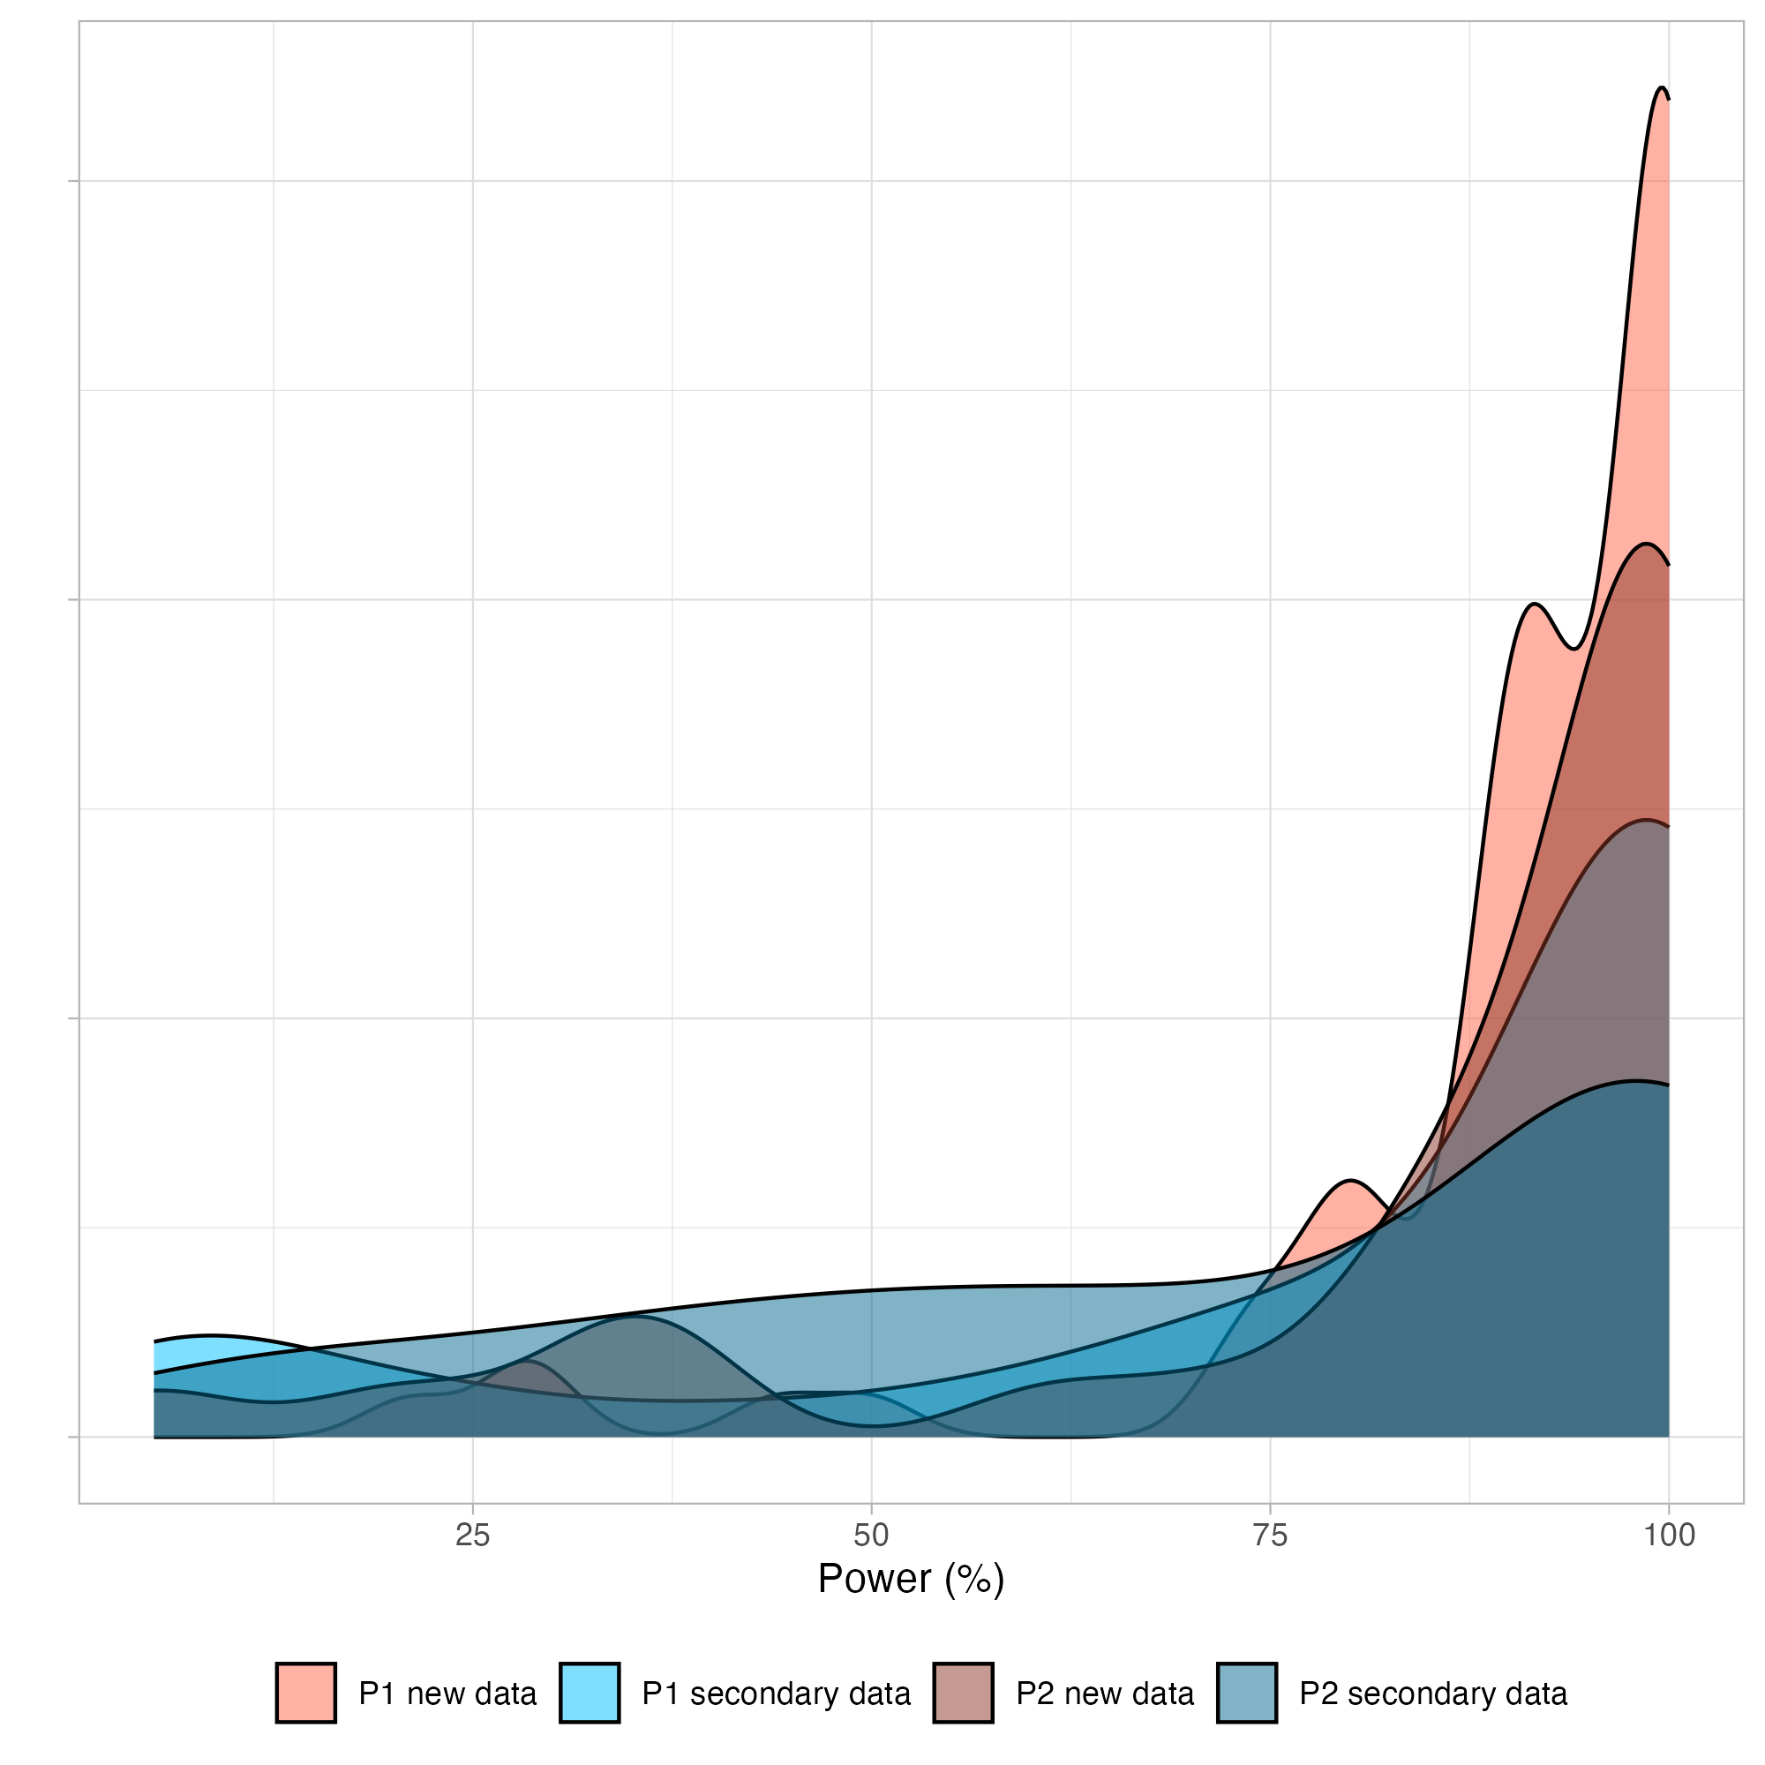
Caption: P1 = Phase 1; P2 = Phase 2. New = new data replications; Secondary = secondary data replications.

Sample Size Planning

Replication attempts with multiple claims

Several replication attempts were made during Phase 2 on papers that were selected during Phase 1 and in the sample of 200 for which all key claims were coded from the paper. For these cases, there could be more than one claim that would be replicated in a single replication study. We conducted a single a priori power analysis for a key claim and inferential test for sample size planning. We defaulted to using the single claim extracted for Phase 1 of the project if it was relevant for the replication study. Replication teams were encouraged but not required to conduct and document power calculations on the other claims and inferential tests included in their replication study. We also then conducted power calculations using the achieved combined sample size.

Estimating power for unusual cases
Nine of the new data replication attempts were recognized at the outset as using sufficiently distinct methods that the original design and effect size might not be an appropriate guide for power estimation. As such, these replication attempts could be categorized as “generalizability studies” and required an independent a priori power analysis that depended on the lab’s study design. As a consequence, the replication team conducted their own power analysis. We provided guidelines for determining the effect size of interest (researchers were free to use the effect size from the original study, other similar studies or relevant effect sizes from the literature, and their own judgment), conducting the power analysis (by providing them with standard power analysis scripts and encouraged their use if relevant), but set required power and alpha levels (i.e., 90% power, 5% alpha). It was ultimately up to the replication lab’s discretion to determine the effect size of interest and appropriate power calculation for their study design, and it was their responsibility to conduct the analysis with documentation and rationale in the preregistration and OSF project. These studies went through the replication peer review process just like other new data replications, and we asked reviewers to review the power analysis during this review.

New data replications conducted during Phase 1
Power calculations were done in accordance with the guidelines of the Social Sciences Replication Project (SSRP; (Camerer et al., 2018)), which defined two stages for determining sample size. In SSRP, replications that failed to achieve the original result with the Stage 1 sample size (90% power to detect 75% of the original effect size) collected additional data to achieve the Stage 2 sample size (90% power to detect 50% of the original effect size). Across all claims, 73% of new data replication attempts started during Phase 1 achieved 90% power to detect 75% of the original effect size, with a mean achieved power of 90% (median = 98%).

Secondary data replications conducted during Phase 1
Secondary data replications were planned to meet the “minimum threshold” sample size (i.e., 50% power to detect 100% of the original effect). Across all claims, 84% of secondary data replications started during Phase 1 achieved 50% power to detect 100% of the original effect size, with an average achieved power of 85% (median = 100%).

New data replications conducted during Phase 2
Power calculations were conducted in accordance with the guidelines of the Social Sciences Replication Project (SSRP; Camerer et al., 2018)) However, in a change from Phase 1, for projects started in Phase 2, we aimed to achieve the Stage 2 sample size (90% power to detect 50% of the original effect size) from the outset. And, if this sample size was not attainable for the replicating lab, then they aimed to achieve the Stage 1 sample size (90% power to detect 75% of the original effect size). This removed the need for an interim analysis and decision about additional data collection, and encouraged replication teams to collect as much data as possible. For papers with multiple claims, only a single key claim was the basis for the power analysis. For claims with a power estimate, 69% of new data replication attempts started during Phase 2 achieved 90% power to detect 75% of the original effect size, with a mean achieved power of 85% (median = 96%).

Secondary data replications conducted during Phase 2
Secondary data replications were required to meet the “minimum threshold” for power that was established in Phase 1 (50% power to detect 100% of the original effect), and participating teams were encouraged to obtain the highest power possible given what data were available. We adopted this more liberal inclusion criterion for secondary data replications because secondary data replications are constrained by however much data are already available. In Phase 2, it was more common for the replication team to ensure that their attempt would meet the minimum power threshold, but each replication’s power analysis or power assessment and rationale was reviewed by external researchers during the preregistration review. For papers with multiple claims, only a single key claim was the basis for the power analysis. Across all claims, 88% of secondary data replications started during Phase 2 achieved 50% power to detect 100% of the original effect size, with an average achieved power of 82% (median = 98%).

SER Method for estimating power versus traditional power analysis
For approximately 153 claims, we used the standard error ratio (SER) method to estimate power (see SER method). Figure S2 shows power estimates using the SER versus traditional power analysis. The top panel shows data censoring at a maximum sample size of 15,000 (n = 191 claims), and the bottom panel shows the same data with a maximum sample size of 5,000 (n = 157). Figure S2 illustrates that SER and traditional power analyses are strongly positively correlated, and that the SER method is more conservative with most of the data points occurring above the diagonal line, indicating that SER suggested a larger sample size for detecting the same effect.
Figure S2. Sample size estimates for SER versus traditional power analysis
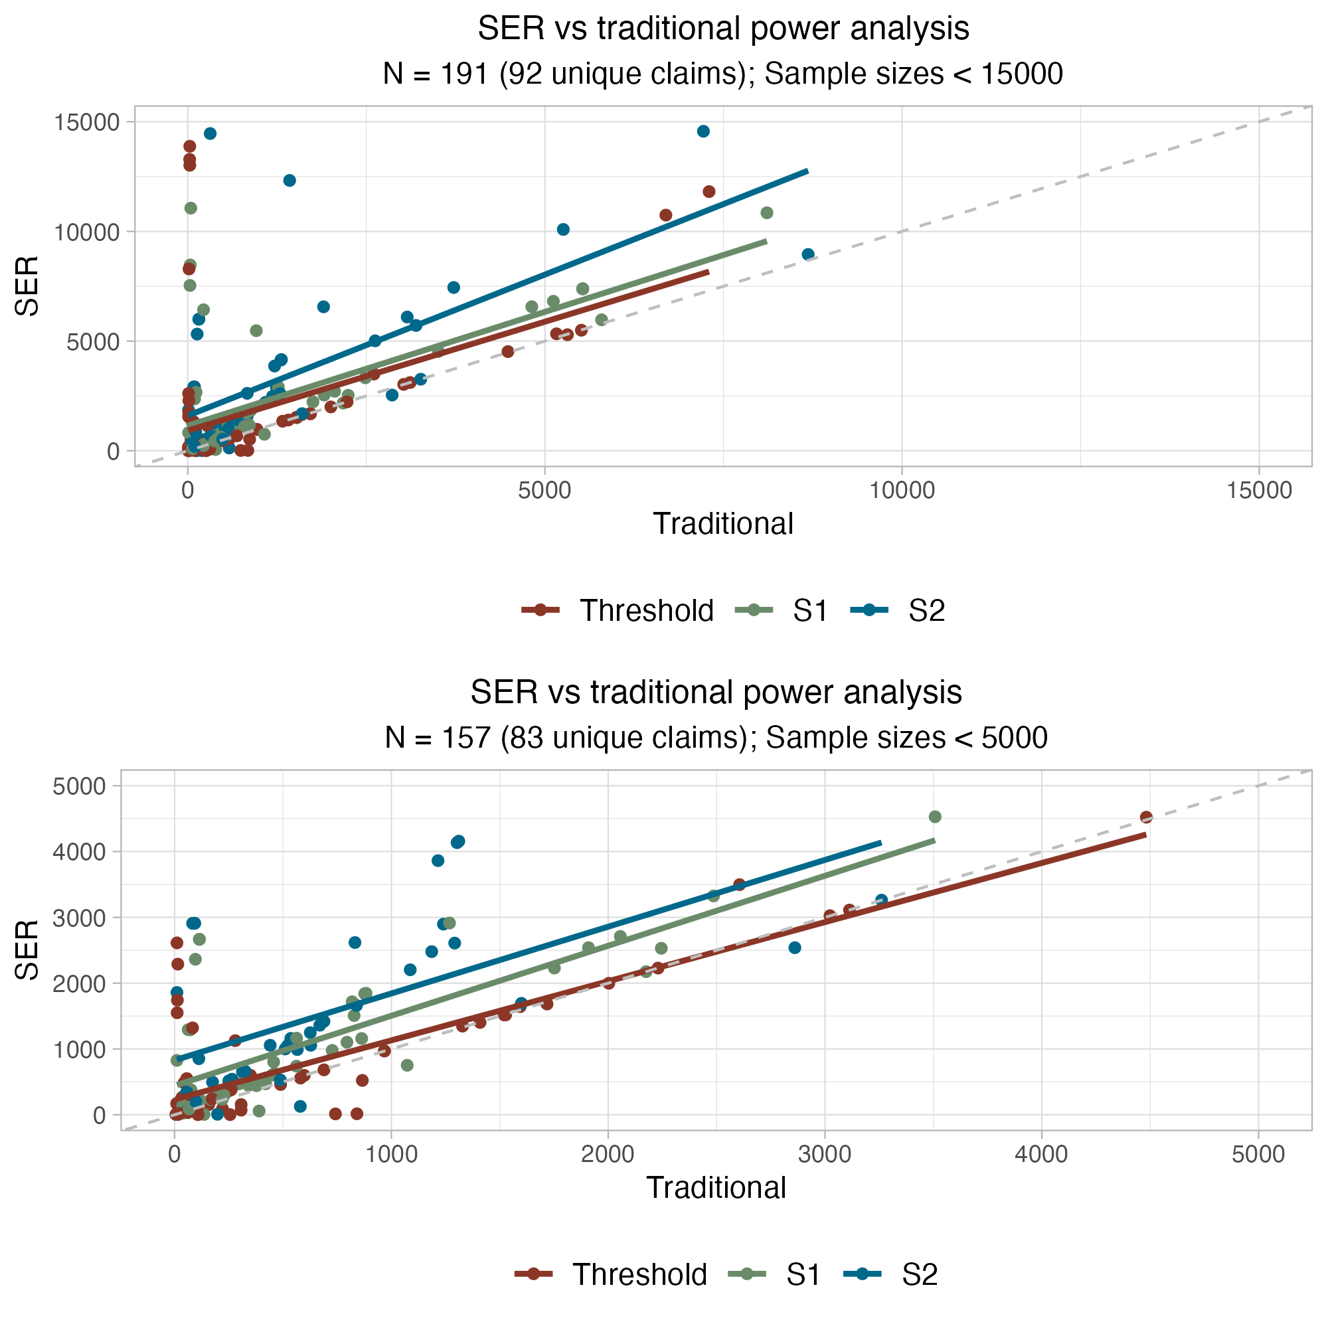
Caption: Threshold = 50% power to detect 100% of the original effect size S1 = 90% power to detect 75% of the original effect size; S2 = 90% power to detect 50% of the original effect size.
Figure S3 highlights that the SER method was used more frequently than non-SER for power estimation in education, political science, and sociology, and less often in psychology and business. The methods were applied with similar frequency in economics.
Figure S3. Distribution of SER and non-SER power estimations by discipline
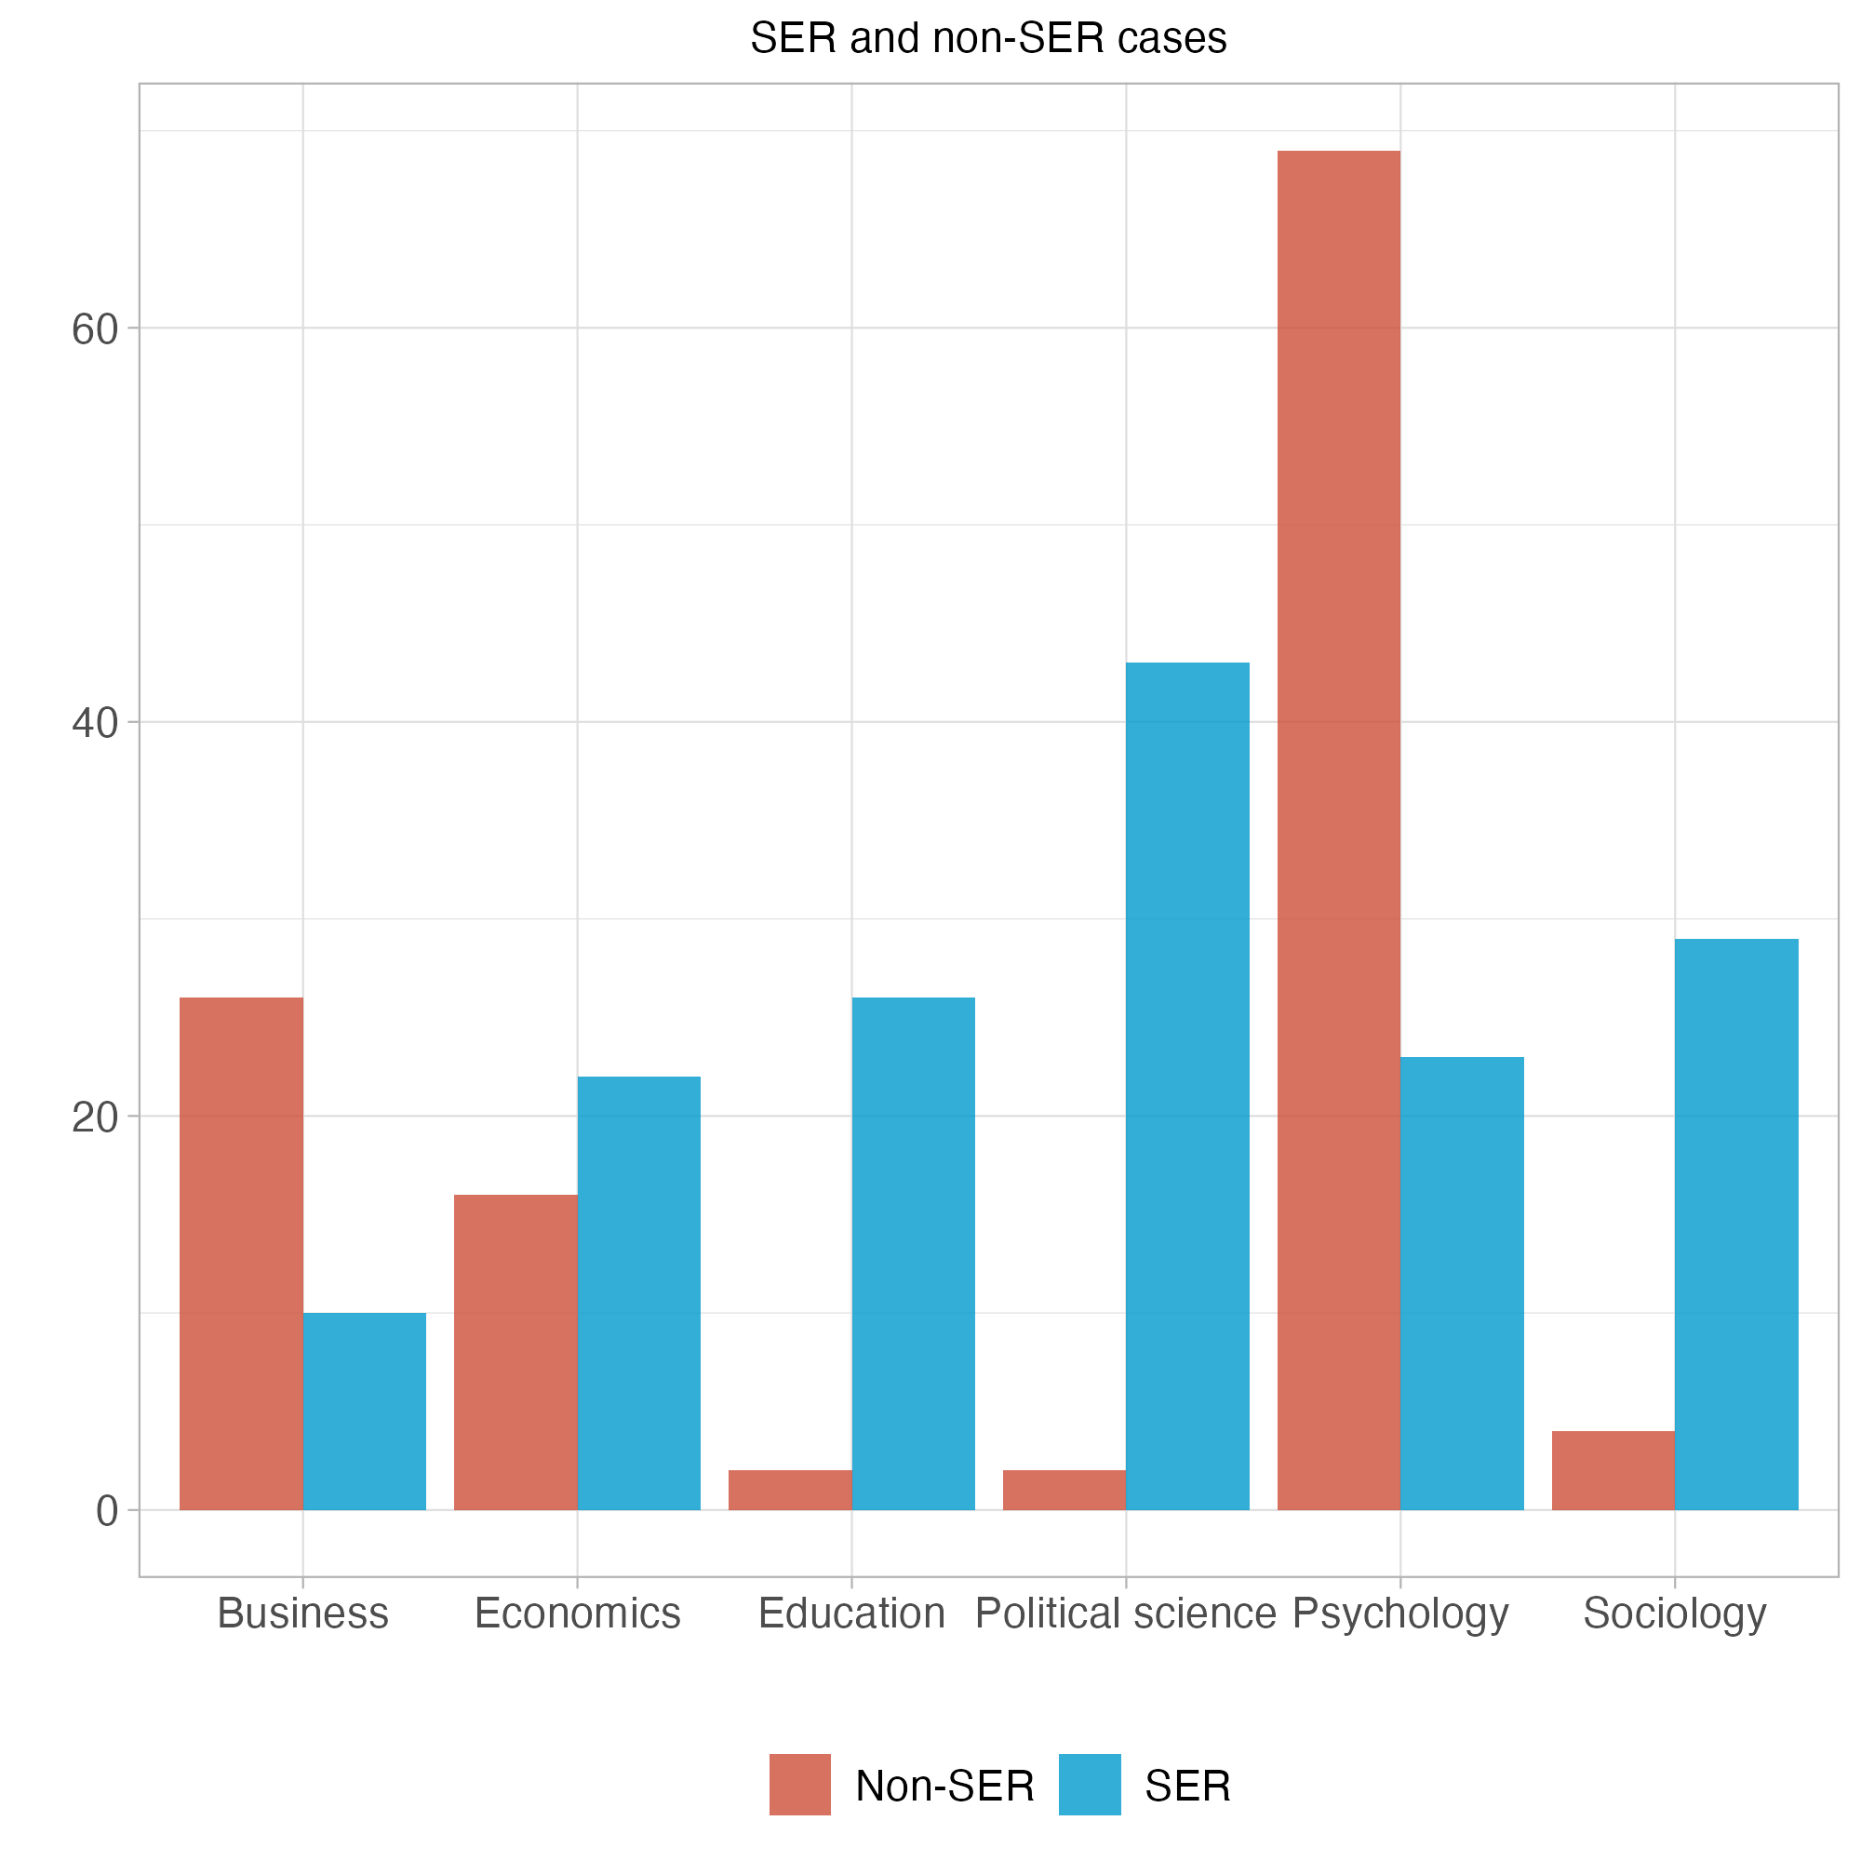

Onboarding Replication Teams
Once a team was matched, project coordinators sent an onboarding email that also included a presentation with all pertinent information provided. The team was invited to an onboarding call to relay key information and answer questions. A project coordinator would reach out to ensure the researchers’ institution had an active Federalwide Assurance (FWA), a requirement to participate in SCORE, and that the team could complete the replication with available resources and time. Primary feasibility criteria was average length of IRB review at the team’s institution, availability of appropriate expertise and instrumentation, availability of the required sample, and appropriateness of the proposed budget. If the team could complete the study within the project timeline, coordinators created a unique ID number for the replication, then created and shared an OSF project, a preregistration template (as a Google document), and IRB/HRPO instructions with the researchers.
The coordination team provided training to replication teams for using OSF and adhering to preregistration and documentation standards for the project. Statistical consultants provided just-in-time support for statistical and methodological issues during the preparation of preregistrations to eliminate any time bottlenecks.
Once a lab showed interest in performing a project on a paper, they completed a budget proposal. Human subjects data collection projects were capped at a maximum of US$10,000 per project, and collaborating labs were asked to specify how much money they were requesting to complete their project and how that money would be allocated between personnel costs, participant recruitment, and any materials needed. These budgets were reviewed and approved by the coordinating team in accordance with guidelines set by the project funding agency.
Recruited replication teams, and also reviewers and editors, were given the following instruction for helping them to think about how to design, evaluate, and conduct their replications: “Remember that your goal in replication is to achieve a design that is a good faith test of the original claim [linked to a preprint of Nosek & Errington, 2020]. Sometimes that is a straightforward repeat of the original procedure in your new sample. Sometimes that means adapting the methodology for the new context. Changing the methodology is not bad if it is done so in the service of improving the quality of the replication for testing the original claim. Also, so that we do not introduce new challenges or delays, keep your goal very focused on testing the original claim and not introducing new design elements that could create complications in IRB or preregistration review.”

Preregistration and Peer Review
The preregistration review process was designed with the goals of promoting integrity, transparency, and rigor for the replication studies. We subjected each replication study's design and analysis plan to peer review before conducting the research. The approach mandated replication teams to engage in open science practices throughout the project. Ideally, these practices would promote accountability for the research team, reproducibility of the outcomes, and accessibility of the research process and outputs to enable examination by interested readers.
For each replication study, teams were required to articulate the claim to be evaluated, outline their study design and sampling plan, specify variables of interest, and describe their analysis plan before conducting any analyses. Teams were provided standardized formats for documentation and protocol planning. These protocols were scrutinized by peer reviewers, who evaluated the strength of the proposed methods and appropriateness of the design for testing the same question as the original study. The peer review process was managed by editors who approved when the replication study was ready to be conducted. Functionally, the process mimicked the Stage 1 peer review process for Registered Reports (Chambers, 2019; Chambers & Tzavella, 2022), but was conducted in a peer review system set up and customized for the purposes of the program rather than in association with a journal.

Recruiting Reviewers and Editors
During recruiting for collaborators, researchers could indicate interest in conducting replication or reproduction studies, and also potential interest in serving in editorial or reviewer roles. Program leaders conducted personal outreach to researchers with substantial experience in editorial roles at disciplinary journals across the social-behavioral sciences to participate as editors for SCORE. Table S2 identifies the Editors that managed the peer review process for one or more replication studies. Replication projects for which they served as editor are identified by their OSF ID which can be found by replacing “abcde” with the five character ID in the following link: https://osf.io/abcde.
Table S2. Editors for SCORE replication studies peer review process.
Name | Institution | Title | OSF Links
Amélie Gourdon-Kanhukamwe | Kingston University | Lecturer | vcfsg, apv5t, 5du7f, jxd7b, rgtnm, f5b6c, yq3jb, hz97d, rcv49, 9n8uh, nb3z9, u52y3, 834de
Annette Brown | FHI 360 (Strategy and Innovation) | Head of Strategy and Principal Economist | na3mh, 3tczs, t9h6p, fhyzs, z4nyv, 8vn2z, agv64, sv4e8, 5tk2e, ta5vh, kgqu5, m4yse, zt5y2
Bert Bakker | University of Amsterdam (Amsterdam School of Communication Research) | Associate Professor | dbw54
Bobbie Spellman | University of Virginia (School of Law) | Professor | md84s, rqwju, ba26p
Cristina Zogmaister | Università di Milano-Bicocca (Dipartimento di Psicologia) | Associate Professor | cs8y2
M. Donabel Yap | Freelance Consultant | Consultant | 68x45, vhu2x, 9vxwz, k6xm9, h7av9, bmzuf
EJ Wagenmakers | University of Amsterdam (Psychology) | Professor | wtm3e, wdgns, tdr6s, w8xun
Eric Sevigny | Georgia State University (Criminal Justice & Criminology) | Professor | 8ndcx
Ernest O'Boyle | Indiana University (Management and Entrepreneurship) | Professor of Management | dk3xz, jsy47, hq4cr, q4fkd, s5v28, eumv2, 6vhnz, xtmy9, n2kma, xzufr, r924g, ty9du, kvsa6, 2dx54, afznv, jb9rq, 4v7ax, devn8, 9u2n4, 4h6v2
Gustav Nilsonne | Karolinska Institutet (Department of Clinical Neuroscience) | Associate Professor | m36y2, 9qjhf, 62xh4, kr7wf
Heather Kappes | The London School of Economics and Political Science (Management) | Associate Professor | qtv6j, 8qkrx, e9y6b, e52qx, vngz9, 2jn6d, 8eaqp
Jan Roer | Witten/Herdecke University (Department of Psychology and Psychotherapy) | Professor | 23ghe, wjh3c, 5k6jg, ujg2c, 3g74a, ebaf2, skj4c, 7vty6, 25mvt, h7wx8, 2be7n, utjhd, 7f42k, q7hpx, yg7d2, u5r47, 7k8sy, q7jk4, z9emg, vg6zy, 8qujb, h37zx
John Lloyd | University of Virginia (Education and Human Development) | Professor Emeritus | 2cjuw, 9r2jw, e7tw2, a4swd, mu4rs, bj9ea, 87qs6, 7qnrs, qczeu, bmwsv, en9md, kr7wf
Kai Jonas | Maastricht University (Work and Social Psychology) | Professor | p7mex, cwmb5, n35c2, ty5be, exrua, s2x3c, tuy3f, vt6ga, tmn3q, bx4hy, p2st5, mztkr, c9n5x, vcjf6, uwnya, e48gd, tz9ef, 697dv, em34f
Kevin Esterling | University of California Riverside (School of Public Policy) | Professor | 8uc5z, rvs4q, 2ug8x, rpumq, rs7e9, wy3tj, 8pxty, xtq68, 4w5g2, nse8t, 8pxty
Kim Peters | University of Exeter (Management) | Professor | ftbmk, 953fa, fncqp, g9v87, y47xc, w56ve, jdb7q, j8en2, 925nz
Kimberly Quinn | DePaul University (Department of Psychology) | Professor | 56jqu, h24z8, 8feku
Miguel Fonseca | University of Exeter (Business School) | Associate Professor | h2cq7, qrjsu, p9k76, fgx67, q4fpr, 82g9j
Nathaniel Porter | Virginia Tech (University Libraries) | Assistant Professor | zfxk9, 6aynt, 4rjbf, u8x9s, efuhg, qru6t, er54t, usv5k, 9mx5w, rywgh, c6pkb, guen5, w2xrp, shvdk, qgm2c, n7m39, qxk38, bcqem, gk92w, psmq5, k4suw, df36m, jegqs
Nick Fox | Center for Open Science | Research Scientist | qy62r
Nick Weller | University of California, Riverside (Political Science) | Associate Professor | 5fjd4, 7tc8b
Richard Lucas | Michigan State University (Psychology) | Professor | etfqz, er4gy, npju2, aykfp, a8eg9, uyt9p, mp3ak, cr6zm, hd3vf, huavw, snx3t, tacvb, e6mfw, 9nt6s, su48v, a6ksz, n9vkh, q8bdv, xnh2r
Rolf Zwaan | Erasmus University Rotterdam (Department of Psychology, Education, and Child Studies) | Professor | 78fvn, 5qwdh
Simine Vazire | University of Melbourne (Melbourne School of Psychological Sciences) | Professor | 7gcjf, dy3wx, sw67c, 8hp5j, tvhma, qe8sp, dhg3q, jhaur, rjhwt
Tabare Capitan | Swedish University of Agricultural Sciences (Department of Economics) | Postdoctoral Researcher | b48am, 6aynt, nd87t, bawh3, t95k2, 2dzn7, yv2am, ub4c6, h8ecm
We invited researchers to serve as independent reviewers of others’ projects. To express interest, researchers’ filled out a short form, identified the journals that published research in their expertise area, and provided their CV. The process of selecting reviewers started as a centralized process with coordinators matching reviewers and editors to protocols. Later in the process, we shifted to sharing protocols that were available for review by email to the reviewer pool and asking reviewers to self-identify interest, expertise, and availability. Reviewers and editors were paid per review unless they declined payment.

Drafting preregistrations with the design and analysis plan
Replication teams described their research plan using a New Data Preregistration Form or a Secondary Data Preregistration Form. The specific claim and sample size were provided by the coordinating team to the replication team. The preregistration forms were based on the standard OSF preregistration template. They included SCORE-specific instructions to guide a researcher through each step. Also, the coordination team provided guidance and answered questions as needed.
For secondary data replications, teams were split into two roles during Phase 1: data finder and data analyst. A data finder identified available data sources that could be used to conduct high-powered and good-faith replications of the selected claims and prepared the dataset for analysis. The coordinating team evaluated prepared datasets to ensure that they would allow for a high quality test of the original claim. Upon approval from the coordinating team, the data finder completed sections of the preregistration that offered procedural information about the data collection process, including the steps required to access the data, an outline of the variables necessary, a detailed narrative describing how the various datasets were cleaned and merged into a final replication dataset along with a commented analysis script (if available), and a data dictionary. The preregistration document was then shared with the data analyst along with the paper, the claim to be replicated, all of the materials developed by the data finder, any available code provided by the original author, and a portion of the replication dataset. The data analyst completed the remaining sections of the preregistration, including description of the analysis plan, and provided final replication outcomes. For the secondary replications conducted during Phase 2, the data finder and data analyst roles were combined into a single person or team.

Peer review process
Once a draft of a preregistration was complete, it was reviewed by between 1 and 3 reviewers. An Editor oversaw the review of each paper, and resolved any conflicts regarding design that were not resolved during the review process. To facilitate easy and asynchronous collaboration, each review was conducted in Google Docs. The reviewers' questions and suggestions were posed using the comment feature. Reviewers reviewed the research designs for clarity, completeness, and quality. Reviewers did not evaluate the quality of the original research, plausibility of the findings, or advisability of the design decisions that are appropriately faithful to the original methodology and findings because the purpose was to conduct a good-faith replication of the original research, regardless of its merits. The review period was set to five days, after which access to the document was closed to external participants and the replication team addressed all outstanding reviewer and editor comments. Often, issues raised by reviewers took additional time to address beyond the five-day window. On average, reviews lasted 7.5 days for new data replications and 19.5 days for secondary data replications.
The Editor assessed whether the replication team adequately addressed the comments, and either asked for additional revisions, approved, or rejected the replication. Once approved by the Editor, the final draft of the preregistration was added as a word document or PDF to the OSF component designated for this replication study and formally registered using the OSF Preregistration template. The coordinating team documented the key variables expected at the conclusion of the replication study, and the replication and coordinating teams aligned their knowledge of what materials were to be delivered at the conclusion of the study. After this, replication teams formally registered their preregistration and any associated materials on the OSF project component they would use for the management of project-relevant files, data, and outcome reporting.
Upon acceptance of the preregistration, teams received a $500 award for successfully completing the preregistration, and an additional $100 if they had submitted the preregistration for review within a week of being matched with a project to incentivize prioritizing the replication.

Engaging original authors
For new data replications, original authors were invited to engage during the peer review process. Just like other reviewers, they could make comments and suggestions directly in the preregistration Google doc. After a preregistration was approved by the Editor, original authors were invited to submit additional feedback as commentary. To ensure transparency, commentaries were uploaded to the replication OSF project alongside the final preregistration.
For secondary data replications, we decided not to include original authors during the peer review process because the data was often publicly accessible and may have introduced unwelcome temptation for original authors to test their original claims during review. Instead, the original authors were provided with a link to the final preregistration after the review period and invited to submit a commentary following the same approach with new data replications.

Acceptance rate
During Phase 1, a total of 125 new data replication plans and 73 secondary data replication plans were peer reviewed. Because the goal was to conduct good-faith replications of as many claims as possible, we tried to support revisions and improvements to make all replications acceptable. However, 4 new data replication plans and 7 secondary data replication plans were ultimately rejected by an Editor, or a 97% and 90% acceptance rate respectively. In these cases, Editors cited unresolvable issues with the study designs or data sources that would have prevented these studies from being high-quality, good faith verifications of the original claim.
During Phase 2, a total of 35 new data replication plans and 50 secondary data replication plans were peer reviewed. Of those, only one secondary data replication plan was ultimately rejected by an Editor (100% acceptance rate for new data replications; 98% acceptance rate for secondary data replications).

Replication inferential criteria
Criterion for a successful replication attempt within the SCORE program was achieving a statistically significant effect (alpha = .05, two tailed) in the same pattern as the original study on the focal statistical evidence. This criterion was used to judge whether humans and machines could predict replication outcomes. We also estimated replication success with other binary assessments methods and effect sizes. To the extent possible, we transformed effect size estimates to a standard metric for reporting in the aggregate across replications. A section below provides additional details about effect size conversions.
For the 200 “bushel” papers in which multiple claims were extracted from a single paper, if there was more than one significant test result for a claim, the test judged to be the most central one was used for the purposes of inferential evidence. If there were multiple test results in the original study, but only one was a significant inferential test, then that was chosen for the inference criteria. And, if there were no significant inferences in the original claim, then the replication outcome was not included in the dataset per the inclusion requirement for a significant result.
The main text provides an overview of 13 binary assessments of replication success. Below are additional details for a few of those assessments.

Subjective Interpretation
The subjective assessment of replication success was made by replication teams or by project coordinators reviewing the submitted outcomes for the replications. There was no explicit guidance for how to make the subjective assessment other than to evaluate whether the claim had replicated successfully. Raters could indicate: Yes, No, or Complicated. In Phase 2, an option of “Not Sure” was added, though none of the replication outcomes reported here were rated as such. For binary assessment, only “Yes” was considered replication success and cases of “Complicated” were excluded.

Meta-analysis
We synthesized the original and replication studies by means of the fixed-effect meta-analysis model (Hedges & Vevea, 1998; also known as the common-effect or equal-effect model in other implementations). This model does not assume that the true effect size underlying both studies is the same, nor does it allow generalizing the results to a population of studies. Instead, it is concerned with reliably combining evidence from two independent studies. While equal-effect and fixed-effect models are conceptually distinct, in this implementation the outputs of the models are identical (Laird & Mosteller, 1990; see also https://wviechtb.github.io/metafor/reference/misc-models.html).

Bayesian meta-analysis
We used a fixed-effect model for this analysis to match the approach used immediately above. In our implementation, (https://danheck.github.io/metaBMA/articles/metaBMA.html), we estimated the model with a prior on the effect size centered at 0 with a standard deviation of 0.25.

Data collection & analysis
Replication teams completed the protocols with active monitoring and assessment by the Project coordinators throughout the process to ensure adherence to quality control expectations and timeline. Figure S4 shows the distribution of time required to complete replication studies separated by phase and whether the replication involved new data collection or used secondary data. Means and standard deviations of project duration are as follows: Phase 1 new data = 517 days (332 days), Phase 1 secondary data = 339 (284), Phase 2 new data = 247 (171), Phase 2 secondary data = 168 (122).
Figure S4. Number of days to complete replication projects from the date the first researcher was added to the study’s OSF project to the date the final report was last modified.
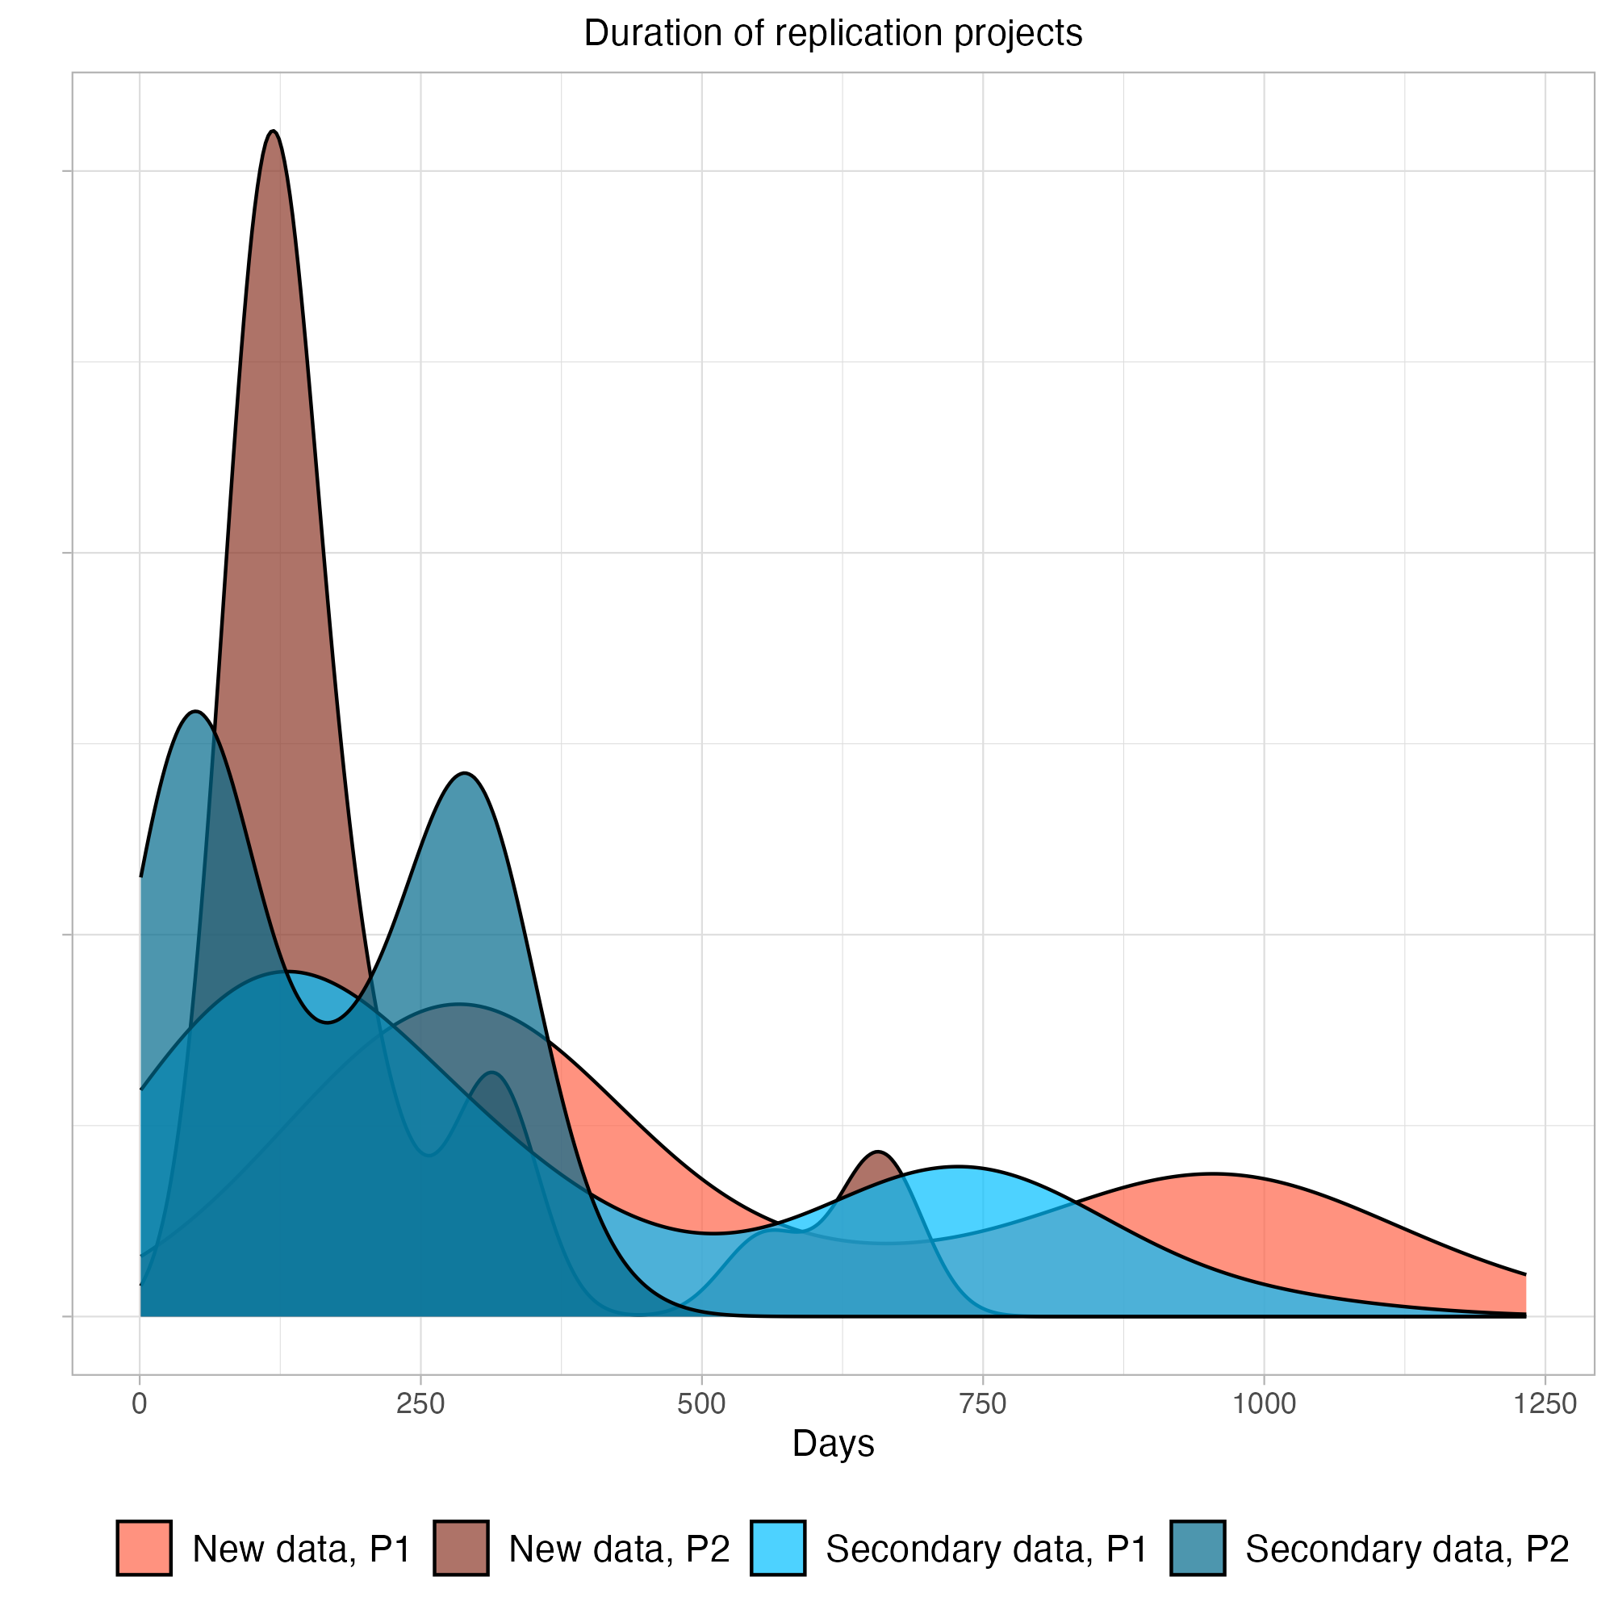
Caption: P1 = Phase 1; P2 = Phase 2. The completion date for replication studies was hardcapped at March 31, 2023 to reflect the late date of SCORE data collection.
Most SCORE replications were conducted after the beginning of the COVID-19 pandemic in Spring 2020. Because of the pandemic seven of the preregistered replication attempts were not completed, either because data collection was not possible or because pandemic-related delays made the replications infeasible with the SCORE timeline. Additionally, in 13 completed studies data collection was shifted online (either entirely or in part); in four studies data collection was cut short or the pandemic was thought to otherwise depress the sample size; in one study the in-person data collection procedure was altered; and in two studies the replication researchers explicitly flagged that the pandemic could have substantively affected the replication attempt.

Outcome reporting
Replication teams authored reports of their observed results and a comparison with the original study. A reporting manual and template guided replication teams through the outcome reporting process. These included instructions for uploading relevant files to the respective OSF project. Replication teams also filled out an outcome variable form to report key information from the study in a structured format. Once the replication variables were returned, a coordinating team member and statistical consultant would assess the reporting and calculate missing variables from original studies, replication studies, and those used to evaluate whether replications were successful. Those results were then reported in a standardized format for extraction to the database and for referencing to the study code and data. A coordinating team member would then evaluate the written report for completeness and accuracy before accepting them and denoting the project as complete. They would also review that private data was removed from any components that would be made public. A complete project included project content (IRBs, materials, data, scripts, etc.) being posted to the project on OSF in a standardized format.
Table S3 provides links to all OSF projects for replication attempts that were started. Paper ID and Project ID columns provide the project-specific identifiers used for tracking and project management. For any given project, replace “abcde” in the link https://osf.io/abcde with the five characters in the OSF column to find the plans, materials, data, and reporting on OSF. The “data collected” column is marked yes if at least some data was collected for that replication attempt. The “completed and reported” column is marked yes if the project met inclusion criteria and outcomes are reported in this paper.
Table S3. Identifiers and links to OSF projects for all replication attempts started
Paper ID | Project ID | OSF | Data Collected | Completed and Reported
0PZl | 41y2 | 5chvj | No | No
0qar | 20g | w8xun | Yes | Yes
0wWk | 28yg6 | efuhg | Yes | Yes
1574 | 2w9k2 | mztkr | Yes | Yes
1574 | 4100 | k9geu | No | No
1VeW | g941 | 3tczs | Yes | Yes
1X9W | 32mk | 9qjhf | Yes | Yes
25Yg | 97g | 2qyfr | No | No
2GKO | 4142 | nse8t | Yes | Yes
2Ypg | 28gg6 | dq4k9 | No | No
2lb5 | y496 | q4fpr | Yes | Yes
347d | m89 | 56jqu | Yes | Yes
3aPw | 05g8 | qczeu | Yes | Yes
3aPw | 2y4gm | k4suw | Yes | No
4q0L | 3z5z | m4yse | Yes | Yes
521q | 286 | aykfp | Yes | Yes
598w | 79k5 | kwsdr | No | No
59bm | 2196 | xd9c8 | Yes | Yes
59bm | m4k7 | 953fa | Yes | Yes
59bm | z96 | y47xc | Yes | Yes
5Awm | 2y2g | k6xm9 | Yes | Yes
5JE | z189 | agv64 | Yes | Yes
5Kgq | k6y7 | 62xh4 | Yes | Yes
5KrD | 935y | sv4e8 | Yes | Yes
5Q82 | 6zy82 | guen5 | Yes | Yes
5XEE | 21z56 | n35c2 | Yes | Yes
5Xaw | 69y36 | 7vty6 | Yes | Yes
5Xeq | 8 | wu5pv | No | No
7RR2 | 86m96 | q7hpx | Yes | Yes
7RR2 | 0y08 | evrxs | No | No
7WjP | m7y9 | d8we7 | No | No
7WjP | 7976 | md84s | Yes | Yes
7X54 | 93k7 | 7qnrs | Yes | Yes
7ybJ | z2416 | w2ahm | No | No
88xa | 1554 | afznv | Yes | Yes
8R9d | 9kgg | mp3ak | Yes | Yes
8qER | 56z6 | 6ycdg | No | No
8w97 | gz2m | sw67c | Yes | Yes
8wZ0 | 276 | tdr6s | Yes | Yes
8wZ0 | 2y486 | vt6ga | Yes | Yes
9DZl | 548 | 9s4tw | No | No
9J1 | g9mm | rqwju | Yes | Yes
9OK1 | 658g7 | h8ecm | Yes | Yes
9R9X | 2kkg2 | tuy3f | Yes | Yes
9Yqy | 99yg | xh4eq | No | No
9ey | z161 | ftbmk | Yes | Yes
9wkl | 94ky | 6aynt | Yes | Yes
9wya | 9k2y | 4w5g2 | Yes | Yes
AOQj | 21487 | 697dv | Yes | Yes
AYQG | 6m33m | n7m39 | Yes | Yes
AYQG | 6g7k | cfra4 | No | No
AgO1 | 895g | 5tk2e | Yes | Yes
AgO1 | 23m12 | z9emg | Yes | Yes
AqDO | 2wyw2 | w2xrp | Yes | Yes
AqDO | 7945 | tacvb | Yes | Yes
AvOr | 24716 | bx4hy | Yes | Yes
AvOr | 92g | jxd7b | Yes | Yes
AvWY | 8g91 | uyt9p | Yes | Yes
BKxK | 4zz0 | nd87t | Yes | Yes
BaDx | 0m7 | 4unjb | No | No
BlRQ | 546 | kr7wf | Yes | Yes
Blxd | 6z3o2 | em34f | Yes | Yes
Blxd | 3053 | mu4rs | Yes | Yes
Br0x | 658m2 | tmn3q | Yes | Yes
Br0x | 7g66 | n2kma | Yes | Yes
Br0x | 2kgg2 | 25mvt | Yes | Yes
BrGp | 247z3 | h37zx | Yes | Yes
D2LY | 65o96 | qgm2c | Yes | Yes
DEqr | 61k8 | 8uc5z | Yes | Yes
E4Am | m5y9 | n9vkh | Yes | Yes
E5qr | 65gm6 | shvdk | Yes | Yes
EAa | yz66 | yhtz4 | No | No
EJpm | 288ok | gk92w | Yes | Yes
EJpm | yk20 | 7tc8b | Yes | Yes
EJpm | 5738 | 7zn4v | No | No
EKBZ | 618k | e9y6b | Yes | Yes
EQxa | 6738 | wdgns | Yes | Yes
EQxa | 6m396 | 7f42k | Yes | Yes
EZ3x | 8z2g | a4swd | Yes | Yes
Eb2N | 23yw2 | rywgh | Yes | Yes
Ej3y | 65km6 | skj4c | Yes | Yes
G1Lr | gz9m | mjfwp | Yes | Yes
G1Lr | 887 | jsy47 | Yes | Yes
G1Lr | 387 | 6vhnz | Yes | Yes
G1Lr | 369z | eumv2 | Yes | Yes
G1Lr | 999g | r924g | Yes | Yes
GNjz | y60 | m36y2 | Yes | Yes
GXEW | 67g8 | 834de | Yes | Yes
J40k | 67z8 | 4h6v2 | Yes | Yes
J4W9 | k144 | qrjsu | Yes | Yes
J4W9 | y2312 | yg7d2 | Yes | Yes
J7Z2 | 317z | x9f3m | No | No
J7ek | 89z7 | yq3jb | Yes | Yes
J7ek | 288g2 | exrua | Yes | Yes
JRpA | 2g7ky | bcqem | Yes | Yes
JRpA | mk67 | xtq68 | Yes | Yes
JWzJ | 6547 | u8x9s | Yes | Yes
K4ZD | y071 | 2jn6d | Yes | Yes
Kj9d | 16yz | 5du7f | Yes | Yes
Kybl | 23w8w | bmzuf | Yes | Yes
LbEB | 6zzo6 | ty5be | Yes | Yes
LbEB | gz7m | ewujm | No | No
LmBx | y2gz6 | p2st5 | Yes | Yes
LyLd | 944y | jb9rq | Yes | Yes
LyLd | 10g2 | 9u2n4 | Yes | Yes
N8pB | 2ggz2 | ujg2c | Yes | Yes
Nj8V | 746 | 2dx54 | Yes | Yes
Njqj | 9k67 | 96vn7 | No | No
NrrW | 24812 | 9vxwz | Yes | Yes
OKRy | 281g6 | 5k6jg | Yes | Yes
OYX0 | 658y7 | yv2am | Yes | Yes
OYX0 | 8zz7 | bj9ea | Yes | Yes
OeGv | 24m16 | as7te | Yes | Yes
OeGv | y050 | 8pxty | Yes | Yes
Ovkm | zz26 | f5b6c | Yes | Yes
Ow0 | 46z8 | q8bdv | Yes | Yes
P1rY | 99kg | ba26p | Yes | Yes
P8Ab | 2wmk2 | 6q87t | No | No
P9Vr | 24z12 | tj9hy | No | No
PNPz | 5zg9 | er4gy | Yes | Yes
Pb9K | 7g95 | rvs4q | Yes | Yes
PlDa | 786 | huavw | Yes | Yes
Q1dl | 40z0 | ndbrp | Yes | Yes
Q1dl | om7 | hq4cr | Yes | Yes
Q1dl | 1642 | xzufr | Yes | Yes
Q1dl | g6936 | 3b49u | No | No
QYNq | kk47 | 5fjd4 | Yes | Yes
Qk5P | 3zz | 7rtpw | No | No
QllV | 249w6 | bawh3 | Yes | Yes
R8RN | 1yz2 | kvsa6 | Yes | Yes
R9dv | 42m8 | z4nyv | Yes | Yes
RJb | 6m4k | vngz9 | Yes | Yes
RYKv | 2k5g2 | df36m | Yes | Yes
RYKv | mkz7 | ta5vh | Yes | Yes
RZdL | 6o946 | c9n5x | Yes | Yes
RrOb | 19gz | devn8 | Yes | Yes
Rvb | 2y582 | ebaf2 | Yes | Yes
VB9K | 2g7z2 | vg6zy | Yes | Yes
VGAe | 4z32 | dk3xz | Yes | Yes
VOwm | ykk0 | 82g9j | Yes | Yes
Vj0p | 2g79y | tz9ef | Yes | Yes
Vj0p | yzm6 | e6mfw | Yes | Yes
VjYA | y01 | kdr3f | No | No
VjjX | 99m7 | 9r2jw | Yes | Yes
Vpgm | m7m3 | hz97d | Yes | Yes
VvZX | 4182 | p9k76 | Yes | Yes
VvlD | 2616 | 8vn2z | Yes | Yes
WLkV | 67516 | q7jk4 | Yes | Yes
WLpV | 1964 | t9h6p | Yes | Yes
WaYe | 556 | fgx67 | Yes | Yes
Wre | 4130 | h24z8 | Yes | Yes
Y8Yx | 21wg2 | usv5k | Yes | Yes
YWep | 75g6 | u52y3 | Yes | Yes
YmQR | 69412 | c6pkb | Yes | Yes
YpZZ | 4930 | g6fkp | Yes | Yes
YpZZ | 3z7z | rjhwt | Yes | Yes
YpZZ | 15yz | qe8sp | Yes | Yes
YpZZ | 8y1 | jhaur | Yes | Yes
YpZZ | 4zy8 | 7gcjf | Yes | Yes
a8jQ | 6mz92 | 3g74a | Yes | Yes
aYyR | 23w12 | 7k8sy | Yes | Yes
aag9 | 6z1o2 | wjh3c | Yes | Yes
amYY | 6mz8 | h2cq7 | Yes | Yes
bLe8 | 329k | t95k2 | Yes | Yes
bY2A | 6zoo2 | vhu2x | Yes | Yes
d24p | 67z12 | cwmb5 | Yes | Yes
d5v3 | 6m492 | vcjf6 | Yes | Yes
dLKV | 11z | 9mb25 | No | No
dqKX | 7965 | e7tw2 | Yes | Yes
dxQp | 2w5k2 | qru6t | Yes | Yes
e227 | 24yw6 | 9mx5w | Yes | Yes
e3G7 | 6o442 | 23ghe | Yes | Yes
eOQm | yk91 | 2cjuw | Yes | Yes
eRbK | 468 | qf4c2 | No | No
eg1q | 6g67 | 8hp5j | Yes | Yes
eg3p | yyy1 | e52qx | Yes | Yes
egX9 | 4z88 | fncqp | Yes | Yes
exBp | 2gy82 | jdz79 | No | No
exd7 | 318z | qtv6j | Yes | Yes
gRWz | m5k3 | tvhma | Yes | Yes
gbAY | g7g1 | 8eaqp | Yes | Yes
gbAY | 165m6 | 8qujb | Yes | Yes
gbg4 | 8z7g | npju2 | Yes | Yes
gbl9 | 393 | vcfsg | Yes | Yes
j2yd | 5796 | su48v | Yes | Yes
j2yd | m5m7 | sxqt8 | No | No
j2yd | 1994 | sxca4 | No | No
jDWN | 0y38 | g9v87 | Yes | Yes
jLr | 4z02 | dy3wx | Yes | Yes
jLr | m707 | dhg3q | Yes | Yes
kXp8 | kzyz | 925nz | Yes | Yes
lJ0w | 931g | ty9du | Yes | Yes
ld8V | y50 | 2afjs | No | No
lkBL | 618 | cr6zm | Yes | Yes
mBL1 | 8m17 | 8qkrx | Yes | Yes
mJDj | m7g7 | snx3t | Yes | Yes
mJDj | g79m | 9nt6s | Yes | Yes
mJDj | y7g1 | u5d2y | Yes | Yes
mrZ | 579 | na3mh | Yes | Yes
mxyQ | g77m | 2ug8x | Yes | Yes
pN7E | 69812 | f49uq | Yes | Yes
plLK | 5g9 | fhyzs | Yes | Yes
plLK | 6ow46 | h7wx8 | Yes | Yes
ppz8 | 4968 | 4cgdw | No | No
pw3m | 2kwg2 | 68x45 | Yes | Yes
q8xv | mkk9 | jdb7q | Yes | Yes
q8xv | 23g12 | ub4c6 | Yes | Yes
qPxQ | 69136 | 2be7n | Yes | Yes
qQ9Z | y71 | vdezq | No | No
qXX2 | gz51 | zt5y2 | Yes | Yes
qYr7 | 675m9 | qxk38 | Yes | Yes
qYr7 | 5z36 | wy3tj | Yes | Yes
qgWj | 2yg | kgqu5 | Yes | Yes
qgWj | 23wwg | xwthk | Yes | Yes
rjb | 9kzy | rgtnm | Yes | Yes
rjb | 24316 | utjhd | Yes | Yes
rpq | 308 | hd3vf | Yes | Yes
rvyb | 356 | 7tr8a | No | No
vGqL | 67y16 | er54t | Yes | Yes
vkYO | 109z | 8weqr | No | No
w5dv | 657 | q4fkd | Yes | Yes
wRvv | 65wm6 | e48gd | Yes | Yes
wRvv | 1634 | rpumq | Yes | Yes
x0pA | 8z81 | en9md | Yes | Yes
x2XO | 1y22 | bn6tj | No | No
x3KP | k5z | a8eg9 | Yes | Yes
xGGO | y11 | w56ve | Yes | Yes
xYbO | yk16 | 8feku | Yes | Yes
xvrb | z591 | xnh2r | Yes | Yes
y3R4 | 2wgk2 | p7mex | Yes | Yes
yAPR | 1762 | j8en2 | Yes | Yes
yDyG | z106 | xtmy9 | Yes | Yes
yJwG | 9ky | wtm3e | Yes | Yes
yQeR | 38 | 4v7ax | Yes | Yes
yypJ | 6g38 | apv5t | Yes | Yes
z0v1 | yz21 | 57f2j | No | No
z4dO | yzz0 | rs7e9 | Yes | Yes
zK2 | m5g9 | etfqz | Yes | Yes
zN22 | m63 | 5qwdh | Yes | Yes
zNEm | 1y02 | 78fvn | Yes | Yes
zb3Y | 2y182 | h7av9 | Yes | Yes
zb3Y | 41k2 | bmwsv | Yes | Yes
zekm | 234w6 | yfmg8 | Yes | Yes
zekm | k17 | s5v28 | Yes | Yes
zlBL | 651m6 | uwnya | Yes | Yes
zlBL | z516 | rcv49 | Yes | Yes
zlm2 | 9977 | qy62r | Yes | Yes
zlm2 | 128g6 | s2x3c | Yes | Yes
zlw | wz9 | jcs54 | No | No
zmYY | g5m | a6ksz | Yes | Yes
zmYY | 6zz3k | 8ndcx | Yes | Yes
zqwm | z4z9 | 87qs6 | Yes | Yes

Audit of replication analyses and outcomes and preparation for public release
The audit and revisions process consisted of multiple parts. Project coordinators reviewed the final reports on each OSF project to check if the outputs matched the reported outcomes in the dataset. If the report did not match or was missing outcomes, then the auditor would check the output from the code of the project. If there continued to be a discrepancy then the issue was flagged for further review. In addition, coordinators completed checks of code to ensure code contained within each OSF project ran without error using the data that the lab provided.
We also audited the final reports and output of each replication with project team members that were not involved in conducting that replication. These auditors reviewed values in the final report and output to check if they matched the dataset. These auditors also completed specific claim reproductions. The majority of replication studies received a computational reproduction check, with priority given to replication analyses that were not conducted in R (since that was the language used for the reproduction checks). After that process, another group of auditors conducted a final review on the data and the output in the report and code within each OSF project. They also provided a holistic assessment of the replication analysis and provided their feedback. Project coordinators resolved any open issues themselves or in coordination with the project authors.
Following the original submission of this manuscript and before public release of the data, we conducted an audit of the OSF projects housing the replication plans, data, materials, and outcomes to verify completeness and appropriateness of shared information. This audit included an internal check for sensitive or proprietary materials and email correspondence with each lab. Each lab received a checklist that contained a step by step guide to check that their OSF project was ready to be made public. Steps within the checklist included: a check for the final report, removal of the pdf of the original paper, a check for other copyrighted materials, steps for handling data de-identification, and steps for handling IRB materials. When labs completed the checklist they emailed the coordinating team confirmation.
A communal tracking sheet was available to all labs as they marked completion of their checklist and observed others’ completing their own. Coordinators confirmed all labs completed their checklist. This included spot-checks of the content of projects to confirm labs’ reports of handling sensitive and proprietary materials properly.
For projects that were started but never completed, the coordinators followed a similar process with the individual labs and provided extra support for checking for sensitive or proprietary materials. Coordinators conducted further review for any cases in which a completed checklist was not returned.

Attrition of replication attempts selected in Phase 1
For the 600 papers made eligible for replication attempts from Phase 1, called the “Evidence set” in some documentation, we conducted additional analysis to assess attrition. Figure S5 shows the proportion of papers from these papers by discipline for which a replication was finished (purple), never attempted (blue), and not completed (other colors). Of the 63 papers for which a replication team was identified but a replication was not completed, 37 (58.7%) were never started meaning that the sourced team did not ultimately begin drafting a preregistration or worked within their OSF project for the study, 1 (1.6%) worked within their OSF project but did not begin a preregistration, 8 (12.7%) drafted a portion of the preregistration, 6 (9.5%) completed the preregistration, and 6 (9.5%%) registered the approved study. Reasons for attrition within these stages varied substantially, including a substantial portion that dropped out due to COVID, conflicting priorities in their work, preregistration designs were rejected, and insufficient time to complete the work before the program ended. Figure S6 presents the same data by year of publication, and Figure S7 presents the same data by journal.
Figure S5. Proportion of papers with a completed replication by discipline
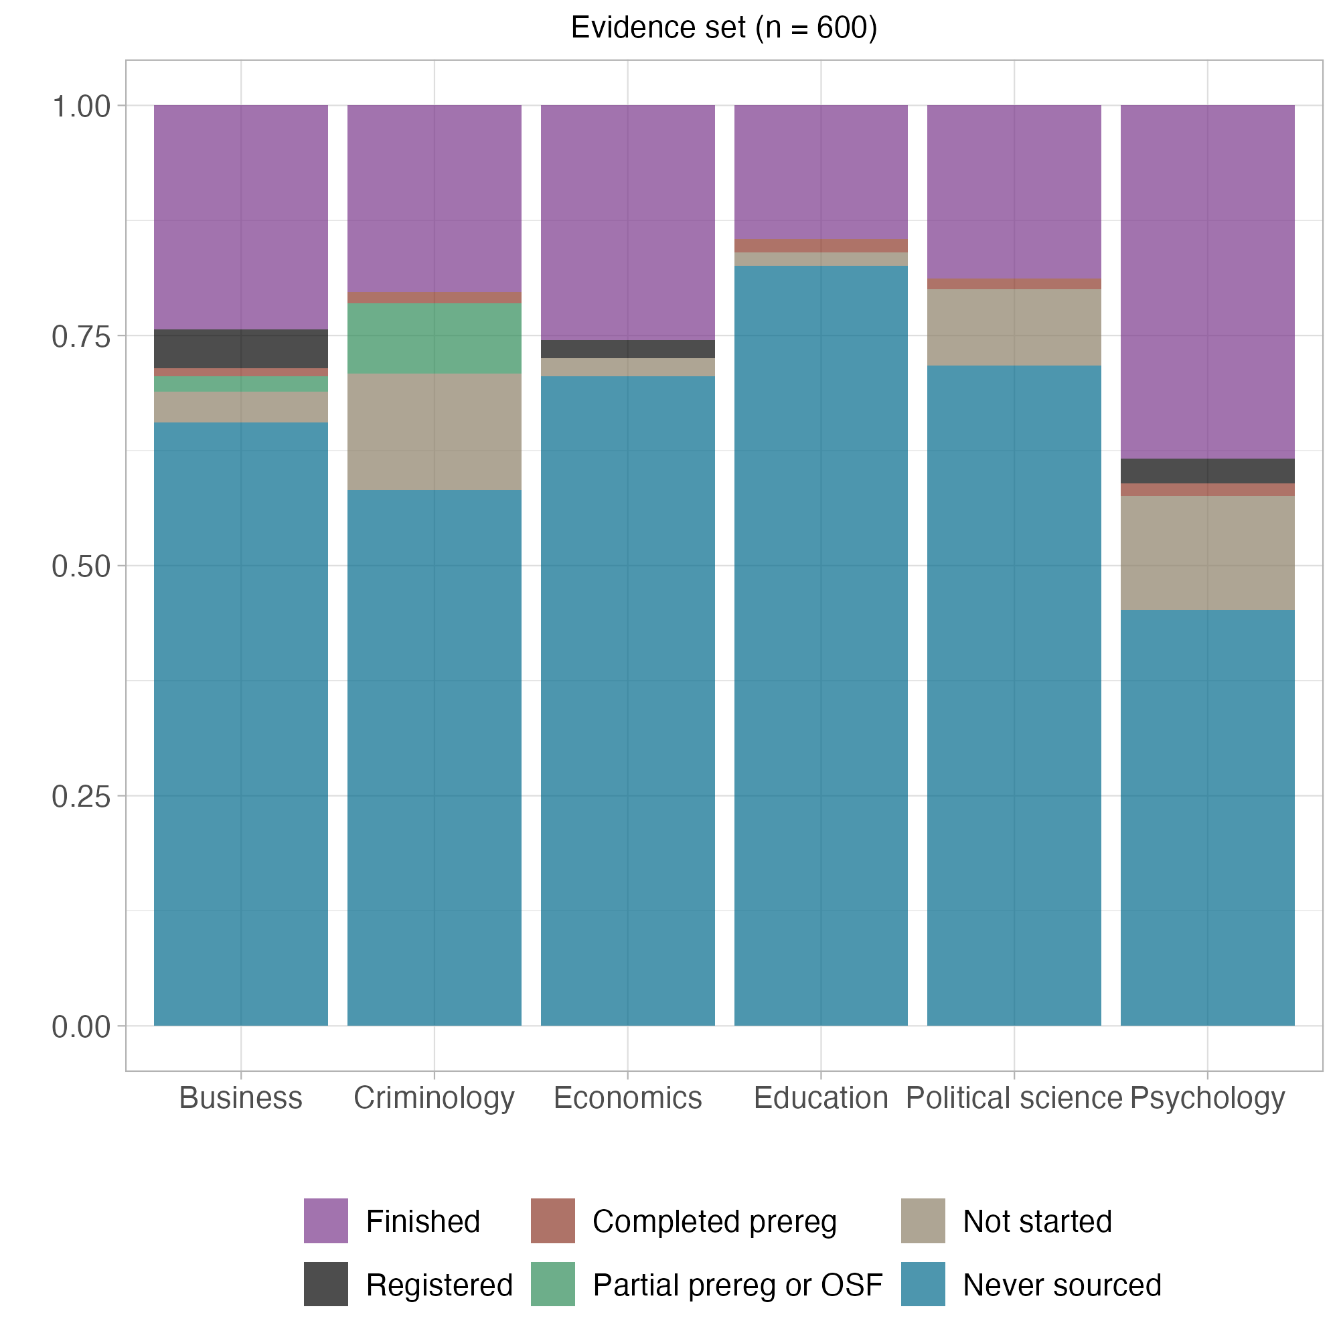
Caption: Proportion of papers by discipline for which a replication attempt was finished (purple), never attempted (blue), or for which a replication team was sourced but the replication study was not started or completed (other colors).
Figure S6. Proportion of papers with a completed replication by year
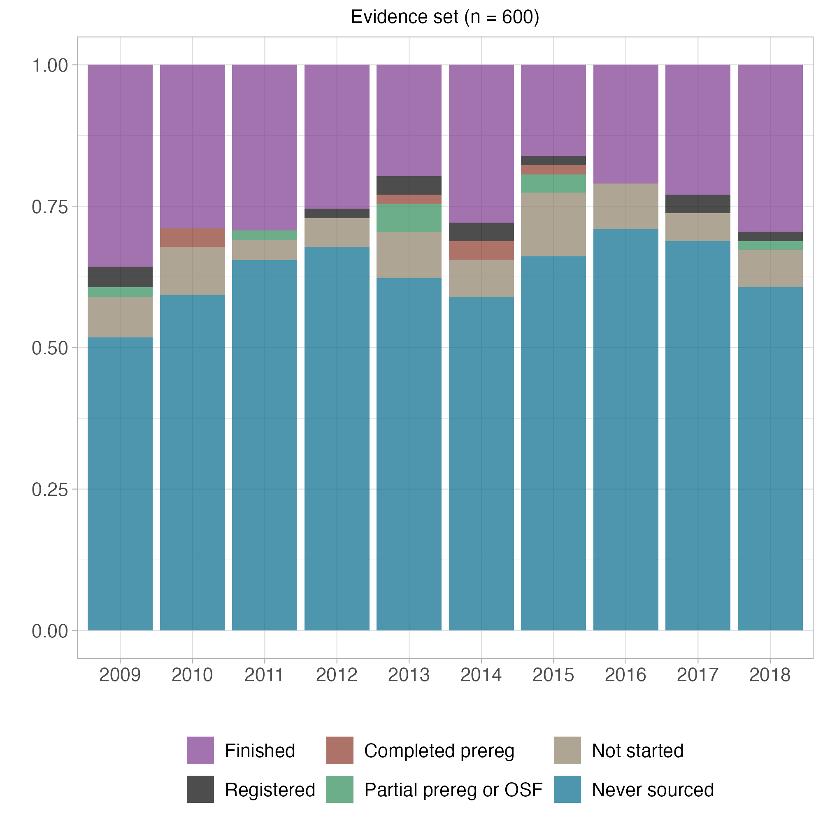
Caption: Proportion of papers by publication year for which a replication attempt was finished (purple), never attempted (blue), or for which a replication team was sourced but the replication study was not started or completed (other colors).
Figure S7. Proportion of papers with a completed replication by journal
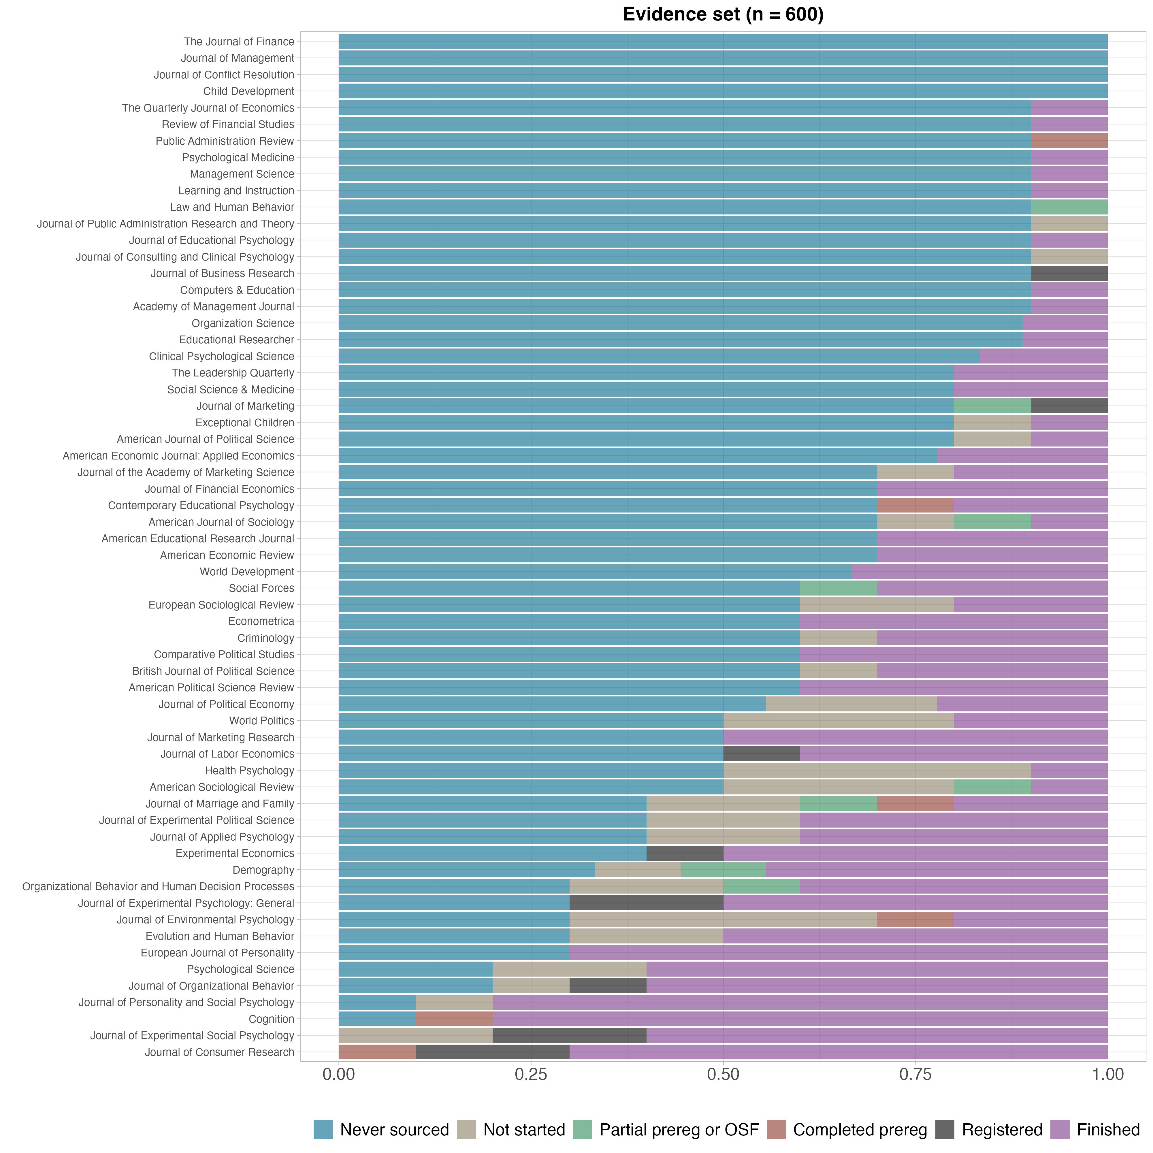
Caption: Proportion of papers by journal for which a replication attempt was finished (purple), never attempted (blue), or for which a replication team was sourced but the replication study was not started or completed (other colors).

Non-random selection and no attrition of replications selected in Phase 2
Given the short timeline for Phase 2, we did not make a random subsample from the full set of 900 papers to be eligible for replication. Instead, we identified papers from the full set of 900 papers with extracted claims that could plausibly go through our review process and produce completed replications within the program time constraints. We engaged SCORE contributors from Phase 1 who contributed new data and secondary replications. These researchers identified 25 papers for replication (12 with new data, 13 with secondary data), all of which were completed following review and preregistration of the study designs. Based on this approach, the 25 replicated papers from Phase 2 are likely to have more distinct characteristics from the sampling frame compared with the 139 replicated papers from Phase 1. Readers interested in probing selection effects further will benefit from distinguishing papers that were considered and replicated in Phase 1 versus Phase 2.

Excluded Cases
There are some cases in which replication outcomes became available but were excluded from the SCORE dataset for the reasons below. The hybrid replication section in the Results below reports several cases that were excluded because they combined original and independent data in the replication study, but offer interesting insights that are reported in this supporting information. Here, we summarize some infrequent cases for exclusion and explain why they occurred.
- Replication evidence for two claims were excluded because the original claim was a negative result, not a positive result. Positive results were an inclusion rule for claims in SCORE. Negative results were rarely replicated. But, they could occur when all of the following were true: [1] the paper was part of the “bushel” set in which all claims from the abstract were coded (~90% positive results), [2] some of the claims coded were negative results, and [3] a replication of that paper was able to include the negative results among the claims replicated. The two claims for which this occurred came from the same paper (ID: 7RR2).
- Replication evidence for six claims were excluded because they fell far short of the planned sample size. Sample size plans can fall short for several reasons. Some SCORE projects were severely affected by the COVID pandemic. The excluded papers (by ID) are: J40k, 9wya, jLr, 9wkl, J4W9, E4Am.
- We did not exclude all cases that fell short of power requirements. There were two occasions for conducting power estimates: [1] a priori estimates were conducted during research planning for peer review, [2] a statistical team conducted power analyses across all projects to assure consistency and address complex cases. These power estimates did not always agree.
  - For new data replication attempts, we included all cases in which both power estimates indicated that the requirements were met, and we included all cases in which the a priori power estimate indicated that the requirements were met. We also included all cases that were at least 80% of either the a priori target or the statistical team’s estimate in recognition that some variation around planned sample size occurs in the normal course of conducting research. We then excluded the 3 cases that did not meet any of these conditions as they were low powered regardless of estimation approach (paper IDs: Br0x, VvlD).
  - For secondary data replication attempts, we followed a similar methodology but without the lenience of achieving 80% power. We included all cases in which both power estimates indicated that the requirements were met, and we included all cases in which the a priori power estimate indicated that the requirements were met. We then excluded the 8 cases that did not meet any of these conditions as they were low powered regardless of estimation approach (paper IDs: AqDO, D2LY, AYQG, 9OK1, xGGO).
All together, 19 claims from 14 papers were excluded. For completeness, 5 of 17 of these claims (still excluding the two original negative results) showed replication success in terms of statistical significance and the same pattern.

Converting Statistical Outcomes to Common Effect Sizes
Comparing original and replication effect sizes has advantages over the binary assessments such as being a continuous representation of similarity and offering an emphasis on estimation rather than the presence or absence of an effect. In estimation contexts, the concept of power corresponds conceptually to the estimates’ precision and is independent of the estimates’ central tendencies. This increases confidence in comparing the average central tendencies for original and replication effect sizes across studies even if there is imprecise estimation for some individual studies. It also has disadvantages such as the lack of standardization of effect size metrics across statistical methods. There are some methods of converting effects in raw units to standardized units that can be applied across different models with few assumptions. But, there are some circumstances that require many assumptions about the comparability of the original and replication research designs and statistical models. There are other circumstances for which there is no possibility of establishing a meaningful, standardized metric.
Replicated papers and claims varied widely in research designs and statistical models. This resulted in a wide variety of native units for reporting the statistical outcomes. Part of the purpose of this project was to provide comparative results across the sample of replications. To achieve this purpose, it is helpful to have statistical outcomes reported on a common effect size metric. For some native units, conversions to common effect sizes is straightforward. For others, it is possible, but some assumptions must be made. And, for others, it is not possible to convert to effect size metrics in common with other replications. For reporting in the main text, we presented results aggregated to common effect size metrics to the extent possible. This involved some conversions with underlying assumptions that may or may not be met. Below, we summarize the conversions that were made, and summarize the results disaggregated by effect size metrics without conversions that require making meaningful assumptions.
In Table S4, we present disaggregated effect size calculations that require fewer assumptions but smaller samples for each metric. The qualitative interpretation of the overall results does not differ between aggregated and disaggregated approaches. Individual study outcomes are not the basis of conclusions in this paper, but any subsequent uses of these data for meta-analyses of individual outcomes should attend to variation based on effect size conversions.
Table S4. Selected ratios of effect sizes for original and replication studies in common units compared to Pearson’s r partial correlation conversions
Effect size | Number of study pairs | Replication:original effect size ratio | Replication:original partial correlation ratio
Cohen's f-squared | 28 | 0.84 | 0.4
Cohen's d | 23 | 0.4 | 0.41
Correlation | 8 | 0.32 | 0.24

Results

Replications completed by year in comparison with the sampling frame
In the main text, we reported changes in representativeness of the sample for replications attempted in comparison with the sample of claims by discipline. Table S5 provides the same information by year of publication. The sampling process drew near equal numbers of papers eligible for replication for each year, and the distribution of papers with completed replications remained within 2.8% of the expectation of 10% per year except for just 6.1% for 2015. By number of unique claims replicated (last row), 2010 claims were most over-represented (from 9.0% [n = 352/3900] to 16.4% [n = 45/274]), and 2011 (from 9.2% [n = 357/3900] to 6.9% [n = 19/274]) and 2015 (from 10.4% [n = 404/3900] to 5.8% [n = 16/274]) claims were most underrepresented.
Table S5. Papers and claims selected, and replication attempts, by year of publication.
 | 2009 | 2010 | 2011 | 2012 | 2013 | 2014 | 2015 | 2016 | 2017 | 2018 | Total
 | n (%)
Claims selected
Papers with claims | 371 (9.5%) | 352 (9.0%) | 357 (9.2%) | 388 (9.9%) | 400 (10.3%) | 391 (10.0%) | 404 (10.4%) | 409 (10.5%) | 409 (10.5%) | 419 (10.7%) | 3900 (100%)
Papers eligible for replication | 140 (9.3%) | 114 (7.6%) | 123 (8.2%) | 152 (10.1%) | 156 (10.4%) | 148 (9.9%) | 157 (10.5%) | 166 (11.1%) | 165 (11.0%) | 179 (11.9%) | 1500 (100%)
Papers with multiple claims | 17 (8.5%) | 18 (9.0%) | 16 (8.0%) | 13 (6.5%) | 20 (10.0%) | 26 (13.0%) | 22 (11.0%) | 25 (12.5%) | 18 (9.0%) | 25 (12.5%) | 200 (100%)
Papers with single claim | 123 (9.5%) | 96 (7.4%) | 107 (8.2%) | 139 (10.7%) | 136 (10.5%) | 122 (9.4%) | 135 (10.4%) | 141 (10.8%) | 147 (11.3%) | 154 (11.8%) | 1300 (100%)
Replications attempted
Papers with replication started | 25 (12.6%) | 18 (9.1%) | 20 (10.1%) | 16 (8.1%) | 21 (10.6%) | 23 (11.6%) | 16 (8.1%) | 14 (7.1%) | 22 (11.1%) | 23 (11.6%) | 198 (100%)
Papers with replication attempts completed | 21 (12.8%) | 16 (9.8%) | 19 (11.6%) | 12 (7.3%) | 15 (9.1%) | 19 (11.6%) | 10 (6.1%) | 13 (7.9%) | 19 (11.6%) | 20 (12.2%) | 164 (100%)
Total replication attempts of claims | 33 (11.1%) | 49 (16.6%) | 20 (6.8%) | 39 (13.2%) | 31 (10.5%) | 28 (9.5%) | 17 (5.7%) | 22 (7.4%) | 28 (9.5%) | 29 (9.8%) | 296 (100%)
Unique claims with replication attempts | 32 (11.7%) | 45 (16.4%) | 19 (6.9%) | 37 (13.5%) | 26 (9.5%) | 24 (8.8%) | 16 (5.8%) | 21 (7.7%) | 26 (9.5%) | 28 (10.2%) | 274 (100%)

Papers from Phase 1 for which a replication was not attempted
The dataset of 600 papers created in Phase 1 remained representative of the sampling frame of quantitative empirical papers from 2009 to 2018 from 62 journals across the social-behavioral sciences. However, which of those papers ultimately had a replication attempt for one of its claims was contingent on available resources and expertise to conduct a good-faith replication. The main text summarizes shifts in representativeness from the sampling frame to the completed replication studies. Here, we provide further insight by providing some evidence for why papers did not get selected for replication. With infinite resources and time, a much higher proportion of papers would have been replicated, but the constraints of time, resources, and sourcing of data, experts, and instrumentation constrained the possibility of starting and completing replication studies.
Within the constrained set of 600 papers, we were able to evaluate reasons that replications were not attempted. 380 (63.3%) were not matched with a team to plan and conduct a replication study. After data collection was completed, we evaluated the papers and claims for potential barriers to replication feasibility as a new data replication (Figure S8) or as a secondary data replication (Figure S9). The Figures present that data by discipline as the reasons vary substantially. For plausibility of conducting new data replications (Figure S8), 132 of the 380 papers (34.7%) were rated as plausible and the rest were deemed implausible because 132 (34.7%) were more likely conducted as secondary data replications, 78 (20.5%) were based on sensitive populations that are more difficult to obtain with time and resource constraints and challenging for the requirement to obtain secondary IRB approval through the Department of Defense (e.g., prison populations), 23 (6.1%) were longitudinal studies that exceeded the time window for data collection, and 13 (3.4%) were based on unique events to which the claim was directly relevant or for which similar events for conducting a replication would be challenging to identify. As could be anticipated, sensitive populations were more common reasons for education and psychology, and secondary data was a more common reason for economics, political science, and business.
Figure S8. Retrospective review of papers that were not matched to replication teams to conduct a new data replication by discipline
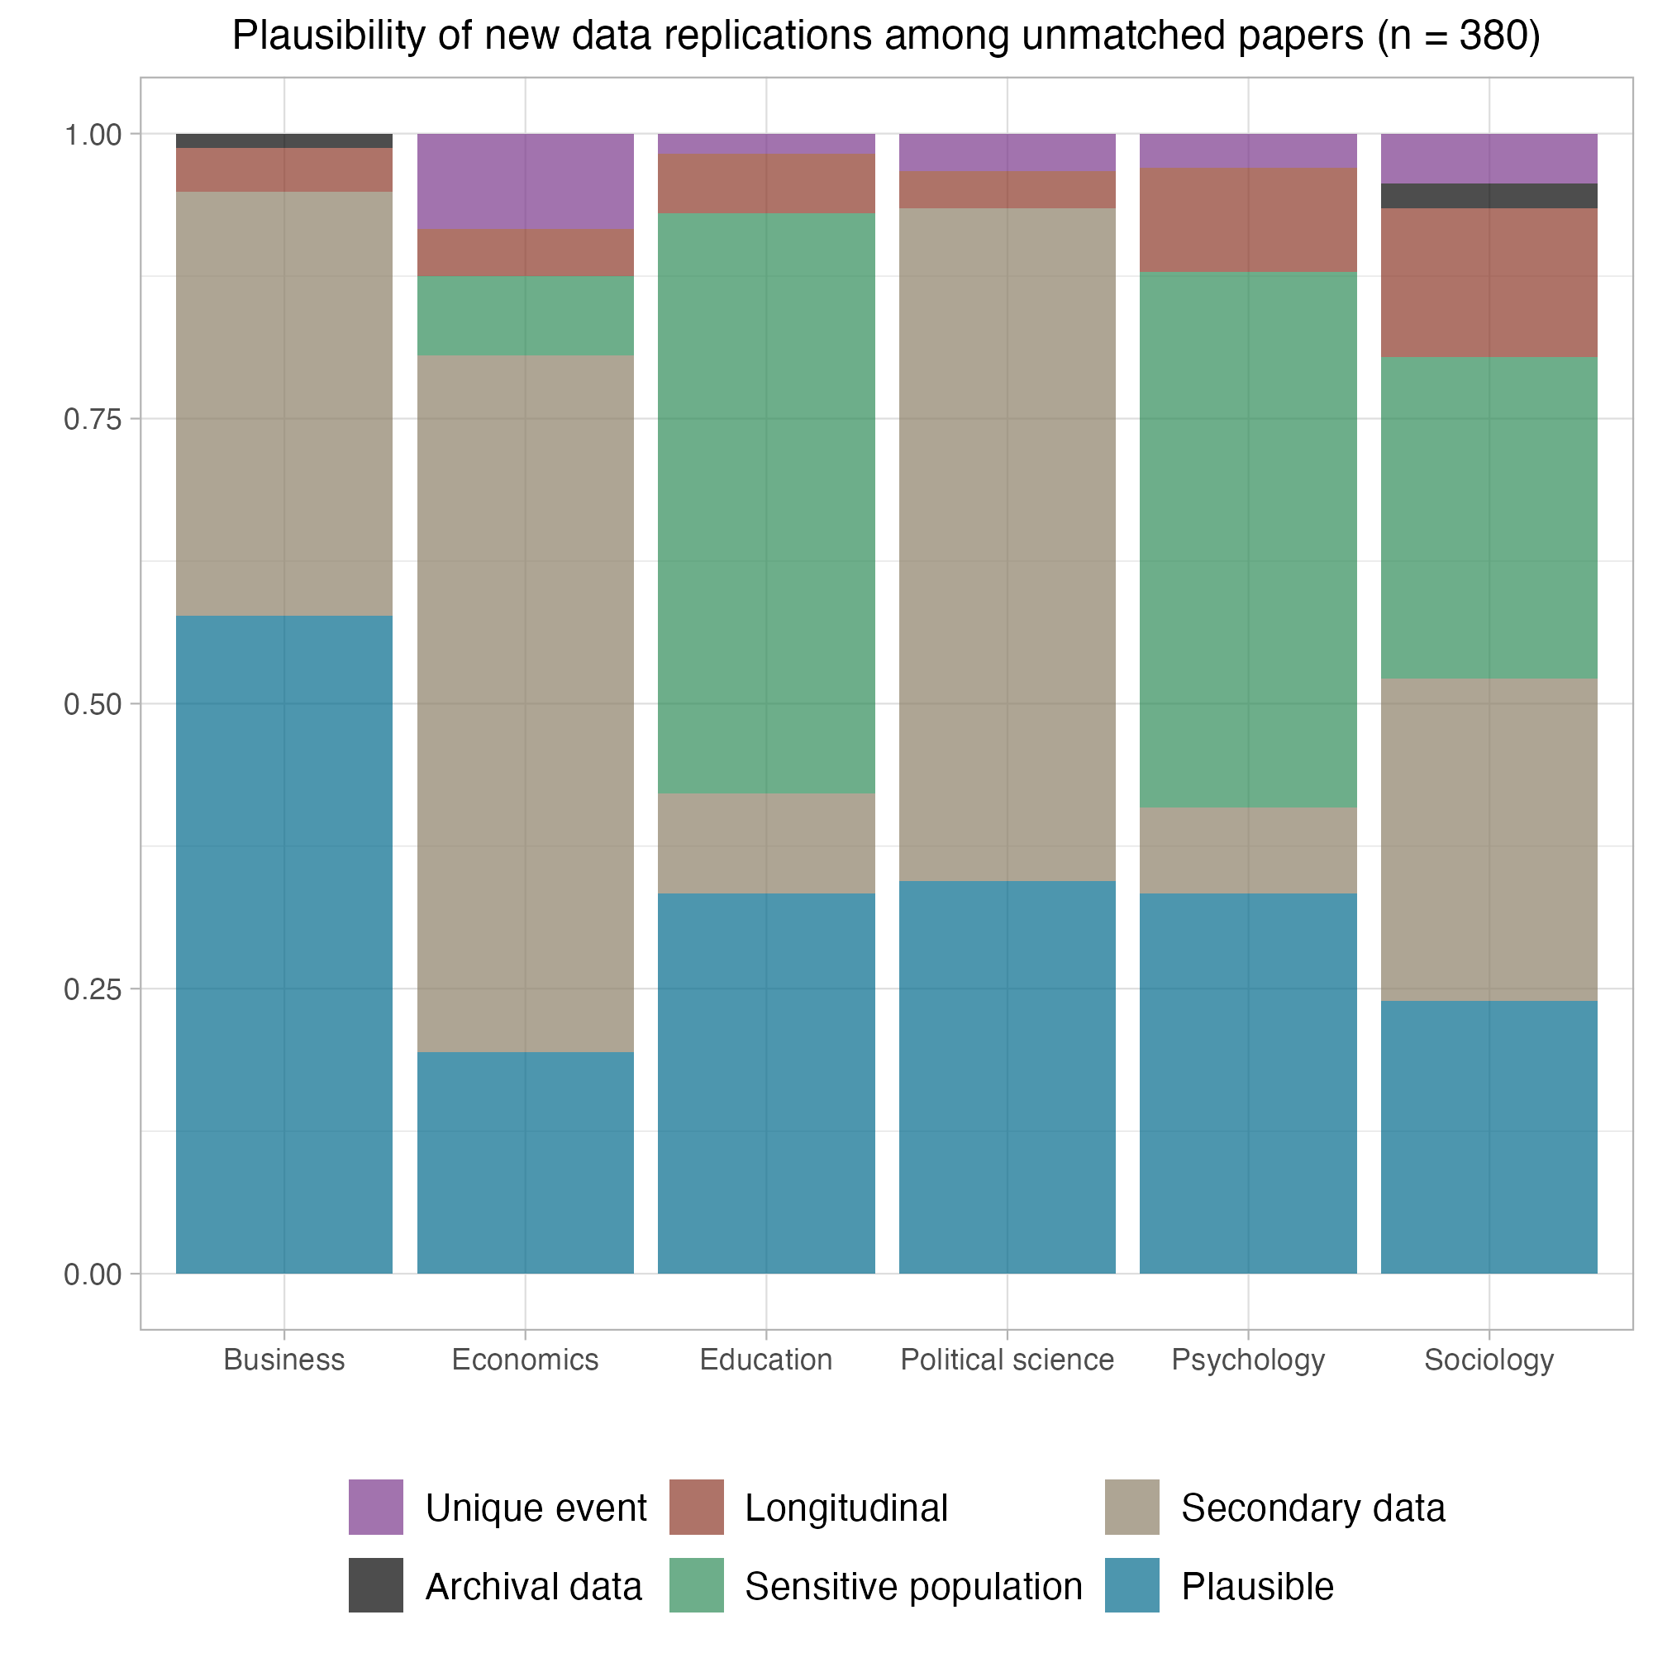
Caption: “Plausible” means that there were no clear barriers to conducting a replication other than capacity within the project. “Secondary data” means that these papers were more appropriate for a secondary data replication.
For plausibility of conducting secondary data replications of the same papers (Figure S9), 53 of the 380 papers (13.9%) were rated as plausible and the rest were deemed implausible because 190 (50.0%) were more likely conducted as new data replications, 60 (15.8%) were based on unique data or events for which it was unlikely to be feasible to find alternative data suitable to conduct a good faith replication, 43 (11.3%) were unlikely to have sufficient data because, for example, the time period examined in the original study was longer than the time period that had since elapsed to conduct a fair replication of the original design, 17 (4.5%) were based on administrative data that is difficult to obtain, and 17 (4.5%) were based on longitudinal data for which it was unlikely there was sufficient independent data to conduct a replication. Figure S9 illustrates, for example, that insufficient new data was most common in political science, whereas unique data or events were common in economics, and all barriers were well represented in sociology.
Figure S9. Retrospective review of papers that were not matched to replication teams to conduct a secondary data replication by discipline
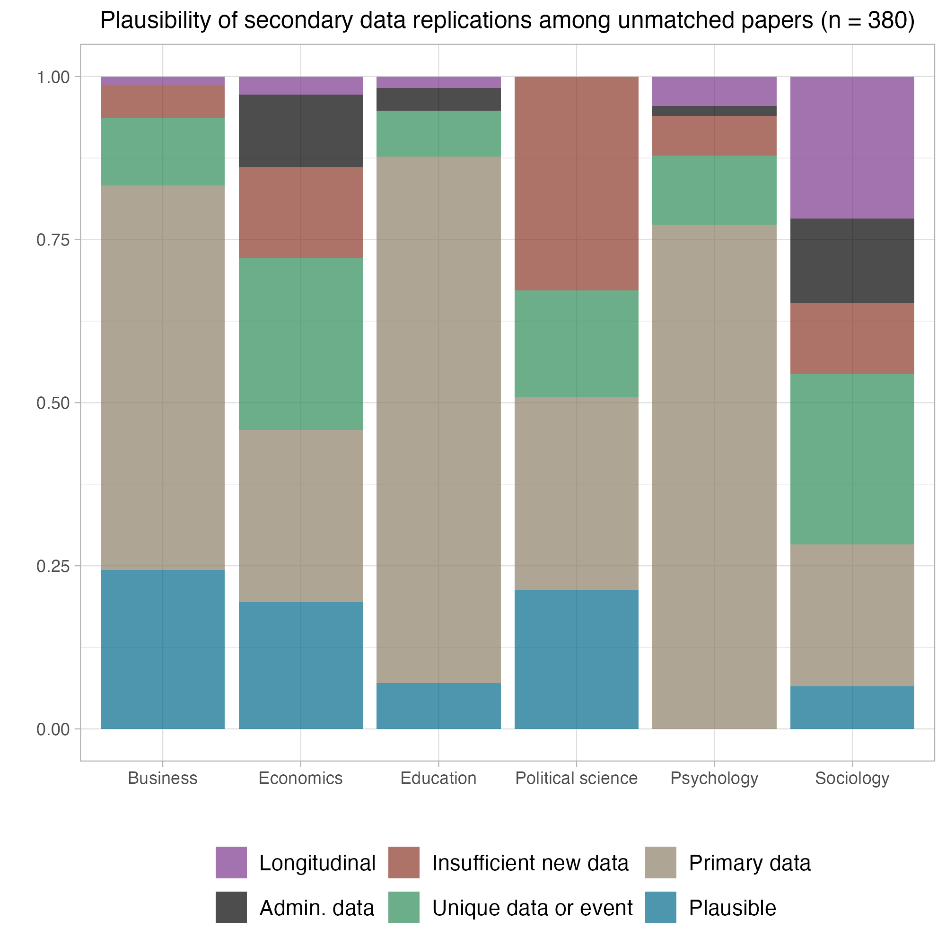
Caption: “Plausible” means that there were no clear barriers to conducting a replication other than capacity within the project. “Primary data” means that these papers were more appropriate for new data replications.
In total, from Phase 1, 181 of the 380 papers (47.6%) were plausible to have conducted a new or secondary data replication in the context of the program, if only there were more capacity available. Many of the other 199 (52.4%) rated as implausible might have been possible to replicate if there were no constraints on time, resources, or expertise.

Comparing replication rates between replications selected during Phase 1 and Phase 2
Of the 164 papers with replications, 139 came from the sample defined during Phase 1 of the program and 25 came from the sample defined during Phase 2 of the program.
Phase 1 included the Evidence set of 600 papers randomly drawn from the dataset of 3000 papers. For Phase 2, an additional 900 papers were randomly drawn from the same original database of 27407 papers to create a complementary annotation set for rating by the human and machine teams. From these 900 papers, we conducted 25 replications, selected for feasibility given the time constraints of Phase 2 before the conclusion of the program (see Abatayo et al. [2025] for details on sampling). Table S6 highlights the distribution of replication papers from Phase 1 and Phase 2 across disciplines.
Table S6. Paper-level count of replications completed from Phase 1 and Phase 2 by discipline.
 | Phase 1 papers | Phase 2 papers
Business | 27 | 9
Economics and finance | 22 | 2
Education | 10 | 3
Political science | 12 | 3
Psychology and health | 54 | 4
Sociology and criminology | 14 | 4
Total | 139 | 25

Statistical significance and effect size for replications completed from Phase 1 sample
Considering only replication attempts from the Phase 1 sample, weighting by paper, 68.8 of 139 papers replicated had statistically significant findings with the same pattern as the original finding 49.5% [95% CI 43.3 - 55.1%], 12.0 had statistically significant findings with an opposing pattern 8.6% [95% CI 4.9 - 11.8%], and 57.2 replications showed a null effect 41.2% [95% CI 35.3 - 47.4%]. Unweighted by claim, 139 of 249 replicated claims had statistically significant findings with the same pattern 50.7% [95% CI 44.8 - 56.6%], 20 had statistically significant findings with the opposite pattern 7.3% [95% CI 4.8 - 11.0%], and 89 showed a null effect 32.5% [95% CI 27.2 - 38.2%].
As summarized in Table S7, among the 125 papers for which a Pearson's r could be calculated for the original and replication outcomes, the median original effect size was 0.26 (SD = 0.20) and the median replication effect size was 0.12 (SD = 0.18), or 54.8% smaller by median. Among the 200 claims (unweighted) for which a Pearson's r could be calculated, the median original effect size was 0.25 (SD = 0.21) and the median replication effect size was 0.14 (SD = 0.17), or 42.6% smaller by median.
Table S7. Original and replication findings by Pearson's r effect size by papers and claims.
 | Papers  (weighted) |  | Claims  (unweighted)
 | Original | Replication | Original | Replication
Number of r effect sizes | 125 |  | 200
Median [IQR] sample size | 198  [571.0] | 484  [1096.0] | 236  [1112.0] | 542.5  [1619.5]
Median Pearson's r effect size (SD) | 0.26  (0.20) | 0.12  (0.18) | 0.25  (0.21) | 0.14  (0.17)
Note: Sample for this table is the studies for which a Pearson's r could be calculated for the original and replication outcomes. Papers are weighted combinations of claims accounting for multiple claims replicated in some papers. SD=standard deviation, IQR=interquartile range.

Statistical significance and effect size for replications completed from Phase 2 sample
Considering only replication attempts from the Phase 2 sample, 12.0 of 25 papers replicated had statistically significant findings with the same pattern as the original finding 48.0% [95% CI 33.3 - 62.5%], 4.0 had statistically significant findings with an opposing pattern 16.0% [95% CI 5.9 - 26.7%], and 9.0 replications showed a null effect 36.0% [95% CI 21.4 - 50.0%]. Unweighted by claim, 12 of 25 replicated claims had statistically significant findings with the same pattern 4.4% [95% CI 2.5 - 7.5%], 4 had statistically significant findings with the opposite pattern 1.5% [95% CI 0.6 - 3.7%], and 9 showed a null effect 3.3% [95% CI 1.7 - 6.1%].
As summarized in Table S8, among the 25 papers for which a Pearson's r could be calculated for the original and replication outcomes, the median original effect size was 0.13 (SD = 0.14) and the median replication effect size was 0.06 (SD = 0.10), or {table_s8_median_R_papers_neg_ratio} smaller by median. Among the 25 claims (unweighted) for which a Pearson's r could be calculated, the median original effect size was 0.13 (SD = 0.14) and the median replication effect size was 0.06 (SD = 0.10), or {table_s8_median_R_claims_neg_ratio} smaller by median.
Table S8. Original and replication findings by Pearson's r effect size by papers and claims.
 | Papers  (weighted) |  | Claims  (unweighted)
 | Original | Replication | Original | Replication
Number of R effect sizes | 25 |  | 25
Median [IQR] sample size | 271  [9942.0] | 1062  [8623.0] | 271  [9942.0] | 1062  [8623.0]
Median Pearson's r effect size (SD) | 0.13  (0.14) | 0.06  (0.10) | 0.13  (0.14) | 0.06  (0.10)
Note: Sample for this table is the studies for which a Pearson's r could be calculated for the original and replication outcomes. Papers are weighted combinations of claims accounting for multiple claims replicated in some papers. SD=standard deviation, IQR=interquartile range.

Replication success rates across binary assessments
In the main text, we reported replication success rates across 13 binary assessments. Because of different assumptions, the binary assessments often were applicable to different subsets of the replication outcomes. As such, observed variation in replication success rates could be due both to different assumptions of each metric and the different subsets of findings to which the metrics were applied. Table S9 reports the replication success rates by claims for each of the binary assessments for all of the replication outcomes to which they could be applied (n’s range 155 to 274) and to only the replication outcomes to which all of the binary assessments could be applied (n = 120).
Table S9. Replication success rates for binary assessments by claims
 | All claims possible |  | Complete cases  (all 13 metrics)
 | Counts | Rate | Counts | Rate
Analyst interpretation | 140 of 256 | 55% | 60 of 120 | 50%
Bayes factor | 96 of 239 | 40% | 43 of 120 | 36%
Bayesian meta-analysis | 148 of 219 | 68% | 72 of 120 | 60%
Correspondence test | 85 of 155 | 55% | 61 of 120 | 51%
Meta-analysis | 178 of 219 | 81% | 91 of 120 | 76%
Orig. in rep. CI | 80 of 225 | 36% | 33 of 120 | 28%
Rep. in orig. CI | 98 of 225 | 44% | 38 of 120 | 32%
Rep. in prediction interval | 123 of 219 | 56% | 40 of 120 | 33%
Replication Bayes factor | 125 of 219 | 57% | 61 of 120 | 51%
Sig + pattern | 151 of 274 | 55% | 59 of 120 | 49%
Skeptical p-value | 106 of 197 | 54% | 65 of 120 | 54%
Small telescopes | 165 of 223 | 74% | 81 of 120 | 68%
Sum of p-values | 95 of 206 | 46% | 59 of 120 | 49%
Figure S10 shows the same correlation matrix as Figure 3 from the main text except the correlations are computed across claims rather than across papers. The pattern of correlations is generally consistent with the strength of correspondence observed between metrics across papers.
Figure S10: Correlation matrix among binary assessments of replication success across claims
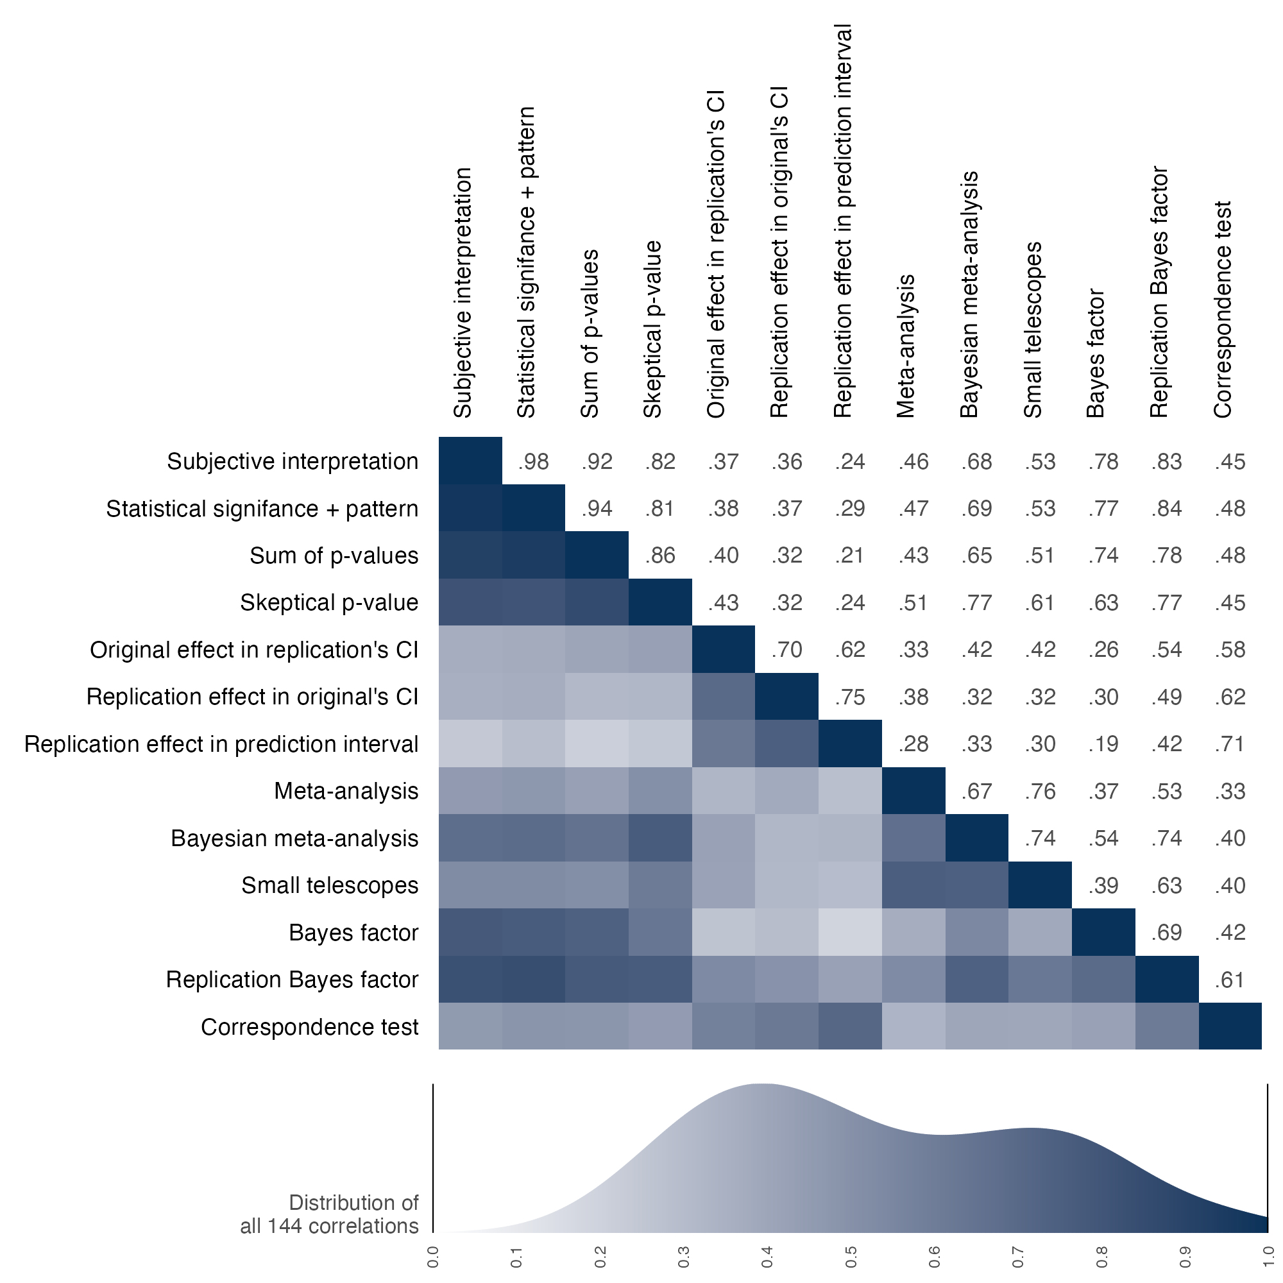
Note: Correlation values are right of the diagonal, and correlation magnitude is visualized left of the diagonal with darker shading indicating stronger correlations. CI = confidence interval.
Figure S11 visualizes the pattern of success rates for relative effect sizes between replication and original studies for each of the 13 assessment methods with logistic curves. These patterns provide complementary insight for the correlations observed between assessments in Figure S10. For example, metrics with more failures when replication effect sizes were either higher or lower than original effect sizes show similar shapes.
Figure S11: Replication success or failure for 13 binary assessments by the effect size difference between the replication and original studies
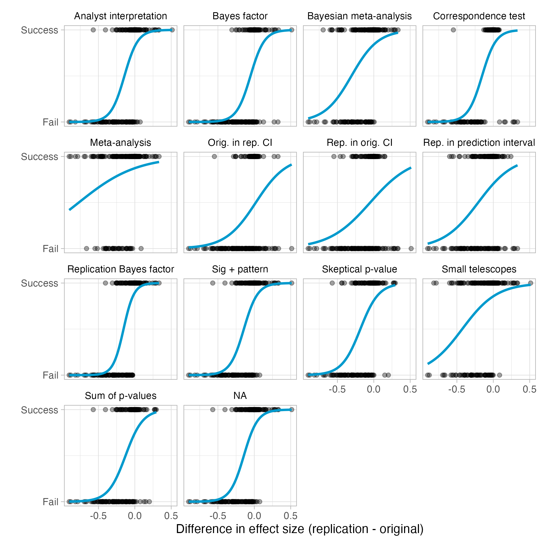
Caption: Data points are differences in effect sizes for individual claims. Data points on top are successful replications, and data points on the bottom are failed replications, according to the metric.

Disciplinary differences in new versus secondary data replications
Table S10 shows the substantial differences by discipline in the proportion of replications that used new versus secondary data, median power to detect effect sizes 75% as large as the original study, and median sample sizes for original studies and replication attempts. Note that the relationships between power and sample size are not necessarily aligned as there is substantial variation in methodologies that can affect power estimation. The relationship between data source, discipline, and replication success deserves systematic attention in future research.
Table S10. Proportion of new versus secondary data replications and power to detect 75% of the original effect size by discipline
 | Proportion of replication type |  | Median power to detect 75% of the original effect |  | Median sample size
 | New data | Secondary data | Assuming same scales | Assuming same designs | Original study | Replication attempt
Business | 91.7% | 8.3% | 99.6% | 79.6% | 228 | 622.5
Economics and finance | 45.8% | 54.2% | 95.3% | 90.4% | 393 | 491
Education | 7.7% | 92.3% | 100.0% | 98.1% | 853.5 | 1745.5
Political science | 33.3% | 66.7% | 98.3% | 90.1% | 4648 | 5881
Psychology and health | 81.0% | 19.0% | 95.6% | 90.1% | 1064 | 1255
Sociology and criminology | 5.6% | 94.4% | 93.3% | 75.4% | 1142 | 666

Replication outcomes by discipline
In the main text, we presented statistical significance and effect sizes by subdiscipline across papers. In Table S11, we reproduce the table with the same comparison across claims.
Table S11. Original and replication outcomes by statistical significance and pattern and by Pearson's r effect size for 6 subdisciplines across claims
 | Replication attempt statistical significance and pattern |  | Median Pearson’s r effect size (SD)
 | Counts | Percentage | Original | Replication
Business | 17 of 36 | 47% | 0.24 (0.12) | 0.06 (0.16)
Economics and finance | 18 of 38 | 47% | 0.41 (0.22) | 0.18 (0.26)
Education | 20 of 28 | 71% | 0.15 (0.16) | 0.13 (0.14)
Political science | 30 of 45 | 67% | 0.16 (0.27) | 0.12 (0.21)
Psychology and health | 51 of 94 | 54% | 0.26 (0.21) | 0.09 (0.19)
Sociology and criminology | 15 of 33 | 45% | 0.13 (0.16) | 0.04 (0.21)
Total | 151 of 274 | 55% | -- | --
Caption: SD=standard deviation
For the main text and the Table above, we aggregated the 62 journals into 6 disciplines. The original selection of journals was done considering representation from more subdisciplines that were aggregated to 6 for expository purposes. Social-behavioral subdisciplines have fuzzy boundaries, and journals do not necessarily abide by those boundaries in the content that they publish. Nevertheless, the selection of journals was based on considering nominations of journals that were representative of these subdisciplines to ensure diverse representation across subfields. Here, we summarize the primary replication outcomes separating the 62 journals into smaller subdisciplines: 2 journals in Criminology, 8 journals in Economics, 7 journals in Education, 3 journals in Finance, 3 journals in Health, 5 journals in Management, 4 journals in Marketing, 3 journals in Organizational Behavior, 7 journals in Political Science, 12 journals in Psychology, 2 journals in Public Administration, and 6 journals in Sociology. Note, however, that subdiscipline boundaries are also fuzzy and several journals publish papers across those boundaries. These categorizations are imprecise given the actual content in the published papers.
Table S12 reproduces the findings reported above but separated out into 12 subdisciplines. An obvious caution is that the sample sizes for some of these subsets are quite small leading to highly imprecise results. There is not a strong basis for interpreting variation across subdisciplines as indicative of meaningful differences in replication success rates.
Table S12. Original and replication outcomes by statistical significance and pattern and by Pearson's r effect size for 12 subdisciplines across claims
 | Statistical significance and pattern |  | Median Pearson’s r effect size (SD)
 | Counts | Percentage | Original | Replication
Criminology | 3 of 5 | 60% | 0.11 (0.06) | 0.19 (0.29)
Economics | 17 of 34 | 50% | 0.41 (0.2) | 0.18 (0.27)
Education | 20 of 28 | 71% | 0.15 (0.16) | 0.13 (0.14)
Finance | 1 of 4 | 25% | 0.59 (0.33) | 0.14 (0.21)
Health | 4 of 7 | 57% | 0.06 (0.02) | 0.09 (0.06)
Management | 2 of 5 | 40% | 0.24 (0.12) | 0.11 (0.29)
Marketing | 8 of 18 | 44% | 0.24 (0.11) | 0.03 (0.13)
Org. behavior | 7 of 13 | 54% | 0.24 (0.13) | 0.12 (0.14)
Political science | 29 of 44 | 66% | 0.16 (0.28) | 0.13 (0.21)
Psychology | 47 of 87 | 54% | 0.27 (0.21) | 0.11 (0.2)
Public administration | 1 of 1 | 100% | 0.12 (NA) | 0.11 (NA)
Sociology | 12 of 28 | 43% | 0.2 (0.17) | 0.03 (0.18)
Caption: SD=standard deviation, Org=Organizational.

Original and Replication Effects by Year of Publication
A weighted chi-squared test on replication success across papers by publication year failed to reject the null hypothesis (p = 0.14). Differences in median estimates for effect sizes were largest for 2011 (original papers median R = 0.32; replications median R = 0.11) and smallest for 2013 (original papers median R = 0.15; replications median R = 0.14). Sample sizes for individual years are small, and there is no obvious trend by publication year for the relative magnitude of the difference between original and replication studies or their success rates in terms of statistical significance.
Across claims, the Pearson's r correlation between the proportion of statistical significant replications with the same pattern of the original finding with publication year was 0.071 [95% CI -0.086 - 0.220]. Differences in median estimates for effect sizes were largest for 2011 (original papers median R = 0.32; replications median R = 0.11) and smallest for 2013 (original papers median R = 0.15; replications median R = 0.14).
Sample sizes for individual years are small, and there is no obvious trend by publication year for the relative magnitude of the difference between original and replication studies or their success rates in terms of statistical significance.

Multiple replications of single claims
In most cases, a single replication was conducted on a single claim from a single paper. For some replication studies (total n = 28), we allowed multiple replications of a single claim. We offered this opportunity in case multiple teams were interested in the same claim and to involve as many replication teams as possible. Even so, we prioritized conducting replications of different claims, so there are not many of these cases. In the main text, the reported findings are based on the aggregated evidence across multiple replications of the same claim. Here, we provide insight to the individual replications comprising that aggregated evidence.

Same protocol
For 3 claims, multiple teams used the same protocol and conducted separate replication studies (n = 10 total studies). This mimics “Many Labs” replication projects (Ebersole et al., 2016, 2019; Klein et al., 2014, 2018, 2019). For these cases, a single preregistration protocol was created, peer reviewed, and approved. Then, multiple teams used that protocol to conduct their replication.
Table S13. Outcomes of individual data collections of the same original claim (3 cases)
Paper | Journal | Original effect | Study ID | Re. sample | Replication effect
Yang et al. (2013) | Journal of Marketing Research | 0.33 (0.14, 0.48) | 887 | 169 | 0.15 (0, 0.29)
Yang et al. (2013) | Journal of Marketing Research | 0.33 (0.14, 0.48) | 369z | 162 | 0.21 (0.05, 0.35)
Yang et al. (2013) | Journal of Marketing Research | 0.33 (0.14, 0.48) | 387 | 162 | 0.23 (0.08, 0.37)
Yang et al. (2013) | Journal of Marketing Research | 0.33 (0.14, 0.48) | 999g | 168 | -0.12 (-0.28, 0.04)
Yang et al. (2013) | Journal of Marketing Research | 0.33 (0.14, 0.48) | gz9m | -- | 0.12 (0.04, 0.2)
King & Bryant (2017) | Journal of Organizational Behavior | 0.27 (0.05, 0.45) | 1642 | 183 | 0.36 (0.23, 0.47)
King & Bryant (2017) | Journal of Organizational Behavior | 0.27 (0.05, 0.45) | om7 | 183 | 0.46 (0.34, 0.56)
King & Bryant (2017) | Journal of Organizational Behavior | 0.27 (0.05, 0.45) | 40z0 | -- | 0.42 (0.33, 0.51)
Ku & Zaroff (2014) | Journal of Environmental Psychology | 0.48 (0.3, 0.62) | 4zy8 | 71 | 0.34 (0.12, 0.52)
Ku & Zaroff (2014) | Journal of Environmental Psychology | 0.48 (0.3, 0.62) | 15yz | 81 | 0.34 (0.14, 0.51)
Ku & Zaroff (2014) | Journal of Environmental Psychology | 0.48 (0.3, 0.62) | 3z7z | 152 | 0.05 (-0.12, 0.22)
Ku & Zaroff (2014) | Journal of Environmental Psychology | 0.48 (0.3, 0.62) | 8y1 | 150 | 0.14 (-0.02, 0.29)
Ku & Zaroff (2014) | Journal of Environmental Psychology | 0.48 (0.3, 0.62) | 4930 | -- | 0.17 (0.08, 0.26)
Caption: Bolded rows denote the aggregated result. All effect sizes are partial correlations. The analysis for study 999g was revised prior to the meta-analysis to reflect the replication team’s recommended data exclusions rather than their preregistered version. The preregistered version remains unchanged in the broader datasets.
As shown in Table S13, 3 of the 10 individual data collections were directionally inconsistent (n = 1) or were directionally consistent but included 0 in their 95% confidence interval (n = 2). However, for all three of these findings, the cumulative evidence across the individual data collections provided a positive result consistent with the original finding.

Different protocol
For 12 claims (n = 24 total studies), multiple teams conducted replications of the same claim but used different protocols (Table S14). For these cases, each protocol was separately created, peer reviewed, and approved. This introduces greater heterogeneity between replications because the protocol, sample, and implementation context differed between the replications. These might show lower replicability rates than replication studies that make every effort to test the original claim as specified -- either by recreating the procedures as closely as possible, or by reproducing all of the key features believed to be necessary to observe evidence for the original claim (Nosek & Errington, 2020). Alternatively, if the claims are well-specified with the conditions necessary to observe them, then the variation in operationalization might be immaterial as long as that variation is irrelevant to the manifestation of the finding. Few claims in the social-behavioral sciences are so well-specified that variation in methods would not be associated with increasing heterogeneity in observed effect sizes.
Table S14. Outcomes of individual data collections of the same claim using different protocols
Paper | Journal | Original effect | Study ID | Rep. sample | Replication effect
Trémolière et al. (2012) | Cognition | 0.28 (0.07, 0.45) | 276 | 533 | 0 (-0.08, 0.09)
Trémolière et al. (2012) | Cognition | 0.28 (0.07, 0.45) | 2y486 | 129 | -0.13 (-0.82, 0.77)
Trémolière et al. (2012) | Cognition | 0.28 (0.07, 0.45) | 6o4o5 | -- | 0.02 (-0.05, 0.1)
Rodriguez-Lara & Moreno-Garrido (2012) | Experimental Economics | 0.65 (0.29, 0.79) | 23m12 | 151 | 0.67 (0.58, 0.74)
Rodriguez-Lara & Moreno-Garrido (2012) | Experimental Economics | 0.65 (0.29, 0.79) | 895g | 27 | 0.63 (0.3, 0.78)
Rodriguez-Lara & Moreno-Garrido (2012) | Experimental Economics | 0.65 (0.29, 0.79) | 6o4z5 | -- | 0.67 (0.56, 0.78)
Alves et al. (2018) | Psychological Science | 0.24 (0.1, 0.37) | 24716 | 388 | 0.13 (0.03, 0.23)
Alves et al. (2018) | Psychological Science | 0.24 (0.1, 0.37) | 92g | 361 | 0.25 (0.15, 0.36)
Alves et al. (2018) | Psychological Science | 0.24 (0.1, 0.37) | 6917o | -- | 0.19 (0.12, 0.26)
Bhattacharjee et al. (2017) | Journal of Personality and Social Psychology | 0.25 (0.14, 0.34) | 2kgg2 | 656 | -0.25 (-0.32, -0.18)
Bhattacharjee et al. (2017) | Journal of Personality and Social Psychology | 0.25 (0.14, 0.34) | 7g66 | 364 | 0.41 (0.32, 0.49)
Bhattacharjee et al. (2017) | Journal of Personality and Social Psychology | 0.25 (0.14, 0.34) | 65k41 | -- | -0.33 (-0.39, -0.28)
Pastötter et al. (2013) | Cognition | 0.29 (0.19, 0.39) | 6738 | 705 | 0.24 (0.17, 0.32)
Pastötter et al. (2013) | Cognition | 0.29 (0.19, 0.39) | 6m396 | 687 | 0.28 (0.21, 0.35)
Pastötter et al. (2013) | Cognition | 0.29 (0.19, 0.39) | 2kk4o | -- | 0.26 (0.21, 0.31)
Griffiths & Tenenbaum (2011) | Journal of Experimental Psychology: General | 0.55 (0.29, 0.7) | 288g2 | 477 | 0.55 (0.49, 0.61)
Griffiths & Tenenbaum (2011) | Journal of Experimental Psychology: General | 0.55 (0.29, 0.7) | 89z7 | 30 | 0.61 (0.42, 0.72)
Griffiths & Tenenbaum (2011) | Journal of Experimental Psychology: General | 0.55 (0.29, 0.7) | 6914o | -- | 0.54 (0.51, 0.58)
Fox (2009) | Journal of Labor Economics | 0.04 (0.03, 0.06) | 10g2 | 202476 | 0 (0, 0.01)
Fox (2009) | Journal of Labor Economics | 0.04 (0.03, 0.06) | 944y | 361381 | 0 (0, 0.01)
Fox (2009) | Journal of Labor Economics | 0.04 (0.03, 0.06) | 2kk9o | -- | 0 (-0.02, 0.02)
Armon et al. (2013) | European Journal of Personality | 0.04 (0, 0.08) | g79m | 28731 | -0.02 (-0.03, -0.01)
Armon et al. (2013) | European Journal of Personality | 0.04 (0, 0.08) | m7g7 | 7796 | -0.01 (-0.03, 0.01)
Armon et al. (2013) | European Journal of Personality | 0.04 (0, 0.08) | y7g1 | -- | -0.02 (-0.03, -0.01)
McCarter et al. (2010) | Organizational Behavior and Human Decision Processes | 0.27 (0.02, 0.47) | 5g9 | 545 | 0.02 (-0.01, 0.04)
McCarter et al. (2010) | Organizational Behavior and Human Decision Processes | 0.27 (0.02, 0.47) | 6ow46 | 320 | -0.02 (-0.08, 0.04)
McCarter et al. (2010) | Organizational Behavior and Human Decision Processes | 0.27 (0.02, 0.47) | 243yy | -- | 0.01 (-0.01, 0.03)
Luttrell et al. (2016) | Journal of Experimental Social Psychology | 0.17 (0.02, 0.31) | 24316 | 370 | 0.14 (0.03, 0.24)
Luttrell et al. (2016) | Journal of Experimental Social Psychology | 0.17 (0.02, 0.31) | 9kzy | 443 | 0.18 (0.09, 0.27)
Luttrell et al. (2016) | Journal of Experimental Social Psychology | 0.17 (0.02, 0.31) | 23my4 | -- | 0.16 (0.09, 0.23)
Boehm et al. (2015) | Psychological Science | -0.05 (-0.08, -0.02) | 651m6 | 4971 | -0.02 (-0.05, 0.01)
Boehm et al. (2015) | Psychological Science | -0.05 (-0.08, -0.02) | z516 | 7981 | 0.12 (0.06, 0.18)
Boehm et al. (2015) | Psychological Science | -0.05 (-0.08, -0.02) | 21zyw | -- | 0 (-0.02, 0.03)
Ohtsubo et al. (2014) | Evolution and Human Behavior | 0.75 (0.54, 0.85) | 128g6 | 41 | 0.17 (-0.14, 0.44)
Ohtsubo et al. (2014) | Evolution and Human Behavior | 0.75 (0.54, 0.85) | 9977 | 38 | -0.07 (-0.37, 0.25)
Ohtsubo et al. (2014) | Evolution and Human Behavior | 0.75 (0.54, 0.85) | 2wgy9 | -- | 0.06 (-0.16, 0.27)
Caption: Bolded rows denote the aggregated result. Italicized rows denote generalizability studies. All effect sizes are partial correlations. The focal analysis for study 24316 was redesigned prior to the meta-analysis to bring it more in line with the original study. Consequently, the individual outcome appears as a successful replication here but as an unsuccessful replication in the reported data.

Hybrid replications
We defined hybrid replications as those that were not based on completely independent data. A common case for this is a longitudinal analysis in which additional waves of data are available since the original study. In 27 cases, replications used some of the original data and added new data. For 11 of those, a “pure” replication is reported with only independent data in the main text, and for 16 there was insufficient data to include an independent replication. Hybrids were not reported in the main text because they are not independent tests of the original claim.
Here, we summarize the hybrid versions that included original and new data together. Table S15 reports the individual effects for 27 cases that had hybrid data. For the 11 cases that had sufficient independent data to include a replication attempt in the main paper, the effects for the hybrid data (labeled “Hybrid” in the analysis column) are immediately followed by the effects with the independent data (labeled “Replication” in the analysis column).
Table S15. Effects for hybrid replication attempts that included original and independent data
Paper | Journal | Claim ID | Original effect | Study ID | Analysis | Rep. sample | Replication effect | SCORE outcome
0PZl | Comparative Political Studies | 0PZl_single-trace | 0.89 (0.84, 0.92) | g241 | Hybrid | 83 | 0.95 (0.93, 0.96) | Success
2GKO | World Development | 2GKO_3pnxyo | 0.19 (0.05, 0.32) | 6m34m | Hybrid | 452 | -0.05 (-0.15, 0.04) | Failed
2GKO | World Development | 2GKO_jr67qq | 0.24 (0.11, 0.36) | 6m34m | Hybrid | 452 | -0.18 (-0.26, -0.09) | Failed
2GKO | World Development | 2GKO_pjp7lx | 0.19 (0.05, 0.32) | 6m34m | Hybrid | 452 | -0.06 (-0.15, 0.03) | Failed
2GKO | World Development | 2GKO_single-trace | 0.19 (0.05, 0.32) | 4142 | Hybrid | 468 | -0.05 (-0.14, 0.04) | Failed
2GKO | World Development | 2GKO_single-trace | 0.19 (0.05, 0.32) | 4142 | Replication | 256 | -0.17 (-0.28, -0.05) | Failed
2GKO | World Development | 2GKO_wl74j8 | 0.19 (0.05, 0.32) | 6m34m | Hybrid | 452 | 0.07 (-0.02, 0.16) | Failed
2GKO | World Development | 2GKO_x76512 | 0.2 (0.07, 0.33) | 6m34m | Hybrid | 452 | -0.24 (-0.32, -0.15) | Failed
3aPw | Demography | 3aPw_single-trace | -- | 05g8 | Hybrid | 420530 | -- | Success
3aPw | Demography | 3aPw_single-trace | -- | 05g8 | Replication | 161855 | -- | Success
4q0L | Social Forces | 4q0L_single-trace | 0.22 (0.1, 0.32) | 3z5z | Hybrid | 500 | 0.18 (0.09, 0.27) | Success
4q0L | Social Forces | 4q0L_single-trace | 0.22 (0.1, 0.32) | 3z5z | Replication | 150 | 0.21 (0, 0.39) | Success
5Kgq | Demography | 5Kgq_single-trace | -0.43 (-0.56, -0.28) | k6y7 | Hybrid | 165 | -0.41 (-0.52, -0.28) | Success
5Kgq | Demography | 5Kgq_single-trace | -0.43 (-0.56, -0.28) | k6y7 | Replication | 159 | 0.03 (-0.13, 0.18) | Failed
7X54 | American Sociological Review | 7X54_single-trace | 0.33 (0.29, 0.37) | 93k7 | Hybrid | 3347 | 0.35 (0.32, 0.38) | Success
7X54 | American Sociological Review | 7X54_single-trace | 0.33 (0.29, 0.37) | 93k7 | Replication | 1438 | 0.4 (0.36, 0.44) | Success
9wya | American Political Science Review | 9wya_single-trace | 0.09 (0.02, 0.15) | 9k2y | Hybrid | 1324 | 0 (-0.05, 0.06) | Failed
BKxK | Journal of Financial Economics | BKxK_single-trace | 0.36 (0, 0.61) | 4zz0 | Hybrid | 30 | 0.48 (0.14, 0.68) | Success
BKxK | Journal of Financial Economics | BKxK_single-trace | 0.36 (0, 0.61) | 4zz0 | Replication | 30 | 0.23 (-0.13, 0.52) | Failed
BebG | Psychological Science | BebG_single-trace | 0.05 (0, 0.11) | 42k8 | Hybrid | 2265 | 0.07 (0.03, 0.12) | Success
E5qr | World Development | E5qr_single-trace | 0.25 (0, 0.46) | 95y | Hybrid | 114 | -0.07 (-0.25, 0.12) | Failed
EJpm | American Journal of Sociology | EJpm_single-trace | -- | yk20 | Hybrid | 713 | -- | Success
Ryq7 | British Journal of Political Science | Ryq7_single-trace | -- | 95my | Hybrid | 29 | -- | Success
VOwm | Management Science | VOwm_single-trace | -- | ykk0 | Hybrid | 32667 | -- | Failed
VOwm | Management Science | VOwm_single-trace | -- | ykk0 | Replication | 12344 | -- | Failed
YRvg | Journal of Financial Economics | YRvg_single-trace | 0.08 (-0.01, 0.17) | 3g4k | Hybrid | 641 | 0.12 (0.04, 0.19) | Success
kXp8 | Organization Science | kXp8_single-trace | 0.24 (0.11, 0.36) | kzyz | Hybrid | 205 | 0.19 (0.05, 0.31) | Success
kXp8 | Organization Science | kXp8_single-trace | 0.24 (0.11, 0.36) | kzyz | Replication | 174 | 0.18 (0.03, 0.31) | Success
l22v | Comparative Political Studies | l22v_single-trace | -- | 68 | Hybrid | 99 | -- | Success
q8xv | Journal of Political Economy | q8xv_single-trace | -0.54 (-0.66, -0.37) | mkk9 | Hybrid | 786 | -0.52 (-0.63, -0.37) | Success
q8xv | Journal of Political Economy | q8xv_single-trace | -0.54 (-0.66, -0.37) | mkk9 | Replication | 391 | -0.54 (-0.65, -0.39) | Success
qgWj | British Journal of Political Science | qgWj_single-trace | 0.48 (0.28, 0.62) | 2yg | Hybrid | 95470 | 0.09 (0.08, 0.1) | Success
qgWj | British Journal of Political Science | qgWj_single-trace | 0.48 (0.28, 0.62) | 2yg | Replication | 45119 | 0.2 (-0.13, 0.47) | Failed
qkNz | Journal of Labor Economics | qkNz_single-trace | 0.43 (0.17, 0.61) | 0y68 | Hybrid | 64 | 0.26 (0.01, 0.46) | Success
vmxO | World Development | vmxO_single-trace | 0.12 (0.07, 0.17) | y4y0 | Hybrid | 2051 | 0.06 (0, 0.12) | Failed
z0v1 | Social Forces | z0v1_single-trace | 0.01 (0, 0.03) | 0056 | Hybrid | 16832 | -- | Success
zmYY | Criminology | zmYY_single-trace | 0.11 (0.06, 0.16) | g5m | Hybrid | 1409 | 0.08 (0, 0.17) | Failed
zmYY | Criminology | zmYY_single-trace | 0.11 (0.06, 0.16) | g5m | Replication | 1384 | -0.01 (-0.14, 0.12) | Failed
Caption: Studies for which there was sufficient data to report an independent replication in the main text are reported in two rows, the first row reporting the hybrid effects and the second row reporting the independent replication. Empty cells for ‘Original effect’ and ‘Replication effect’ mean the effect could not be reliably converted to a partial correlation. The SCORE outcome labels the effect “success” if it was statistically significant (p < .05) with the same pattern as the original study, and “failure” if it was not.
Among the 16 cases that had only hybrid data, 8 succeeded and 8 failed to observe statistically significant evidence with the same pattern as the original study (50% success rate). Among the 11 cases for which there was sufficient data to report an independent replication, 5 succeeded with both hybrid and independent data (45%), 3 failed with both hybrid and independent data (27%), and 3 succeeded with hybrid data and failed with independent data (27%). Overall, 16 of 27 hybrid datasets successfully replicated the original study (59%), and the 5 of 11 independent datasets from this sample did so (45%).

Success Rates on Binary Assessments Across Claims
In the main text, we reported the replication success rates across 13 binary assessments weighting claims by paper. In Figure S12, we report the same findings unweighted by claims.
Figure S12. Replication success rates across 13 binary assessments for claims
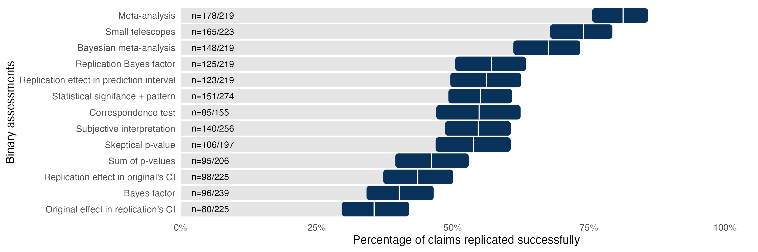
Caption: The vertical white line for each row is the estimate, and the 95% confidence interval around the estimate is represented by the dark bar. CI = confidence interval.

References
Abatayo, A. L., Achakulvisut, T., Acuna, D., Aczel, B., Balaji, L., Bandrowski, A. E., & Benjamin, D. M. (2025). Empirical, Human, and Machine Assessments of Research Credibility in the Social and Behavioral Sciences.
Camerer, C. F., Dreber, A., Holzmeister, F., Ho, T.-H., Huber, J., Johannesson, M., Kirchler, M., Nave, G., Nosek, B. A., Pfeiffer, T., Altmejd, A., Buttrick, N., Chan, T., Chen, Y., Forsell, E., Gampa, A., Heikensten, E., Hummer, L., Imai, T., … Wu, H. (2018). Evaluating the replicability of social science experiments in Nature and Science between 2010 and 2015. Nature Human Behaviour, 2(9), 637–644. https://doi.org/10.1038/s41562-018-0399-z
Chambers, C. (2019). What’s next for Registered Reports? Nature, 573(7773), 187–189. https://doi.org/10.1038/d41586-019-02674-6
Chambers, C. D., & Tzavella, L. (2022). The past, present and future of Registered Reports. Nature Human Behaviour, 6(1), Article 1. https://doi.org/10.1038/s41562-021-01193-7
Champely, S., Ekstrom, C., Dalgaard, P., Gill, J., Weibelzahl, S., Anandkumar, A., Ford, C., Volcic, R., De Rosario, H., & De Rosario, M. H. (2018). Package ‘pwr.’ R Package Version, 1(2). http://14.63.219.55/web/packages/pwr/pwr.pdf
Ebersole CR, Atherton OE, Belanger AL, Skulborstad HM, Allen JM, et al. 2016a. Many Labs 3: evaluating participant pool quality across the academic semester via replication. Journal of Experimental Social Psychology, 67:68–82.
Ebersole CR, Mathur MB, Baranski E, Bart-Plange D-J, Buttrick NR, et al. 2020. Many Labs 5: testing pre-data-collection peer review as an intervention to increase replicability. Advances in Methods and Practices in Psychological Science, 3(3):309–31.
Hedges, L. V., & Vevea, J. L. (1998). Fixed- and random-effects models in meta-analysis. Psychological Methods, 3(4), 486–504.
Klein RA, Cook CL, Ebersole CR, Vitiello C, Nosek BA, et al. (2024). Many Labs 4: failure to replicate mortality salience effect with and without original author involvement. Collabra. https://doi.org/10/ghwq2w
Klein RA, Ratliff KA, Vianello M, Adams RB, Bahník Š, et al. (2014). Investigating variation in replicability: a “many labs” replication project. Social Psychology, 45(3):142–52.
Klein RA, Vianello M, Hasselman F, Adams BG, Adams RB, et al. (2018). Many Labs 2: investigating variation in replicability across samples and settings. Advances in Methods and Practices in Psychological Science, 1(4):443–90.
Laird, N. M., & Mosteller, F. (1990). Some statistical methods for combining experimental results. International Journal of Technology Assessment in Health Care, 6(1), 5–30.
Miske, O., Abatayo, A. L., Daley, M., Dirzo, M., Fox, N., Haber, N., Hahn, K., Mawhinney, B., Silverstein, P., Stankov, T., & Tyner, A. H. (2025). Investigating the reproducibility of the social and behavioral sciences.
Nosek, B. A., & Errington, T. M. (2020). What is replication? PLOS Biology, 18(3), e3000691. https://doi.org/10.1371/journal.pbio.3000691

